.

BROAD AREA ANNOUNCEMENT FOR

**JOINT NON-LETHAL WEAPONS PROGRAM (JNLWP) (BAA) N66001-10-X-0012 Call 01**

**FULL PROPOSAL**

**Haleakala Research & Development Inc.,**

**7 Martin Road, Brookfield, MA. 01506-1762**

**High Powered Smart Reconfigurable Plasma ADS Antennas**

[**www.haleakala-research.com**](http://www.haleakala-research.com/)

**Dr. Theodore R. Anderson, CEO**

518 409 1010 (cell); 508 867 3918 (office)

[TedAnderson@Haleakala-research.com](mailto:TedAnderson@Haleakala-research.com) and [anderdrted@aol.com](mailto:anderdrted@aol.com)

**Date submitted: July 1, 2010**

**Haleakala Research and Development, Inc is a small business , CCR registered, and DUNS number: 126284624 and CAGE number 30RQ9.**

**Subcontractor: University of Tennessee**

**This is a 15 month proposal. Applications:**

1. **Non-lethal vehicle/vessel stopping at extended range (multiple technology areas)**
2. **Compact mm-wave sources as an Active Denial weapon subsystem capability (includes but is not limited to 95 GHz solid state and Radio Frequency (RF) tube technologies)**

**,**

Volume I

1. **BAA title and number, and BAA topic area(s) addressed by the proposal;**

BROAD AREA ANNOUNCEMENT FOR JOINT NON-LETHAL WEAPONS PROGRAM

(JNLWP) (BAA) N66001-10-X-0012 Call 01; High Powered Smart Reconfigurable Plasma ADS Antennas . Date submitted: July 1, 2010

1. A summary of key elements within the proposal

**Introduction to smaller and less expensive ADS antennas..**

* + Raytheon has a very large and expensive device to transmit signals at the ADS frequencies (95GHz)
  + We believe we can make a much smaller, lighter, more powerful, and much less expensive device for ADS transmission through walls using plasma antennas and plasma physics.

First plasma antenna ADS design

* RF signals impinging on a bank of plasma tubes perpendicular to the direction of propagation can be focused by a plasma lens.
* A plasma lens is formed by increasing the plasma density away from the bore sight of the impinging antenna beam.

– this is a refraction effect due to the fact that the speed of RF signals in a plasma depends on the density of the plasma

* The Raytheon ADS device uses a large transmitting surface to enhance directivity and gain. It is unwieldy without focusing, steering and reconfiguration like our plasma antennas have.
* Like the Raytheon device, the Malibu FLAPS is also unwieldy without focusing, steering and reconfiguration like our plasma antennas have.
* We can make a smaller transmitting surface and compensate for the smaller size by using plasma lens focusing.
* Plasma lens focusing is reconfigurable.
* The amount of plasma lens focusing can be controlled electronically.

With a bank of plasma tubes in front of a plasma antenna transmitting at 97 GHz we can use plasma lenses to focus the antenna beam, enhance the gain, and reduce the antenna size.

**Haleakala R&D, Inc and a group in Australia have both done work in plasma lenses. Haleakala holds the only patent pending on this and the Australian group has published a paper.**

**Haleakala R&D, Inc. patent pending: Satellite plasma antennas. U.S. Serial No. 61/230,936. Filed 8/4/09**

**Paper published by Australian group on plasma lenses: Plasma-based lens for microwave beam steering Linardakis, P. Borg, G. Martin, N.**

**Res. Sch. of Phys. Sci. & Eng., Australian Nat. Univ., Canberra, ACT, Australia; This paper appears in: Electronics Letters**

**Publication Date: 13 April 2006 Volume: 42, Issue: 8**

**On page(s): 444- 446 ISSN: 0013-5194**

**INSPEC Accession Number: 8980337**

**Digital Object Identifier: 10.1049/el:20064259 Current Version Published: 2006-04-24**

1. **Describe the ability of the proposed work to satisfy BAA goals.**

We can address all the points in the solicitation on weapon subsystem capability. subsystem must We address the following performance attributes in its design/capabilities:

1. Shoot on the move capability. ***Our current smart plasma antenna is highly reconfigurable, portable, compact and lightweight. We will built and test our smart plasma antenna at 95 GHz.***
2. 5 minute warm-up time from complete system shut-down to full power. ***Our current smart plasma antenna and our high powered plasma antenna do not need a 5 minute warm-up time from complete system shut-down to full power.***
3. Operation; “Instant-on” capability is desired. ***We can reconfigure the plasma antenna in milliseconds and our research into the Fabry-Perot Etalon Effects on plasma indicate that we can do this in microseconds.***
4. A minimum of 35% efficiency. ***We have developed plasma feeds in terms of plasma waveguides and plasma co-axial cables. Theses feed can be reconfigured with the plasma antenna to maintain high efficiency. The radiation efficiency of the plasma antenna is as high and in some cases higher than in a corresponding metal antenna. Together we comfortably exceed 35 % efficiency I our plasma antenna systems.***

W-band output power of ~30 kW continuous wave or pulsed (with a high repetition rate ~ 100- 1000 Hz). ***We have achieved these criteria at 2.5 GHz. We will do R&D to achieve this in the W band and built a prototype of it.***

Effective on-target spot-size and effective high (yet safe) power density with a uniform spot and minimal side-lobes. ***We can achieve reconfigurable high yet safe uniform power densities with our plasma lensing and plasma reconfigurablity in general. We have experimentally observed that the side lobes of plasma antennas are less than in the corresponding metal antennas. See the comparison of our plasma reflector antenna with the corresponding metal reflector antenna in figures 12 and 13 which clearly shows that the side lobes of the plasma antenna are less than in the corresponding metal antenna. We attribute the side lobe reduction of plasma antennas to the soft surface effects of the plasma antenna.***

Premium placed on light weight, robustness, and overall system size/compactness***. Our current smart plasma antenna, (which we will convert to a smart ADS plasma antenna) weighs about 10 pounds and is about 10 inches in height and 6 inches in diameter with cylindrical shape.***

***We have built a ruggedized version of our smart plasma antenna.***

Premium placed on a system design that can support early system ruggedness and hardening and support an early in-field military utility assessment .

***How can we ruggedize plasma antennas so glass tubes will not get broken?***

Concerning alternates to glass tubes, we have at least 3 possibilities;

1. A plastic tube with a glass liner.
2. A resistant plastic tube (silicone).
3. Synfoam.

**Synfoam**

* 1. We have a ruggedized material to put the plasma antenna in called Synfoam. It is a very rugged and lightweight material and is transparent to RF signals.
  2. We have made the following progress on ruggedizing:

**Progress on Ruggedizing Plasma Antennas**

The plasma tubes are currently being encased in strong/light-weight synthetic foam called Synfoam, which can be molded into most any shape. SynFoam is a high- performance, syntactic foam, which provides

* + - High-strength (greater than 2000 psi)
    - Low-density (less than 20 pcf)
    - Very low moisture absorption.
    - Index of diffraction is nearly one so it is invisible to RF signals

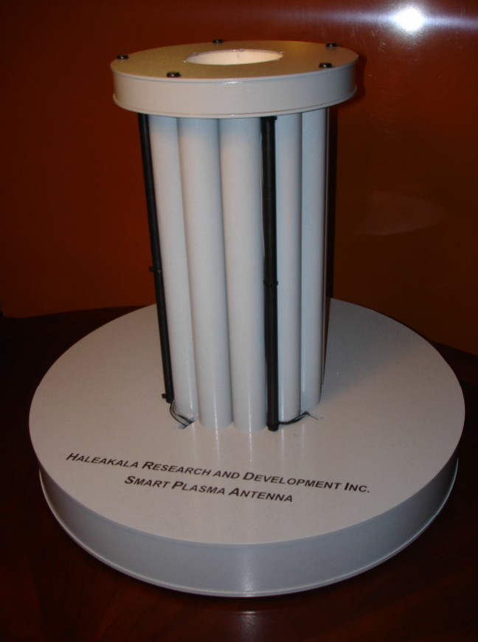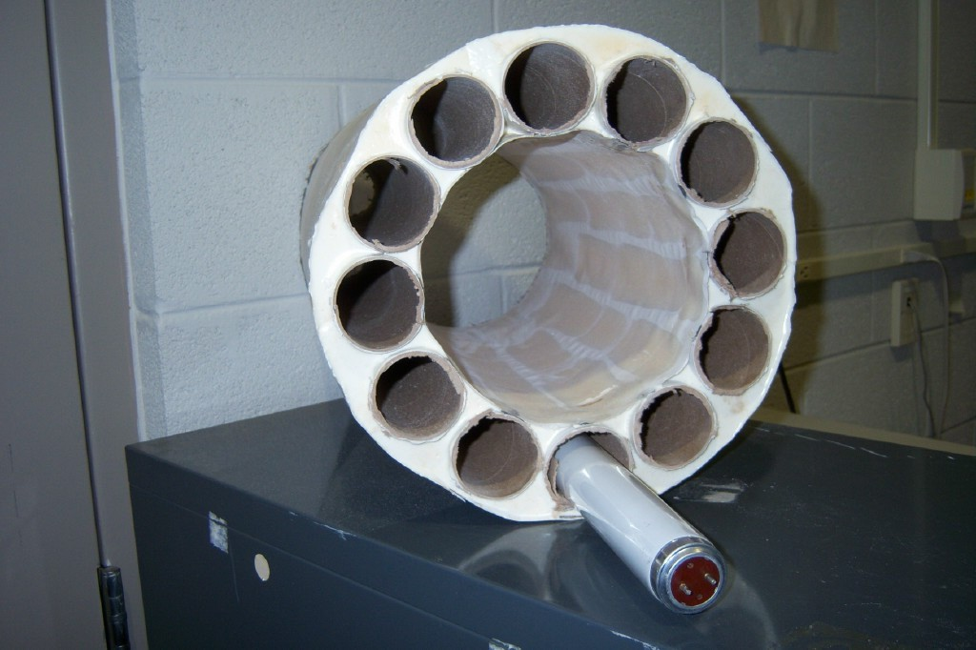

Right: Synfoam Cast. Left: Smart Plasma Antenna in Synfoam Cast Surrounded with Rugged Plastic

**Our next step on ruggedization is to put the plasma in the open chambers in the Synfoam without glass tubes. We also plan to make rugged custom made plasma tubes out of ceramic material**.

**Our High Powered Plasma Antenna Prototype will be Redesigned to Operate at 95 GHz**.

We have successfully tested a 2 megawatt pulsed power supply on a plasma antenna. We found

received power from the pulsed power transmitter was the same as for the plasma antenna. We

then disconnected the wire antenna from the pulsed power supply, and connected it to a 10 Megahertz transmitter, and measured the received power on a panoramic receiver. We then connected the transmitter directly into the panoramic receiver, adjusted the signal strength to the previous value, and recorded the attenuation needed to do so. The attenuation required was 70 decibels. If we multiply the power received from the pulsed power supply via the plasma antenna by 70 decibels, we get the radiated power from the plasma antenna to be 5 Megawatts! This result is in agreement with the measured radiation output from the Naval Research Laboratory, except that they used a metal antenna, and we used a plasma antenna. The power output from the pulsed plasma antenna is impressive. In addition, we attempted to calibrate the plasma antenna by coupling in radiation from a 10 Megahertz oscillator. The oscillator was immediately destroyed, a result that would be expected for electronic warfare!

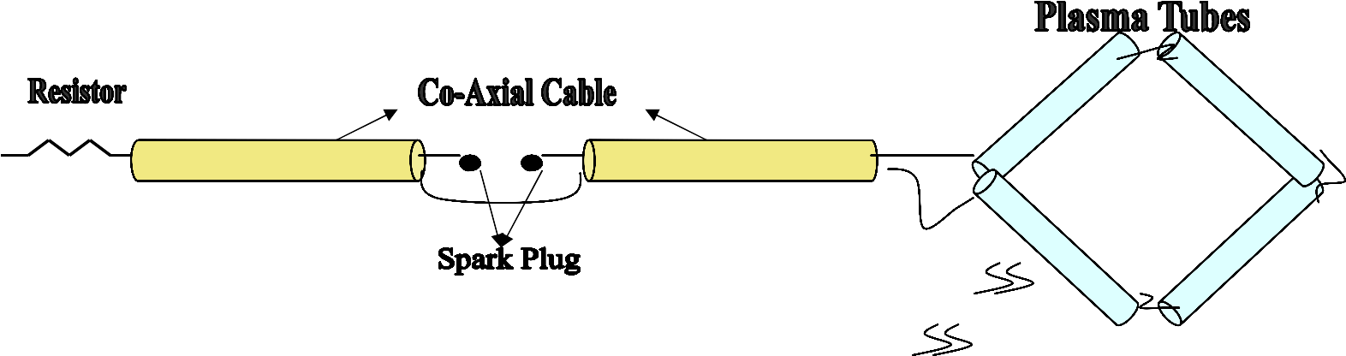

that in the transmitting mode, the plasma antenna was as efficient as a metal antenna for high power. The plasma antenna has the added advantages of reconfigurability which a metal antenna does not have. This reconfirms what we found for lower powers.

We have tested a megawatt power supply on a plasma antenna. We used a pulsed power supply similar to the one used at the Naval Research Laboratory1 to generate megawatt radiation pulses. The design of the apparatus is shown in the figure below. A section of 50 Ohm coaxial cable is charged to 25 Kilovolts. It then discharges through a spark gap into a second section of coaxial cable, then into four fluorescent lamps connected in series, forming a loop antenna. Previous

experiments have shown that if the pulse repetition rate is over a Kilohertz, the plasma in the fluorescent lamps is in essentially the steady-state2. The pulse of microwave radiation entering the plasma antenna radiates and is received on a small wire antenna about one meter away.

The signal is about 5 Volts in amplitude. Since the input impedance of the antenna is 50 Ohms, as determined by terminating resistors, the received power is ½ Watt. The frequency of the radiation is about 2.5 GHz. To calibrate the power output from the transmitter, we replaced the plasma antenna with a wire loop antenna of the same physical dimensions.

1. Private communication, Mark S. Rader, Naval Research Laboratory, October 2005.
2. Igor Alexeff and Ted Anderson Invited Paper, International Conference on Plasma Science, Monterey, CA, June 2005.

**Schematic of our High Powered Plasma Antenna Schematic of our Prototype Transmits 5 Megawatts in the Pulsed Mode.**

**Material: Our Current Reconfigurable, Smart, Adaptable, Plasma Antenna Prototype.** Haleakala Research and development, Inc. has built reconfigurable, smart, adaptable, plasma antennas prototypes. Our smart, adaptable, plasma antennas can reconfigure antenna patterns from omnidirectional to single lobe or multilobe directional antenna beams currently in milliseconds and operating at 2.4 GHz. Our antennas can be used for individual marines or vehicles. Features of Our Current Reconfigurable, Smart, Adaptable, Plasma Antenna Prototype

* + It currently weights about 10 pounds.
    - Some weight (but not much) will be added when we make the base rugged and surround the tubes with SynFoam to protect the tubes.
    - Future iterations of the prototype can be made smaller.
    - But nevertheless it is much smaller and lighter than large phased array antennas, and the performance is in many ways better.
    - Even in the prototype stage, our prototype is relatively inexpensive for a steerable smart antenna. Manufacturing would significantly reduce the price.
  + It can steer the antenna beam 360 degrees in milliseconds.
    - Our future prototypes will steer in microseconds using Fabry-Perot-Etalon Effects.
  + It is intelligent and smart.
    - It can find and lock on to a transmitter.
    - In addition, one plasma window can lock on to a transmitter and a second plasma window can find a second transmitter.
    - It can reconfigure from single lobe, to multilobe, to no lobe configurations.
  + It can run on a 12 volt car battery.
  + It is optically compact and electromagnetically stealth. Plasma can be turned off or made low density and transparent to EM waves.
  + It can be mounted on a tank, a humvee, a surface ship, a sub, etc. conveniently.
    - Other applications: last mile, Wi-Fi, base stations, etc.
  + This commercial prototype is packaged and made rugged by encasing it in SynFoam.
    - SynFoam is a lightweight, heat resistant, and very strong material.
    - SynFoam has an index of refraction of nearly one, making it invisible to RF waves.

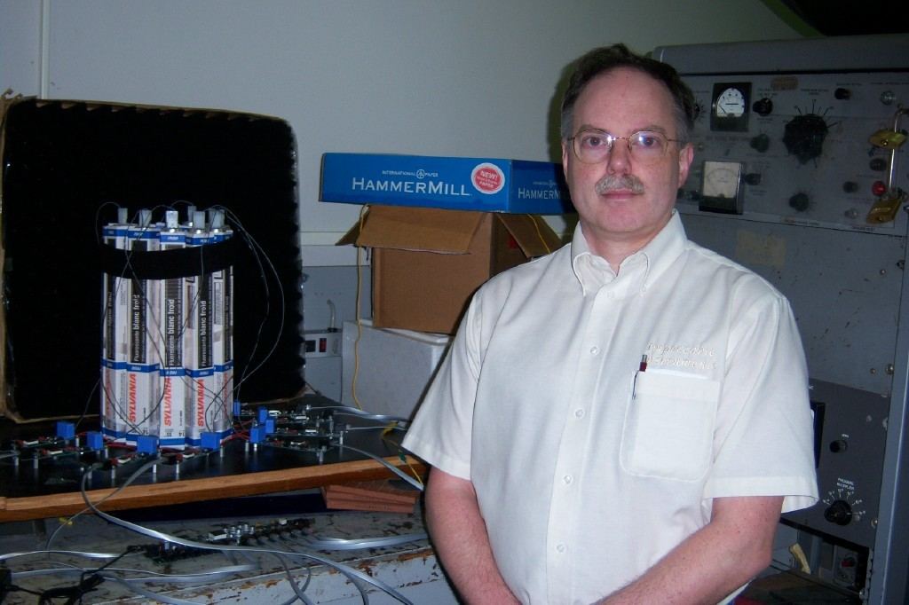

**Haleakala R&D, Inc. un-ruggedized smart plasma antenna prototype next to prototype engineer**

1. A motivation of value and purpose (i.e., if this is successful what impact it would have to the commercial and/or military world?

Our plasma nested and stacked array antennas, being smaller and covering wider bandwidths that those available will find communications applications in commercial airliners, Coast Guard ships, aircraft, and helicopters. Other applications are vehicular and personal communications and navigation applications. Its high power capability will find applications for various radars and frequency hopping wide band applications. For production military applications it will include high power jamming systems and broadband frequency hopping radars. High-speed wireless networking under constraints of limited spectrum, non-line-of-sight issues remains a challenging problem. Current systems (eg: 3G and 4 G networks) promise a maximum of about

2 Mbps, shared among users. Smart plasma antennas, in combination with appropriate modulation and medium-access-control (MAC) schemes, promises to break this bandwidth barrier, and lower costs. Our plasma antennae technology represents a disruptive technology in that it will provide the customer with increased bandwidth along with unprecedented security via its directionality. This technology, combined with new patents filed will give the company a strong foundation on which to build.

Smart antennas typically use a multi-element-array antenna, and place the intelligent processing (“smarts”) in the signal processing aspects. The antenna hardware itself is a fairly simple structure consisting of omni-directional or directional elements arranged in a particular geometrical configuration. In our plasma technology, we aim to dramatically increase the degrees of freedom offered by the antenna hardware itself, so that the signal processing software can leverage it to achieve even more sophisticated capabilities (rejection or leverage of multi- path effects) while lowering overall system cost. The cost reduction in the antenna and signal processing elements will allow new high-speed wireless networking architectures to be developed as described below.

In particular, consider the multi-hop meshed wireless distribution network architecture in Figure 1 that connects a final-hop smart antenna to a base-station. For simplicity a fixed wireless network is depicted in the figure. Lampposts (or equivalent structures) would host a “last-hop” smart-antenna and also participate in a relaying function. The “mobile” or “home” user would reach the base-station after traversing several hops in this network.

Now, high-speed communication in this model becomes feasible when the home or mobile has a directional antenna and the last-hop has smart antennas with the associated signal processing capabilities. This is because of the spectrum reuse, focusing of energy, and multi-path fading rejection that leads to dramatically higher signal-to-noise ratios. The additional key is to design such smart antennas at low cost and small form factors. Moreover, if the front-end antenna hardware also allows sophisticated and tunable beam-forming capabilities, then it provides new degrees of freedom that can be leveraged by signal-processing systems which control and interface to it.

In fact, even with current simple multi-element-array antennas at both ends, the Lucent

BLAST(Bell Labs Layered Space-Time) system has demonstrated tremendous spectral efficiency of 20 bits/Hz!

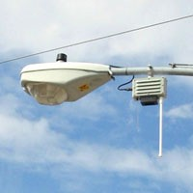

**A Meshed High-Speed Wireless Distribution Network**

However, these results were demonstrated for indoor operation and small distances. We have intellectual property for an omnidirectional antenna surrounded by a plasma barrier that allows new degrees of freedom, and simulate the gains (distance, bandwidth, efficiency etc) achievable using outdoor fading and propagation models and advanced signal processing capabilities (e.g.: MIMO processing (Multiple-Input-Multiple-Output)).

Once our smart antenna design and basic signal processing is developed, we will perform experimental tests on combining the new antenna capabilities, higher power transmission and

* 1. MAC protocol. This will provide a testbed for our smart antenna and demonstrate its capabilities and functions.

In wireless communications which employ smart antennas, the bases use signal processing techniques to virtually direct the antenna array gain lobes towards the direction of the desired signals, as well as directing the gain nulls towards the direction of interfering signals. Since wireless signals experience multipath scattering, the most prominent multipath signals can be used by a RAKE receiver to enhance the signal to interference and noise ratio (SINR) and thus improve the quality of the link. In such a setting, the base would use a training sequence to determine the direction of the desired multipath signals and direct the lobes of the antenna array

towards them.

The number of lobes which can be directed and the number of nulls depends on the number of antenna elements in the array. The beamwidth of each lobe depends on the distance between the elements. A higher number of antenna elements provides a higher number of lobes to capture several multipath, and thus improve the SINR(signal to interference and noise ratio). However, the increase in antenna elements also implies a higher computational cost, since the dimension of the problem increases with the number of antennas.

The beamwidth of the antenna array lobes is chosen so as to minimize the gain towards interfering signals. The narrower the beamwidth, the more isolation is provided for the desired signal. However, we have another trade-off, since a narrow beamwidth requires longer training signals to secure the direction of the desired signal. An unreliable estimate of the desired signal direction with a narrow beam may result in severe attenuation of the desired signal, which defeats the purpose of the antenna array.

We propose to develop this smart antenna that allows new degrees of freedom, and simulate the gains (distance, bandwidth, efficiency etc) achievable using outdoor fading and propagation models and advanced signal processing capabilities (e.g.: MIMO processing (Multiple-Input- Multiple-Output)).The challenge is to choose an array configuration, which provides adequate SINR, levels, while requiring a low computational cost. Our smart antenna provide the flexibility to emulate the radiation pattern of antenna arrays with different numbers of elements and distances between the elements. The utility of this arrangement can be seen in the figure below.

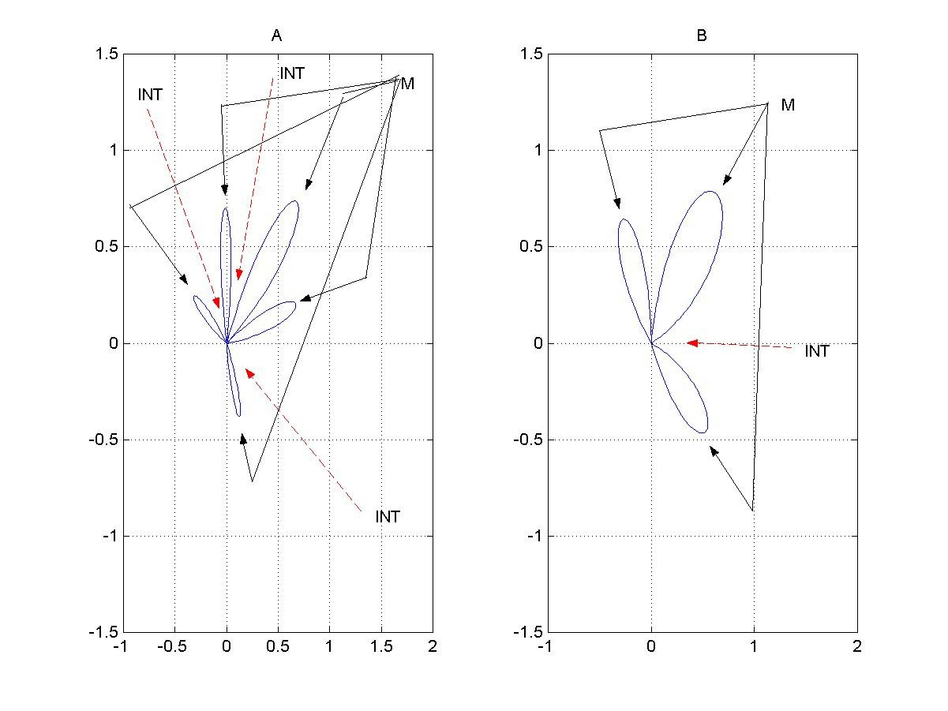

* + 1. **Antenna lobes for peak hour service with many interfering signals or many reflecting surfaces. B. Antenna lobes for low demand period or few reflecting surfaces**

Most communications systems experience peak time periods as well as low demand periods. During the peak hours, the system resources are strained to provide adequate SINR levels. Even with CDMA (Code Division Multiple Access) systems, the cross-correlation between user codes is not zero, so the presence of a large number of undesired signals increases the interference. In this case, we would want very narrow gain lobes to attenuate as many undesired signals as

possible. This can be appreciated in Figure A. Also in Figure A, we see that the presence of a

large number of scattering surfaces can be used with BLAST to increase the signal strength. Both of these techniques will improve the link quality, but they will require a large number of calculations.

Figure B shows the opposite situation with few interferers and fewer scattering surfaces. In this situation, we may significantly reduce the complexity of an antenna array problem by using fewer and wider lobes.

In a military setting, where our goals are to provide as much flexibility, mobility, stealth, and protection from jamming as possible, we tailor our design to meet these needs. We consider a wireless ad hoc network, where there are several nodes deployed which provide as a network backbone. An example are the humvees in the figure below Each humvee is equipped with an array of plasma antennas, where each of our smart antennas can create a variable number of antenna gain lobes of adaptive beamwidth and direction. Each soldier has a low power omni- directional antenna which is served by the humvee which can offer the best signal to noise ratio and has the capacity to serve that user.

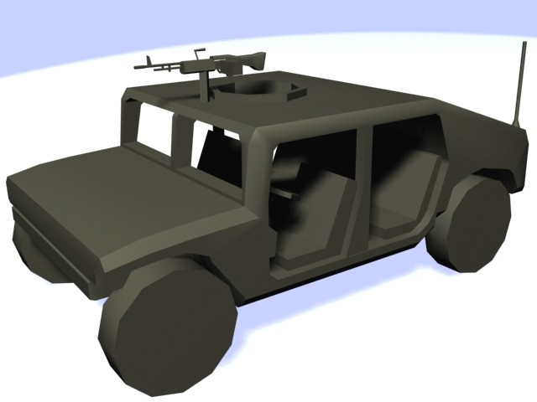

The signal to noise ratio levels and directions of service can be determined by performing a 360° sweep by each of our smart antennas. In order to distinguish between users of a given sector, as well as lower power usage, a user spreading code can be applied to users of each sector.

This setup provides mobility, since the periodic scanning performed by our smart antennas allows all users as well as all ad hoc nodes to move about without loosing the network contact. Each user may be served by any node, which allows for additional flexibility.

The adaptive directionality of our smart antennas provides a plethora of advantages. The directivity of each antenna beam minimizes the power levels broadcast which might interfere with adjacent users. In this sense, it provides a form of SDMA. The directivity of the antenna also reduces the power levels that could be detected by unfriendly agents. The adaptive nature of the plasma antenna allows the beam to follow the user with a minimum of computation required, as well as to alter the beamwidth depending if the user is in an area of high user density or requiring greater stealth, where the beam can be made very narrow, or if the user is relatively isolated moving at a great speed, where the beam can be made wider.

In order to further reduce the transmission power levels, thus conserving battery power and

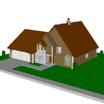

concealing the position of the users and nodes, a low spreading gain code can be applied to each user’s signal. The low gain permits us to maintain a high data rate. The highly directional property of our smart antenna does not require a high gain for multiple access. A low tap Walsh code would be enough to permit very low transmission levels, and good protection for each user. In addition, automatic power control can be implemented to decrease the collective power transmission of the entire network.

In a civilian setting, where our goals are to provide low cost and flexibility, we can use the directivity of our smart antenna as a form of implementing SDMA. The figure below shows an example of this.

In this case, we consider the angle of service for each user can be estimated by a pair of omni- directional antennas placed on the same tower. This setup allows the array of our smart antennas to provide uninterrupted service to users without having to estimate the direction of service. The adaptive beamwidth can be adjusted to accommodate users who are in close proximity, providing protection from interference for each user. The variable number of beams from our smart antenna allows the base to service a variable number of users at diverse locations. This

eliminates the need for a technician to install additional antennas or make changes when new

users initiate service or when other users terminate service.

1. A concise technical scope and/or goal;

**Background.**

Plasma (ionized gas) conducts current like a metal and one can create an antenna from plasma.

The advantage of the plasma is that it can be created on demand and one plasma antenna can be reconfigured

**Proposed New Capability over Existing State of Art**:

Our smart, adaptive plasma antenna is currently more compact and lighter and with greater beam steering ability than phased array antennas. We steer the antenna beam with plasma physics and we use no phased arrays or phased shifters. Our final product from this project will be wideband by implementing our plasma nesting designs.

**Comparison against Competing Technological Developments.:**

Our smart, adaptive plasma antenna is currently more compact and lighter and with greater beam

steering ability than competing technological developments. We steer the antenna beam with plasma physics and we use no phased arrays or phased shifters. Our final product from this project will be wideband by implementing our plasma nesting

1. A detailed explanation of proposed work, technical approach, critical issues, risks, etc.

Haleakala R&D, Inc has developed a smart plasma antenna. A video of this smart plasma

antenna appears on the Haleakala R&D, Inc website: [www.haleakala-research.com.](http://www.haleakala-research.com/) Our smart plasma antenna was designed at 2.5 GHz. We will redesign it to operate at 95 GHz or at the ADS frequencies. We have also developed a high powered plasma antenna which radiates a directive beam at a few megawatts in the pulsed mode. We will combine both technologies and develop a smart reconfigurable high powered plasma antenna at ADS frequencies which can penetrate walls which can non-lethally clear spaces before entry.

1. Complete technical details

Plasma antennas use partially or fully ionized gas as the conducting medium instead of metal to

create an antenna. The advantages of plasma antennas are that they are highly reconfigurable and can be turned on and off. The disadvantage is that plasma antennas require energy to be ionized. Hence research to reduce the power required to ionize the gas at various plasma densities is important.

Since 1993 contributions to plasma antennas have mainly been made by a few groups in the United States and Australia..

The Naval Research Laboratory in the United States under Manheimer et al 1, 2 developed the reflector plasma antenna called the Agile Mirror which could be oriented electronically and had

the capability of providing electronic steering of a microwave beam in a radar or electronic warfare system.

Moisan et al 3, have proposed that a plasma column could be driven directly from one end by excitation of an RF plasma surface wave. His paper was the foundation of research on plasma antennas in Australia under Borg et al 4, 5 and they used surface waves to excite the plasma

column. Borg et al used one electrode to simplify the antenna design. The need for two

electrodes is eliminated and the plasma column projects from the feed point. The frequency range studied was between 30 MHz to 300 MHz.

In the United States, Anderson and Alexeff 6, 7, 8 did theoretical work, experiments, and built prototypes on plasma antennas, plasma waveguides, and plasma frequency selective surfaces. Their research and development reduced the power required to ionize a plasma tube with higher plasma densities and frequencies and the development of the smart plasma antenna (reference here for the smart plasma antenna). They have built and tested plasma antennas from 30 MHz to

20 GHz. They also have reduced the power required to maintain ionization in a plasma tube to

an average power of 5 Watts or less at 20 GHz. This is much less than the power required to turn on a florescent lamp. It is anticipated that power requirements will continue to decrease.

In 2003, Jenn 9 wrote an excellent survey of plasma antennas, but much progress has been made since then.

**Fundamental Plasma Antenna Theory**

In the case of plasma antennas, plasma fluid models 10, 11 can be used to calculated plasma antenna characteristics. For example, we proceed with the derivation of net radiated power from a center fed dipole plasma antenna with triangular current to obtain an analytical solution. For simplicity, the equations are linearized and one dimension is

considered with the plasma antenna dipole antenna oriented along the z-axis.

The momentum equation for electron motion in the plasma is: (please number equations also cite one good reference that defines these equations)

 *d* υ

*m*



+ *v* υ  =

− *e* (*Ee*

*j* ω *t*

− ∇ φ )

( 1)

 *dt* 



Where m is the mass of the electron, υ is the electron velocity in the fluid model, ν is the collision rate, and e is the charge on the electron, E is the electric field, ω is the applied frequency in radians per second, and φ is the electric potential.

The continuity equation for electrons in the plasma is:

∂ *n* +

∂ *t*

∂ υ

*n* 0 = 0

∂ *z*

(2)

Where *n* is the perturbed electron density and

*n*ο is the background plasma density.

Combining the momentum equation with the continuity equation yields:

*n jn* 0 *e*

 ∂ *E* −

∂ 2 φ 

= ω (*v* −



*j* ω  ∂ *z*

)

∂ *z* 2 

(3)

Gauss’s Law is given as:



∂ 2 φ

##### =

###### en

(4)

∂ *z* 2 ε

The dielectric constant for the plasma is defined as:

ε 1 ω *p*

2

= −

ω (ω −

*jv* )

Where:

ω *p* =

4 π *ne* 2

###### me

(6)

is the plasma frequency.

Assuming the plasma antenna is a center fed dipole antenna with a triangular current distribution as given in Balanis12 and substituting ( 4) , ( 5), and

( 6) into (3), .we obtain for the dipole moment of the plasma antenna:

*p* = *a*

*e n* 0 *E* 0 *d*

2 *m* [ω (ω +

2

*jv* ) − ω

2 *p* ]

(7)

Where a is the radius of the plasma antenna and d is the length of the plasma antenna. The total radiated power is then given by:

2 2

2

*P rad*

= *k* ω *p*

12 πε 0 *c*

:

Where k is the wavenumber.

Substituting equation 7 into equation 8 yields:

:

 2  2

 ε *a* 2

 ( )2  ω  (νω *E* )

*P* =  0

 *kd p*

0

(9)



ν

*rad*



 

 12 π *c* 

  [(ω

− ω *p*

2 )2

− ν 2ω 2 ]

***In this last expression we see that the net radiated power for a plasma antenna is a function of the plasma frequency and collision rates. Since there is a resonance in this result, it suggests the possibility of aperture enhance over a metal antenna of the same size.***

**Plasma Antenna Windowing (Foundation of The Smart Plasma Antenna Design)**

Plasma antenna windowing is a term we coined to describe a RF signal being transmitted

through plasma tubes that are off or low enough in plasma density that RF signals pass through. Various designs of plasma windows appear in patents by T. Anderson .14, 15, 16, 17, 18, 19 Papers and conference presentations on plasma windowing have been made by T. Anderson et al. 20, 21. A detailed numerical analysis of the performance of a reconfigurable antenna comprised of a linear omni-directional antenna surrounded by a cylindrical shell of conducting plasma is presented. The plasma shield consists of a series of tubes containing a gas, which upon electrification, forms a plasma (in practice fluorescent light bulbs are used). The plasma is highly conducting and acts as a reflector for radiation for frequencies below the plasma frequency. Thus when all of the tubes surrounding the antenna are electrified, the radiation is trapped inside.

By leaving one or more of the tubes in a non-electrified state, apertures are formed in the plasma shield which allow radiation to escape. This is the essence of the plasma window based reconfigurable antenna. The apertures can be closed or opened rapidly (on micro-second time scales) simply by applying voltages.

***Theoretical analysis with Numerical Results***

The goal of the theoretical analysis is the prediction of the far-field radiation pattern of the plasma window antenna (PWA) for a given configuration. In order to simplify the analysis we make the approximation that the length of the antenna and surrounding plasma tubes are irrelevant to the analysis. Physically assuming that the tubes are sufficiently long so that end effects and be ignored. In so doing, the problem becomes two-dimensional and as such allows for an ***exact*** solution. The problem is therefore posed as follows: (1) assume a wire (the antenna) is located at the origin and carries a sinusoidal current of some specified frequency and amplitude. (2) Next assume that the wire is surrounded by a collection of cylindrical conductors

each of the same radius and distance from the origin. (3) Solve for the field distribution

everywhere in space and thus obtain the radiation pattern.

***Geometric construction***

One particular configuration for the PWA is illustrated in **Figure 1** for the case of seven cylinders. Adopting the following simple geometric construction for creating the plasma shield. For a complete shield we assume *N* cylinders are placed with their centers lying along a common circle chosen to have the source antenna as its center. Thus choosing some distance from the origin *d* and divide the circle of radius *d* into equal segments subtending the angles

ψ*l* = 2π*l* / *N*,

(10)

where the integer *l* takes on the values *l* = 0,1,L(*N* − 1). The apertures are formed by simply

excluding various cylinders from consideration.

Until this point we have considered only touching cylinders, however, there is no need to restrict our attention only to touching cylinders. In the following analysis, it is convenient to specify the

cylinder radius through the use of a dimensionless parameter τ , which takes on values between

zero and unity (i.e. 0 ≤ τ ≤ 1) where τ = 0 corresponds to a cylinder of zero radius (i.e. a wire)

and τ = 1 corresponds to the case of touching cylinders. More explicitly, the radius of a given

cylinder (all cylinder radii assumed to be equal) is given in terms of the parameter τ , the

distance of the cylinder to the origin *d* ,

and the number of cylinders needed for the complete

shield

*N* , by the expression:

*a* = *d*τ sin(π / *N*). (11)

Defining a number of geometric parameters which are need in the analysis that follows. The coordinates specifying the center of a given cylinder are given in circular polar coordinates by

(*d* ,ψ *l* ) , and in Cartesian coordinates by:

and

*dlx* = *d* cos(2π*l* / *N*),

(12)

*dly*

= *d* sin(2π*l* / *N*).

(13)

Defining the displacement vector pointing from cylinder *l* to cylinder *q* by the equation:

*dlq* = *dq* −*dl* . (14)

The magnitude of this vector is given by:

r

*dlq* =

2 1 − cos(ψ *q* −ψ *l* ).

(15)

The angle ψ *lq*

is subtended by vectors *d q* and *d q* . In other words, if we consider the triangle

consisting of the three sides

r

r

*d q* ,

r

*dl* ,

and

r

*dlq* , the angle ψ *lq*

is the angle opposite to the side

*dlq* . This angle is easily obtained by the following two relations:

*dlq* cosψ( *lq*) =*dq* cosψ( *q* )−*dl* cosψ( *l* ),

(16)

and

*dlq* sinψ(

*lq* ) = *dq* sinψ(

*q* ) −*dl* sinψ(

*l* ).

(17)

Lastly, defining the coordinates of the observation point relative to the source as well as with respect to coordinate systems centered on the conducting cylinders. The coordinates of the

observation point ρ with respect to the source are denoted by (ρ,φ ). To specify the observation

point with respect to cylinder *q* , and defining the displacement vector:

## r = ρr

ρ

*q*

− *d q* .

(18)

The coordinates of the observation point in the system centered on cylinder *q* are thus (ρ *q* ,φ*q* ),

which are determined in the same way that the coordinates *dlq* ,

and ψ *lq* , were obtained above.

To complete the specification of the geometric problem and specifying the coordinates of the source with respect to each of the coordinate systems centered on the cylinders. Obviously, the

distance coordinate *dls*

of the source with respect to the coordinate system centered on cylinder

*l* is given by *dlq* = *d*. The angular coordinate ψ *ls* ,

is easily seen to be given by:

ψ*ls*

=ψ*l* +π.

(19)

***Electromagnetic boundary value problem***

The solution to the boundary value problem is obtained by assuming the cylinders to be perfect conductors, which forces the electric fields to have zero tangential components on the surfaces of the cylinders. Enforcing this condition on each of the cylinders leads to *N* linear equations for

the scattering coefficients. The consequence is an an then solved by matrix inversion.

*N* × *N* ,

linear algebraic problem which is

The field produced by a wire aligned with the

*z*ˆ − axis, which carries a current *I* :

r  

*E* ( ρ ) =

− *I*π*kz*ˆ  *H* (1) (*k*ρ ),

*inc*

 *c*  0

(20)

where, *k* is the wave vector defined by *k* = ω / *c*,

where *c* is the speed of light, and the angular

frequency ω is given in terms of the frequency *f* by ω = 2π*f* .

kind, of order *n* (in this case *n* = 0 ) is defined by:

The Hankle function of the first

*H*(1) (*x*) = *J*

*n*

*n*

(*x*) + *iYn*

(*x*),

(21)

where,

*J n* (*x*),

and *Yn* (*x*) are the Bessel functions of the first and second kind respectively.

Assuming all quantities have the sinusoidal time dependence given by the complex exponential with negative imaginary unit exp(−*i*ω*t*).

***Partial wave expansion (addition theorem for Hankel functions)***

The key to solving the present problem hinges on the fact that waves emanating from a given point (i.e. from the source or scattered from one of the cylinders) can be expressed as an infinite series of partial waves:

r

*E* ( ρ , φ ) =

∞

*z*ˆ ∑

*m* = −∞

*Am H m* (*k*ρ ) exp( −*im* φ ),

(22)

where, dropping the superscript on the Hankel function, and because of the fact that any given term in the series can be expanded in a similar series in any other coordinate system by using the addition theorem for Hankel functions. The addition theorem for Hankel functions is written:

∞

exp(*in*ψ )*Hn* (*kR*) = ∑*Jm* (*kr*′)*Hn*+*m* (*kr*) exp(*im*ϕ)

*m*=−∞

(23)

where, the three lengths *r*′,

*r*, and *R*,

are three sides of a triangle such that:

*R* = *r*′2

+ *r* 2

− 2*rr*′ cos(ϕ ),

(24)

with *r*′ < *r*, and ψ is the angle opposite to the side *r*′.

follows:

Another way to express this is as

exp( 2*i*ψ ) =

*r* − *r* ′ exp( −*i*ϕ ) .

*r* − *r* ′ exp(*i*ϕ )

(25)

**Setting up the matrix problem**

A system of

*N* , linear equations for the scattering coefficients is obtained by expanding the total

field in the coordinate system of each cylinder in turn and imposing the boundary condition that the tangential component of the field must vanish on the surface of each cylinder.

r

We write the total field as the sum of the incident field

written as:

*Einc*

plus the scattered field which, is

r *N* −1 *M*

*E scat*

*q*

= ∑ ∑

*An H n* (*k*ρ *q* ) exp( *in*φ *q* ),

(26)

*q* = 0 *n* = − *M*

where we have truncated the sum over the angular variable and retained terms in the range

− *M* ≤ *n* ≤ *M* .

Next we isolate a particular cylinder, say cylinder *l* , and express all fields in the coordinate

system centered on cylinder *l*. obtaining:

Upon setting the total field equal to zero and rearranging and

*M*    

*Al* =

− exp[−*i*(*m* − *n*)ψ

] *Jm* (*ka*) *H*

(*kd*

)*Aq* + πω*I* exp(−*im*ψ

) *Jm* (*ka*) *H*

(*kd* ).

*H*

*H*

*m* ∑ ∑ 

*q*≠*l n*=−*M* 

*lq*

*m*

(*ka*)

*m*−*n*

*lq*  *n*



 *c*2 

*ls*

*m*

(*ka*) *m ls*

(27)

This can be written compactly in matrix notation as,

*A*α = ∑*D*αβ *A*β

β

+ *K*α ,

(28)

by adopting the composite index α ≡ (*l*, *m*), and

β ≡ (*q*, *m*).

By writing this symbolically as

*A* = *DA* + *K* , and collecting terms we obtain (*I* − *D*) *A* = *K* , where *I* is the unit matrix. This

equation is solved for the scattering coefficients with matrix inversion to yield:

*A* = ( *I*

− *D* ) −1 *K* .

(29)

***Exact solution for the scattered fields***

The solution derived in the previous section is formally exact. In practice, one chooses a specific

range for the angular sums: − *M* ≤ *n* ≤ *M* , which leads to a

*N* (2*M* + 1) dimensional matrix

problem, the solution of which gives 2*M* + 1 scattering coefficients

*Aq* . The quality of the

solution is judged by successively increasing the value of *M* until convergence is reached.

*n*

Lastly it is convenient to use the addition theorem to express all of the scattered fields in terms of the coordinate system centered on the source. Thus:

*N* −1 *M M*

∑ ∑ *Aq H*

*n*

*n*

(*k*ρ*q*

) exp(*in*φ*q* ) ≡

∑*Bp H p*

(*k*ρ) exp(*ip*φ) ,

(30)

*q*=0 *n*=*M*

*p*=−*M*

from which, obtaining the new coefficients as:

*N*−1 *M*

*Bp* = ∑ ∑*An J p*−*n* (*kdq* )exp[−*i*(*p* − *n*)ψ*q* ].

*q*

(31)

*q*=0 *n*=−*M*

***Far-Field Radiation Pattern***

Now, for convenience we choose the amplitude of the source current so as to obtain unit flux in the absence of the cylinders. In other words we choose the source field to be given by:

# r

*E inc* = −

2π*k*

*c*

*H* 0 (*k*ρ ).

(32)

Now verifying that this gives unit flux. The far-field limit of the Hankel function is:

*H m* ( *k*ρ ) ≈

2

π *k*ρ

exp[ *i* ( *k*ρ

− (( 2 *m*

+ 1)π

##### / 4 ],

(33)

and the magnetic field is obtained from the electric field as:

r − *ic* r

*B inc* = ω

∇ × *E inc* .

(34)

The radiation intensity is obtained from these field by computing the Poynting vector:

r r

*c*

*P* = ℜ [ *E* ×

r ∗ ].

8 π (35)

*B*

By integrating this over a cylindrical surface of unit height, at a distance ρ , and obtaining the unit flux as stated.

Now, by extracting a factor of

2π*k* / *c* , the total electric field can be expressed as:

r 2π*k*  *M* 

*E* = −

 *H*0 (*k*ρ) −

∑*Bn H n* (*k*ρ) exp(*in*φ) .

(36)

*c*  *n*=−*M* 

Using this in the expressions above gives the Poynting vector. The far-field radiation pattern is obtained by plotting the radial component of the Poynting vector at a given distance (in the far field) as a function of angle.

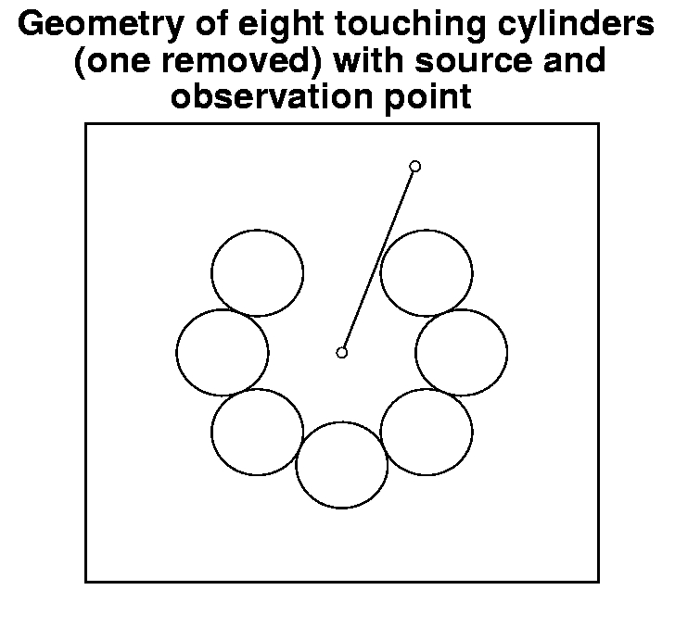

**Figure 1:** Plasma window antenna consisting of seven touching cylinders. The cylinders are arranged with their centers lying on a common circle of a given radius and their radii are chosen so that they are touching. By adding one more cylinder, a complete plasma shield is formed. The source and an arbitrary observation point are also illustrated.

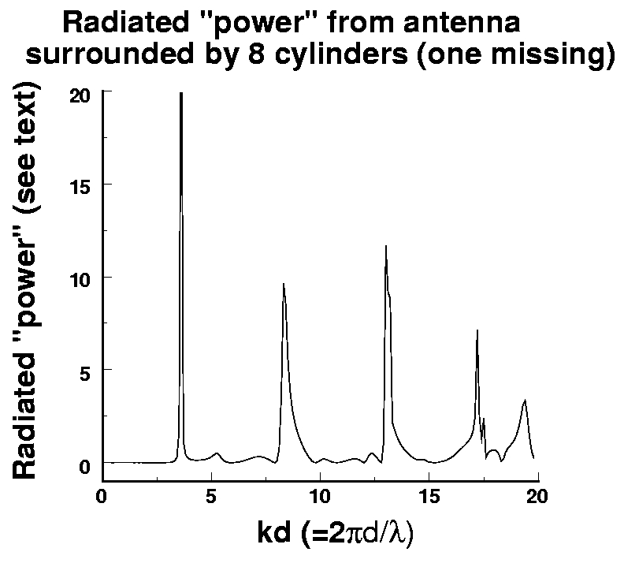

**Figure 2:** Plot of the radiated flux in the far field. This quantity is obtained by integrating the Poynting vector over a cylindrical surface of unit height in the far field. Physically this quantity should not exceed unit. Situations in which values greater than unity are obtained indicate the presence of eigenvalues which lead to singular matrices.

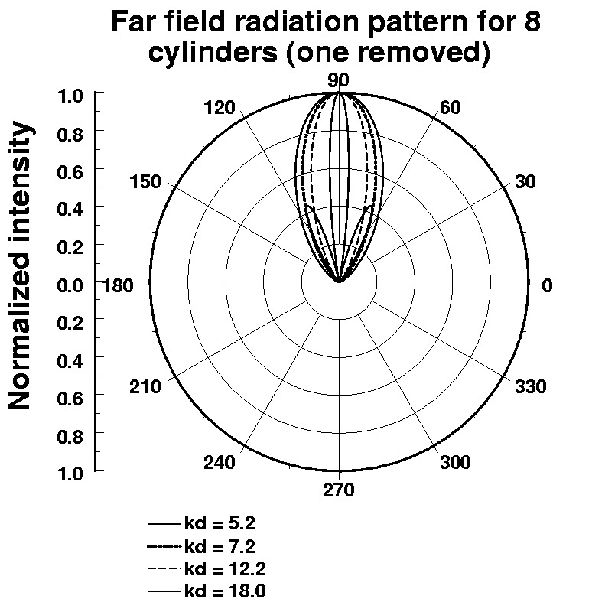

**Figure 3; Far-field radiation patterns for various solutions illustrated in 2.**

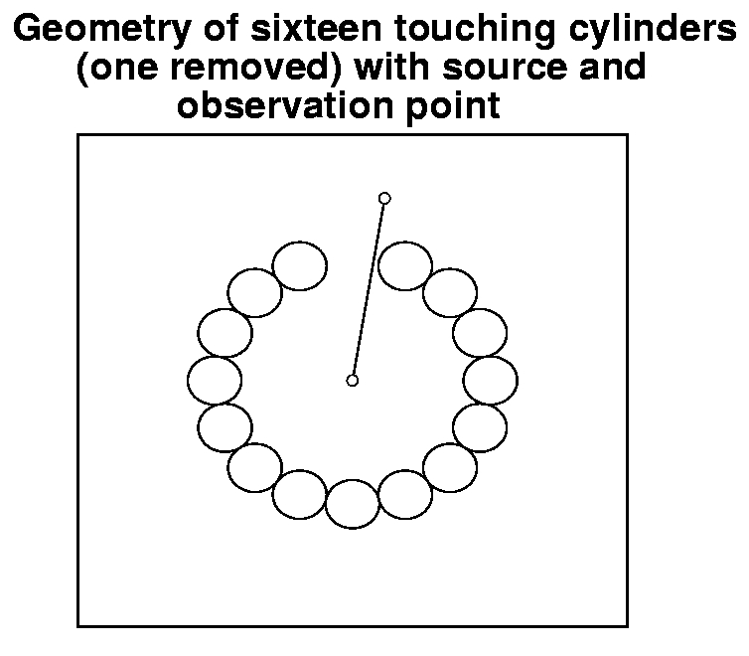

**Figure 4: Plasma window consisting of 15 touching cylinders.**

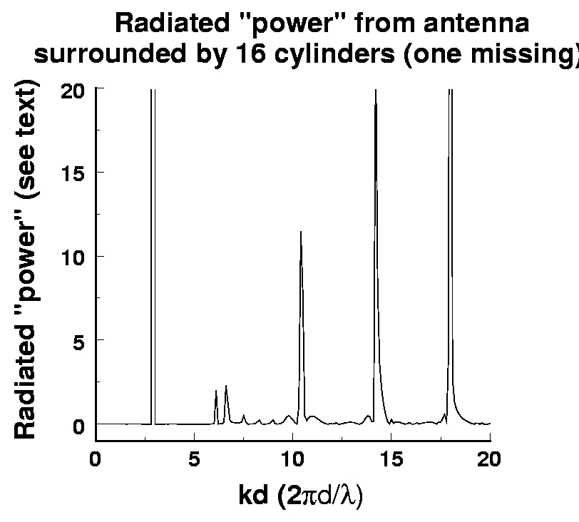

**Figure 5: Plot of the far-field flux radiated from the 15-cylinder plasma window antenna. As in figure 2 this plot includes all solutions including unphysical solutions for which the flux exceeds unity.**

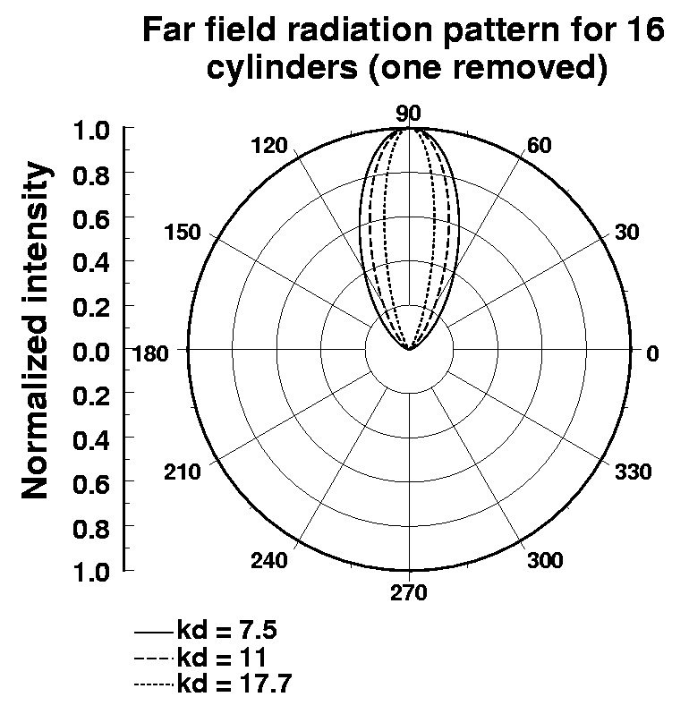

**Figure 6: Far-field radiation patters for the 15-cylinder plasma antenna for several of the solutions illustrated in Figure 5.**

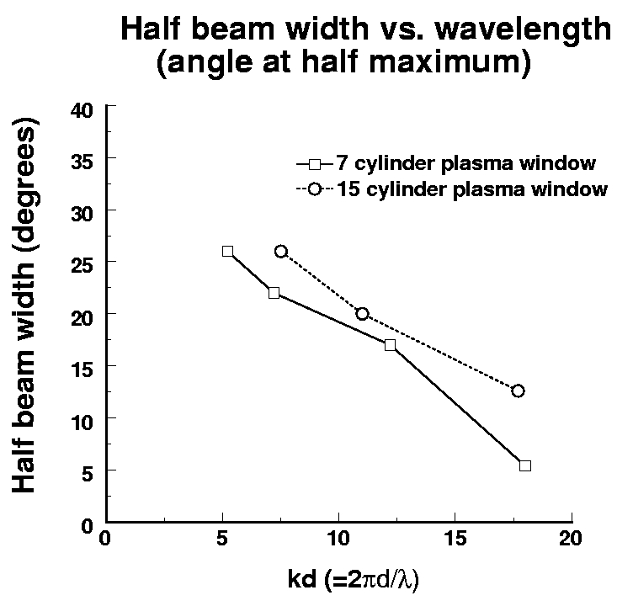

**Figure 7: Beam half-width versus wavelength for the two plasma window antenna configurations. This is defined as the angle at which the far-field radiation pattern is reduced by a factor of one half.**

**Smart Plasma Antenna Prototype**

A smart plasma antenna has been developed. 24 Various applications of the smart plasma antenna appear in patents by T. Anderson 14, 15, 16, 17, 18, 19.

The smart plasma antenna currently weighs less than15 pounds. It can steer the antenna beam 360 degrees in milliseconds. The future prototypes could steer in microseconds using Fabry-

Perot-Etalon effects. It is an intelligent, high performance steerable antenna with compact size, light weight, and it is stealth and jam resistant.

Below figure 8 is a photograph of the smart plasma antenna commercial prototype

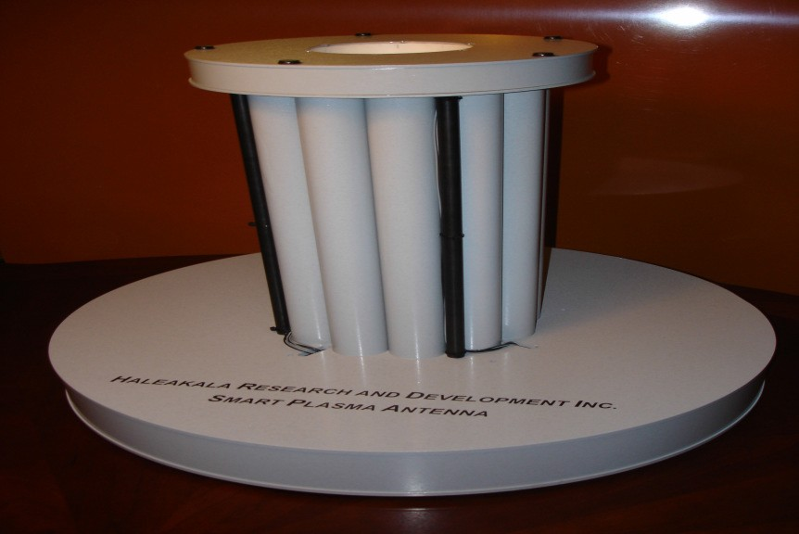

**FIGURE 8. Ruggedized smart plasma antenna prototype.**

**(f) SOW. Work Plan. Tasks.**

**Task 1.** Experiments on plasma antenna 95 GHz, ADS frequency.

**Task 2.** Theoretical modeling of the plasma antenna at 95 GHz..

**Task 3.** We will do High Powered Plasma Pulsed and Steady State Experiments. We will continue the testing of our high - power pulsed and high powered steady state plasma antenna in the 95 GHz ADS frequency. Our previous tests were at 2.5 GHz. We achieved 5 MW in pulsed transmission using 20 KV input.

**Task 4**. Increase the rapid switching between directionality modes and frequencies from our current millisecond speeds to microsecond speeds using Fabry Perot Etalon Effects. House the plasma tubes in strong and lightweight synthetic foam called Synfoam which can be molded into any shape we want. UDC SynFoam is a high performance syntactic foam combining high strength and low density with very low moisture absorption. SynFoam's syntactic foam products feature a density of less than 20 pcf and a compressive strength greater than 2000 psi. The index of diffraction of the Synfoam is nearly one so it is invisible to rf signals. See website: [http://www.udccorp.com/products/synfoamsyntacticfoam.html.](http://www.udccorp.com/products/synfoamsyntacticfoam.html)

**Task 5.** Prototype development of our smart plasma antenna at 95 GHz ADS frequencies. We will design, make, and test rugged plasma antenna tubes made of ceramics.

**Task 6.** Field testing of our prototype in a variety of environments including urban, within structures and forested areas.

**Task 7.** Substitute the metal cross elements in the Malibu FLAPS with plasma cross elements and test for reconfigurability in focusing and steering which the current FLAPS does not have. **Task 8.** Develop manufacturing capability.

**Task 9.** Delivery or smart adaptable ADS plasma antenna with operational manuals and final report.

**SEE THE GANTT CHART OF THE FOLLOWING PAGE FOR THE SHEDULE**

**HALEAKALA**

**Reasearch& Development INC. GANTT CHART Schedule of Tasks**

Task 1

Task 2

Task 3

Task 4

Task 5

Task 6.

Task 7

Task 8

Task 9

0 1 2 3 4 5 6 7 8 9 10 11 12 13 14 15

**Months**

1. **A clear description of any technical data, information or computer software deliverables that would be provided to the Government with other than unlimited rights;**

Haleakala R&D, Inc will provide the government with the software which will run our smart plasma ADS antenna.

**Deliverables and products**:

We will deliver an adaptable smart plasma antenna operating at high power at 95 GHz that will have the following properties:

* 1. Our current smart plasma antenna prototype weighs around 10 pounds. We will deliver our ADS prototype that is the same weight or lighter.
  2. It will be a smart, adaptable plasma antenna that is field tested.
  3. It will be a low cost smart, adaptable plasma antenna.
  4. We will deliver user manuals.
  5. We will deliver reports on experimental and theoretical work.
  6. we will deliver a final report.

1. An explanation of how the proposed effort satisfies the definition(s) of basic research, applied research, or development that is not related to the development of a specific system;

The proposed effort satisfied the definition of development. Haleakala R&D, Inc has built

several plasma antenna prototypes and the technology of these prototypes will be used in this proposal. The readers of this proposal should check the current July issue of Popular Mechanics on page 18 where some of the Haleakala R&D, Inc commercialization efforts are discussed.

1. A discussion of related work so as to put this proposed work into context;

We have had the following experimental demonstrations of plasma

antennas.1,2 Most of these demonstrations are documented as videos and are available on request.

1. **Transmission and Reception** - We have demonstrated transmission and reception of operating plasma antennas over a wide frequency range. (500MHz to 20 GHz) The surprising results were that the efficiencies are comparable to a copper wire antenna of the same configuration, and the noise level seemed comparable with a wire antenna. The noise measurements will be repeated with a precision noise meter.
2. **Stealth** - When de-energized, the plasma antenna reverts to a dielectric tube which has a small radar scattering cross – section.
3. **Reconfigurability** - At 3 GHz, we have demonstrated a parabolic plasma reflector. When energized, it reflects the radio signal. When de - energized, the radio signal passes freely through it.
4. **Shielding** - The plasma reflector, when placed over a receiving horn and energized, prevents an unwanted 3 GHz signal from entering. When the antenna

is de-energized, the signal passes through freely

1. **Protection from electronic warfare** - We have demonstrated that with a plasma reflector operating and reflecting a signal at 3 GHz, a signal at 20 GHz freely passes through the same reflector. The idea is that a plasma antenna can be so configured that a high - frequency, electronic - warfare signal can pass through the antenna without appreciable interaction, while the antenna is transmitting and receiving signals at a lower frequency.
2. **Mechanical Robustness** - We have developed two kinds of robust plasma antennas. In one design, the glass tubes comprising the plasma antenna are encapsulated in a dielectric block. In a second design, the plasma antennas are composed of flexible plastic tubes. We have found that the plasma does not damage the plastic tubes over periods of several hours, if the plastic tubes are kept cool. Heat, not plasma, causes damage to plastic.
3. **Mechanical Reconfigurability** - We have been able mechanically to manipulate the operating plasma antenna composed of flexible plastic tubes. In particular, we have designed a plasma antenna that may be compressed and stowed when not being used.
4. **Plasma Waveguides -** We have demonstrated a coaxial plasma waveguide. The advantage of such a waveguide is that it reverts to dielectric tubes when de - energized, and does not have

large RADAR cross - section.

1. **Noise Reduction –** We have found that plasma – generated noise is in general not a problem.

However, to further improve the system, we have discovered several new methods of noise reduction.

**Review of Previous Results:**

The first phase of the plasma antenna project started with the idea of a coaxial plasma

closing switch, shown in **Figure 9, Coaxial Plasma on Switch.**

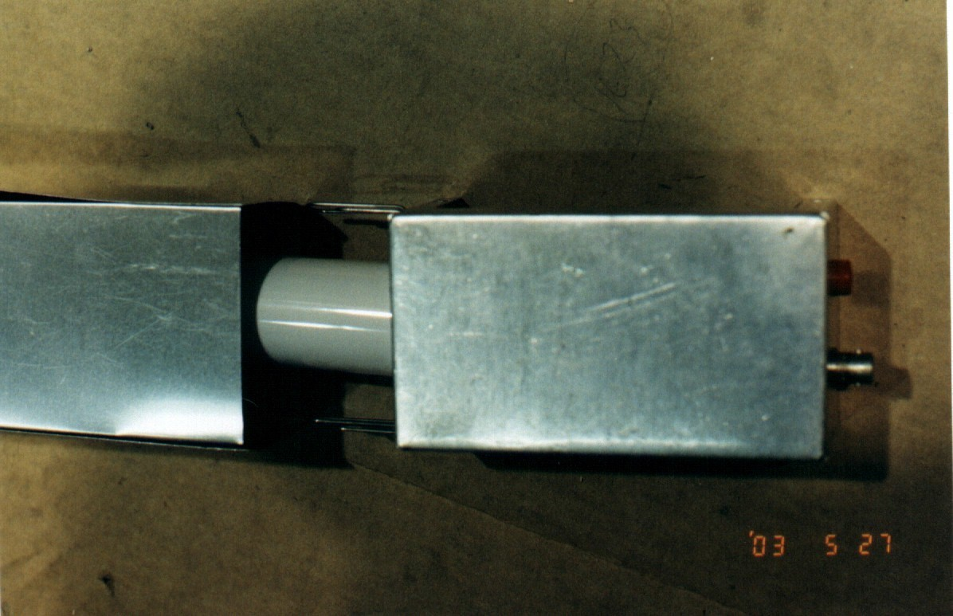

**Figure 9, Coaxial Plasma on Switch.**

In this switch, the outer conductor was a metal shell, and the inner conductor was a plasma discharge tube. When the tube was not energized, the outer shell comprised a metal waveguide beyond cutoff, and no radiation was transmitted. When the plasma discharge tube was energized, the apparatus became a coaxial waveguide, and transmission of radio signals was excellent. The work was done by Weng Lock Kang, as a thesis project, and was presented at a scientific meeting.

The second phase of the research started when researchers at the Patriot Scientific Corporation in California, read of our work, and called Igor Alexeff in as a consultant. They had an ongoing plasma antenna project, in which they wanted to use the disappearing feature of the plasma antenna to prevent ringing on signal turn – off. Their problem was poor plasma antenna transmission and reception. A version of the first plasma antenna is shown in **Figure 10, Early Plasma Antenna.**

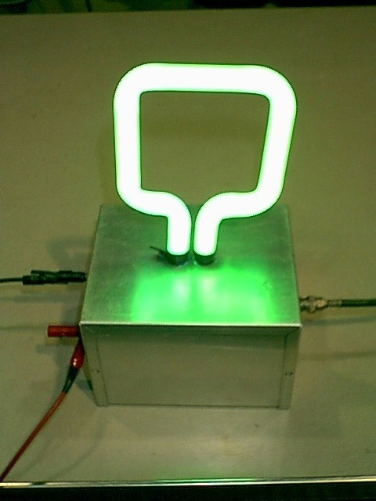

**Figure 10** Early Plasma Antenna

Our investigation showed that under their conditions of operation, the plasma antenna’s resistance was a megohm, and so did not match the 300 ohm resistance of space. The solution was to pulse the plasma antenna to higher currents, as the plasma discharge has a resistance that decreases with increasing current. Under the proper conditions, we found that the plasma antenna transmitted and absorbed radiation virtually identically to a metal antenna. In addition, the plasma – generated noise appeared to be rather low.

In the third phase of research started at, we constructed the plasma antenna shown in **Figure 10,** as well as the parabolic reflector shown in **Figure 11, Early Plasma Reflector Antenna.**

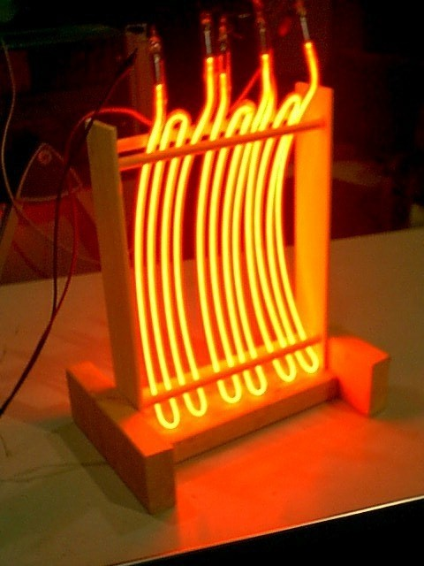

**Figure 11** Early Plasma reflector antenna

With this apparatus, we demonstrated stealth, reconfigurability, and protection from electronic warfare.

The fourth phase of research was done at the Malibu Research Corporation, an antenna design facility in California. This work was done under an SBIR subcontract with ASI Technology Corporation. We felt that precision measurements were required in a proper facility. In **Figure 11, Plasma Antenna,** we show a plasma antenna installed in an electrical anechoic chamber.

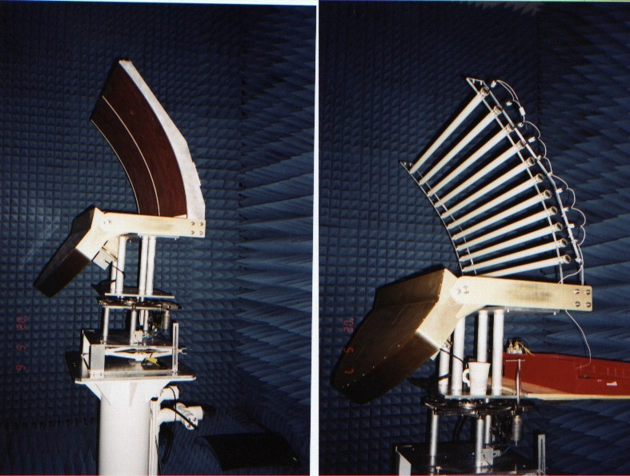

**Figure 12** Metal Reflector Antenna on the right and corresponding Plasma Reflector Antenna on

the left

The microwaves are generated by a line antenna, focused in one dimension by the metal pillbox, and focused in the second dimension by either the plasma antenna or a metal twin. The results were remarkably successful, as shown in **Figure 13, Radiation Pattern.**

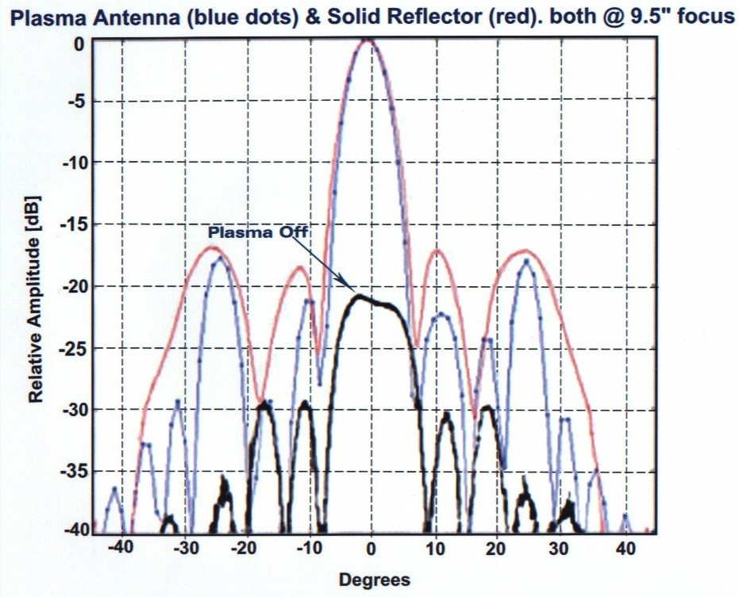

**Figure 13** Radiation pattern

First, when the plasma antenna was on, the transmission efficiency was virtually identical to the metal antenna. Second, the radiation pattern was also quite similar to the metal antenna. **However,** when the plasma antenna was de – energized, the reflected signal dropped by over 20 dB! In other words, the reflected signal dropped by over a factor of 100.

For stealth projects, the first metal reflector could be incased inside the body of a structure. However, this project is really a proof – of – principle, rather than a deployable system.

**Other Plasma Antenna Projects**

One of the criticisms directed at the plasma antenna is that it is fragile. As a researcher

from another company told us, he built a glass plasma antenna, but it was no good, because it broke when he installed it underneath an airplane. To make a robust plasma antenna, we imbedded one in an epoxy block, as shown in **Figure 14, Imbedded plasma antenna.** This imbedded antenna transmits and receives quite well, and has survived several years of hard treatment.

**Figure 14**

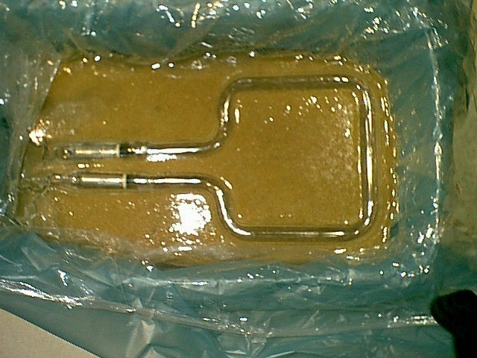

Embedde

d Plasma Antenna

A second, antenna related, plasma application is a plasma waveguide, as shown in **Figure 15, Plasma Waveguide.** Here we have an inner conductor comprising one plasma tube surrounded by an outer shell of eight plasma tubes.

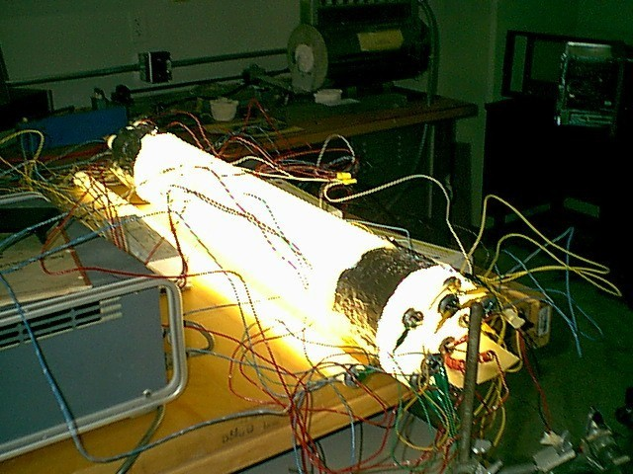

**Figure 15** Plasma waveguide

When on, the structure transmits radiation almost as well as a coaxial cable, but when off, the transmitted signal decreases by over 100 dB –a factor of 10 exp 10 Such plasma waveguides could convey radiation to the antennas on the mast of a ship, yet become transparent to radiation when deenergized.

Radar signals would pass through a de – energized waveguide rather than be reflected. In fact, these waveguides could pass in front of operating antennas and be virtually invisible when off.

A third plasma antenna application is reconfigurability. The effects of a reconfigurable plasma filter are shown in **Figure 16**

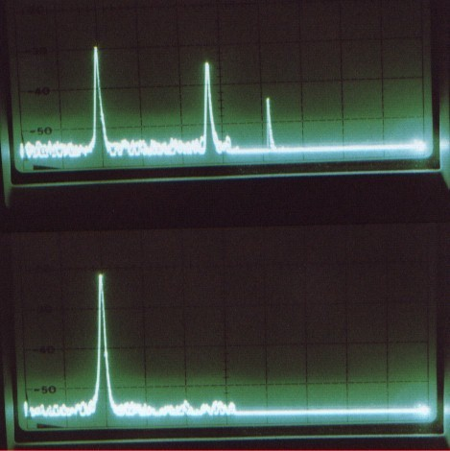

**Figure 16** Plasma Filter

In one oscilloscope trace, we observe several spectral lines emitted from an oscillator driven to a non – linear limit. In the second oscilloscope trace, several of the higher – frequency lines have been removed by the energizing of a plasma interference filter placed between the transmitter and receiver. We have made remarkable discovery in the operation of plasma. In the past, our plasma tubes were ionized by DC current. However, if the tubes are ionized by extremely short bursts of DC current, we find the following remarkable improvements. The plasma is produced in an extremely short time -2 microseconds. However, the plasma persists for a much longer time- 1/100 second. This is the reason why fluorescent lamps can operate on 60 or 50 Hz electric power. Consequently, if the pulsing rate is increased to 1 KHz, the tubes are operating at essentially constant density.There are three benefits to this new mode of operation.

First, the exciting current is on for only 2 microseconds, while it is off for one millisecond. Consequently, the discharge current is only on for 0.2% of the time, so current- driven instabilities are not present for most of the time. However, the current-driven instabilities in general have proven to be not serious.

In general, operating the plasma tubes in the non-current-carrying, afterglow state should produce considerably less noise than in operating in the current-carrying state. The decrease in plasma noise is obvious, but detailed measurements have been deferred till later in the program.

Second (this was unexpected), the plasma density produced by the pulsed-power technique is considerably higher than the plasma density produced by the same power supplied

in the steady-state. This observation produces two beneficial results.

We can operate at much higher plasma densities than before in the steady-state without destroying the discharge tube electrodes. Formerly, using commercial fluorescent tubes, we were limited to steady-state operation below 800 MHz. Now we can operate at several GHz. The upper frequency limit has not been explored.

We can operate at much higher plasma densities using lower average consumption. This results both in much lower power consumption and reduced heating of the antenna structure. Our new results are shown in the following figures.

**Figure 17** In this figure, the lower trace shows signals from two transmitters at 1.7 GHz and 8 GHz passing through a de-energized plasma barrier. The upper trace shows the 1.7 GHz

signal being blocked by the energized plasma barrier while the 8 GHz signal is able to pass through.

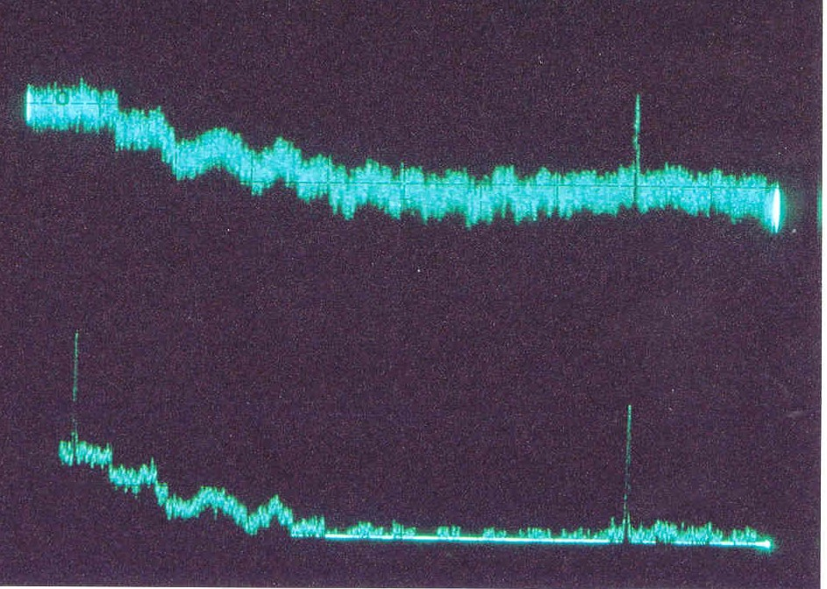

**Figure 17. Signals from the two transmitters**We note that the received signal with the plasma window on shows considerably more noise than that with the plasma window off. Surprisingly, we found that this noise signal apparently is not present on the microwave signal, but primarily is due to receiver pickup via the power line. Disconnecting the receiving antenna from the panoramic receiver does not change the observed noise level.

**Figure 18** In this schematic, we show the present experimental apparatus. Two transmitting antennas are placed inside a ring of fluorescent lamps. The two signals are received by a horn antenna outside the ring of fluorescent lamps.

Receiving horn

Plasma Tubes

8 GHz

Transmitter

Panoramic Receiver

1.7 GHz Transmitter

**Figure 18. Experimental Apparatus**

**Figure 19. This is a schematic of our pulsing apparatus. A 0-30 KV supply is connected to a RC supply comprising 1.5 Mega ohm resistor feeding a nanofarad capacitor.**

Plasma Tubes (12 Total)

Spark Gap

1.5 * 106 ohm

Fan to extinguish arc

10-9F

**Figure 19 Pulsing Apparatus**

**The resultant high voltage arc over a spark gap to provide pulsed current to the fluorescent lamps-up to 12 wired in series We find that when operating arc high pulsing frequencies-1 KHz up- the spark gap tends to go over to a steady-state arc.**

In conclusion, our recent inclusion of a pulsed power supply for our plasma tubes provides reduced noise, higher steady-state DC plasma density, and reduced power consumption. There are possibly minor problems because of a slight plasma density fluctuation during the pulsing cycle.

Plasma antenna research by the Australian group used surface waves to excite plasma columns.

**Other Plasma Antenna Prototypes**

A 2 megawatt pulsed power supply was tested on a plasma antenna. It was found that in the transmitting mode, the plasma antenna was as efficient as a metal antenna for high power. The

plasma antenna has the added advantages of reconfigurability which a metal antenna does not have. This reconfirms what has been found for lower powers. A pulsed power supply was used similar to the one used at the Naval Research Laboratory to generate megawatt radiation pulses with metal antennas. A section of 50 Ohm coaxial cable is charged to 25 Kilovolts. It then discharges through a spark gap into a second section of coaxial cable, then into four fluorescent lamps connected in series, forming a loop antenna. Previous experiments have shown that if the pulse repetition rate is over a Kilohertz, the plasma in the fluorescent lamps is in essentially the steady-state. The pulse of microwave radiation entering the plasma antenna radiates and is

received on a small wire antenna about one meter away. The received signal is about 5 Volts in amplitude. Since the input impedance of the antenna is 50 Ohms, as determined by terminating resistors, the received power is ½ Watt. The frequency of the radiation is about 13 Megahertz, in approximate agreement with the Naval Research Laboratory results with metal antennas. To calibrate the power output from the transmitter, we replaced the plasma antenna with a wire loop antenna of the same physical dimensions. We found that the received power from the pulsed power transmitter was the same as for the plasma antenna. The wire antenna was disconnected from the pulsed power supply, and connected it to a 10 Megahertz transmitter, and measured the received power on a panoramic receiver. The transmitter was then directly into the panoramic receiver, adjusted the signal strength to the previous value, and recorded the attenuation needed to do so. The attenuation required was 70 decibels. If the power received from the pulsed power supply is multiplied via the plasma antenna by 70 decibels, we get the radiated power from the plasma antenna to be **5 Megawatts**! This result is in agreement with the measured radiation output from the Naval Research Laboratory, except that they used a metal antenna..

. Figure 20 is a photograph of AM/FM radio plasma antenna.

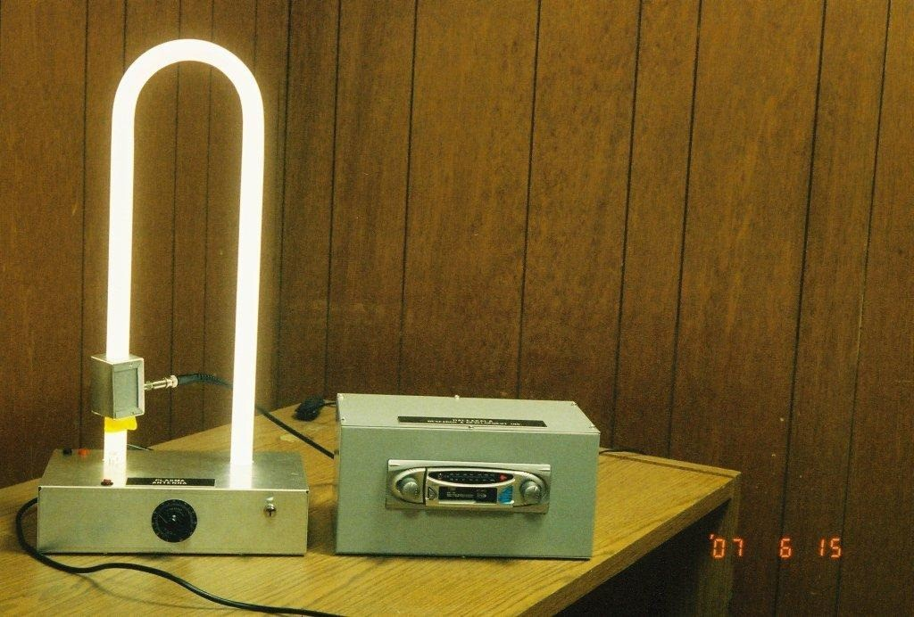

**Figure 20. Plasma Antenna for AM/FM Radio Prototype.**

**Plasma Antenna Thermal Noise**

This material is an expansion of the work in the book by Reif 29 for the standard Nyquist’s

Theorem. in which the well known result is:

*H* = 4*RKT* , where H is the noise spectrum as Volts

squared per Hertz (not Watts), R is the resistance of the object in Ohms (not Ohms per unit

length) , K is Boltzmann’s constant in Joules per degree K, and T is the temperature in degrees K.

The book acknowledges that the equation is a low-frequency approximation, but states that this approximation is correct, since in metals the collision frequency is a terahertz.

The correction term found by Anderson 30,31.

*H* = 4*RKT* ( 1

)

2

1 + (2πυ )

υ

2

*cc*

( 37)

Where υ is the frequency of the transmitter in Hertz, and υ*c* is the electron-gas atom collision

frequency in Hertz.

The factor of 2π

is a numerical constant that arises from the Fourier Transform process.

To compare the noise in a given spectral region, R and υ*c*

for metals and for plasmas must be

obtained. Considering operation at 10 GHz (3 cm wavelength),

29

in metals, υ*c*

from textbook, Reif

, is 1 THz.

For the resistance, assuming a rod 1 cm square in cross section and 3 cm long. The resistance of copper is 1.692exp -6 (“Handbook of Chemistry and Physics” 32), so the metal antenna would be

5.076 exp -6 Ohm if skin depth were to be neglected.

Skin depth is given by

2 1

( ) 2

σµω (38)

Where σ is the conductivity, µ is the permittivity, and ω is the angular frequency of the

microwaves (radians per second or 2πυ in Hertz).

The skin depth is 2 exp -5 cm. Hence the resistivity corresponds to a copper sheet 3 cm long, 4

cm wide, and 2exp -5 cm thick. This corresponds to a resistance of .063 Ohms. The temperature of the copper is 300 degrees Kelvin.

For the plasma, the collision frequency is computed as follows. In Cobine’s book, “Gaseous Conductors” 33, the pressure in a fluorescent tube to be a maximum of 2 mm hg. The electron- gas atom scattering cross section corresponds to an electron temperature of 1 electron-volt, is deep in the Ramsauer minimum, and is found in Fig. 2.3. The mean-free-path is about 1 cm at a pressure of 1 mm hg. This gives a scattering cross section of 2.8 exp -17 cm squared (It is at the

Ramsauer minimum.), at a pressure of 1 mm hg.

The electron velocity corresponds to 1 electron volt. The thermal velocity is *v* = *KT*

*m*

where

v is the velocity, K is Boltzmann’s constant, T is the electron temperature, and m is the electron mass. Inserting the proper values gives an electron thermal velocity of 4.2 exp 7 cm per second. Using the atom density at s mm hg to be 7.02exp 16 per cc, the collision frequency is computed to be 82 MHz. Actually, if the tube is about 1 cm in diameter, the collision frequency at the wall exceeds this.

Concerning the resistance of the tube, Cobine 33 gives the voltage drop for a 9 inch tube to be 45 and for a 48 inch tube to be 108. Subtracting these to get rid of the cathode drop and to find the

voltage drop on the positive column, we get 1.62 volts per inch, or 0.638 volts per cm. The current ranged from .15 to .42 Ampere. Since the tube has essentially a voltage drop independent of current, we use the .42 Ampere value. This yields a resistance of 1.52 Ohms per cm. For a 3 cm long column of plasma, we have 4.56 Ohms.

Computing the noise figure in volts squared per Hertz, the metal gives us 1.04 exp -21. For the plasma antenna at 10 GHz, we obtain 4.29 exp-24.

Thus in this frequency range, the noise in the plasma antenna is much less than the metal antenna. Of course, at low enough frequencies, the inequality is reversed, but we can address that by reducing the gas pressure in custom made plasma tubes.

Note that we used the upper limit for gas pressure in this report on the plasma tube. In the patent application, pressures two thousand times lower have been used. (US Patent 1,790,153). Using the lowest pressure would reduce the plasma noise by about a factor of 2000.

Keep in mind that this analysis has been and is for a fluorescent lamp. Plasma antennas have been made out of florescent lamps because they are inexpensive and it shows that people can do research and development and build prototypes of the plasma antenna technology cheaply. When plasma antennas are ruggedized with custom made plasma tubes, the gas pressure inside the plasma tubes can be made much less than in a fluorescent bulb and lower the frequency at which the plasma antenna thermal noise is equal to the metal antenna thermal noise.

Using the highest gas pressure in a florescent tube of 2 millimeters, the frequency at which the plasma antenna and the metal antenna have the same thermal noise is 1.27 GHz. Using the lowest gas pressure of a fluorescent tube of 1 micron, this cross over frequency at which the plasma antenna thermal noise and the metal antenna thermal noise are equal is much lower.

Above the cross over frequency where the thermal noise of the plasma antenna and the metal

antenna, the plasma antenna thermal noise drops rapidly.

As stated above, custom made plasma tubes can be made such that pressure is much lower than in a fluorescent lamp. This would give a number in which the thermal noise of the plasma antenna and the metal antennas are equal much lower than 1.27 GHz antenna frequency. Again, florescent tubes have been used often to make plasma antennas because this has been an inexpensive way to do our plasma antenna research and development. Custom made plasma

tubes are being planned to be made to be rugged and have lower noise than metal antennas over very wide frequency range.

A patent has been filed on low thermal noise designs of plasma antennas.34

**Current Work Done To Make Plasma Antennas Rugged.**

Concerning alternates to glass tubes, we have at least 3 possibilities;

1. A plastic tube with a glass liner.
2. A resistant plastic tube (silicone).
3. Synfoam.

The plasma tubes have been housed in a strong and lightweight synthetic foam called Synfoam (see figure 21) made by Utility Development Corporation (<http://www.udccorp.com/products/synfoamsyntacticfoam.html)35>which can be molded into various shapes. SynFoam is a high performance syntactic foam combining high strength, heat resistant, light weight, and with very low moisture absorption. SynFoam's syntactic foam

products feature a density of less than 20 pcf and a compressive strength greater than 2000 psi. The index of refraction of the Synfoam is nearly one so it is transparent to rf signals.



**Figure 21. Synfoam housing for plasma tubes. Experiments are planned using the cavities in the Synfoam to directly house the plasma gas without using glass tubes at all.**

**Latest Developments on Plasma Antennas**

Plasma tubes will intercept microwaves regardless of polarization

A layer of plasma tubes is used as a microwave reflector. The plasma tubes work extremely well in intercepting microwave radiation when the incident wave electric field is parallel to the tubes. However, if the electric field is perpendicular to the tubes, the normally induced plasma current cannot flow, and the plasma effects are not expected to appear. When the plasma tubes were experimentally tested with the electric field perpendicular to the tubes, the plasma tubes not only intercepted the microwave signal, but the observed cut-off with a pulsed plasma lasted about twice as long. .

**Theory for Polarization Effect.**

The effect appears to be due to an electrostatic resonance, and preliminary calculations suggest

that a normally ignored term in Maxwell’s Equations is responsible**.**

∇2 *E* − ∇(∇ ⋅ *E*) = µ ε (ω2 +

0 0 *p*

∂2 *E*

)

∂*t*2

(39)

The term responsible appears to be:

#### ∇ ( ∇

* *E* )

(40)

**Generation of Dense Plasmas at Low Average Power input by Power Pulsing.**

One of the remarkable plasma effects experimentally discovered is the large increase in plasma density at the same average power input provided by pulsing the power input 32, 33, 34, 35 . In our experiments, a density increase of over 100 has been observed. Although various experimenters have observed similar effects using different power input techniques, to our knowledge no one has provided a theoretical explanation as yet.

A theoretical model for this effect is provided. Since the power is obviously

being deposited into the plasma, assuming that during the power input, an enhanced plasma loss occurs. This plasma loss occurs on a time scale T1. On turning off the power input, this plasma loss process disappears on a time scale T2. The resulting afterglow plasma disappears on a much slower time scale T3. Modeling this as a system driven by a power delta function repeating on a time period T4. The height of the delta function is proportional to T4, so the longer the time between pulses, the higher the delta function, but the average power input is preserved.

As a first approximation on a single pulse basis, we obtain,

*N AG*

*N SS*

= exp

 *T*

 −

2

 *T* 1

 *T*



4

 *T* 5

(41)

Where NAG is the afterglow density during pulsing and Nss is the density during steady-state operation. In our experiments, T4 is about 1000 times T5 (the duration of the delta function). If we assume that the fast decay process T1 is of the same approximate length as the time in which this decay process disappears T2, the above calculation yields a density enhancement of about 300. This number agrees with our observed density enhancement. This calculation ignores plasma left over from the preceding pulse, but most of this is dumped by the effects of the pulse. In any case it can only improve plasma density.

**Fabry- Perot Resonator for Faster Operation of the Smart Plasma Antenna.**

The characteristic decay time of the plasma after power turn-off is typically many milliseconds,

so the opening time of such a barrier generally is predicted also to be many milliseconds. However, the plasma barrier can be opened and closed in faster time scales.

This can be done by increasing the plasma density rather than waiting for it to decay. If a standing wave is produced between the two lawyers of plasma that results in microwave transmission, analogous to the transmission found in an optical Fabry- Perot Resonator. The secret lies in the boundary layer behavior of the plasma. Once microwave cut-off occurs, one would expect the plasma behavior to be static. What actually occurs is that at microwave cut-off, the reflection is in phase with the incident wave, in analogy to an open coaxial line. (The electron and displacement currents are equal, but out-of-phase) As the plasma density further increases, the reflection smoothly changes from in-phase to 180 degrees out-of-phase, in analogy to a shorted coaxial line. (The reflection current is much greater than the displacement current.)

The boundary condition at a vacuum-plasma interface of the reflected electric field in terms of the incident electric field is:

1−*i*β

*E* =

*r* (

1+*i*β

)*E*0

(42)

Where the phase shift is given by:

2

ω

β = *p* − 1

ω 2

(43)

The consequence of this phase shift is that, given any kind of a plasma resonator, if the plasma

density is raised high enough, the resonance required for the Fabry-Perot effect to take place must occur.

**References**

1. W. Manheimer, “Plasma Reflectors for Electronic Beam Steering in Radar Systems,”

*IEEE Transactions on Plasma Science*, vol. 19, no. 6, December 1993, p. 1228.

1. J. Mathew, R. Meger, J. Gregor, R. Pechacek, R. Fernsler, W. Manheimer, and A.

*3.* Robson, “Electronically Steerable Plasma Mirror for Radar Applications,” *IEEE International Radar Conference*, June 1995, p. 742.

1. M. Moisan, A. Shivarova, and A. W. Trivelpiece, Phys. Plasmas **20**, 1331, 1982
2. G. Borg, J. Harris, N. Martin, D. Thorncraft, R. Milliken, D. Miljak, B. Kwan, T. Ng, andJ. Kircher, “Plasmas as Antennas: Theory, Experiment, and Applications*,” Physics of Plasmas*, vol. 7, no. 5, May 2000, p. 2198.
3. G. G. Borg, D. G. Miljak, J. H. Harris, and N. M. Martin, Appl. Phys. Lett.

**74**, 3272, 1999.

1. Alexeff, I , T. Anderson., “Experimental and Theoretical Results with Plasma Antennas”, IEEE Transactions on Plasma Science, Vol. 34, No.2, April 2006
2. Alexeff, I , T. Anderson*,* “ Recent Results of Plasma Antennas” *,* Physics of Plasmas, 15, 057104(2008)..
3. T. Anderson, I.Alexeff, “Plasma Frequency Selective Surfaces”, IEEE Transactions on Plasma Science, Vol. 35, no. 2, p. 407, April 2007.
4. D. C. Jenn,” Plasma Antennas: Survey of Techniques and the Current State of the Art” , Naval Postgraduate School, September 29, 2003, <http://faculty.nps.edu/jenn/pubs/PlasmaReportFinal.pdf>
5. N. Krall, A. Trivelpiece, “Principals of Plasma Physics”, McGraw-Hill Inc, 1973, pp 84- 98
6. F. Chen, “ Introduction to Plasma Physics and Controlled Fusion”, Volume 1. second edition, Plenum Press, pp 53-78
7. C. Balanis, “ Antenna Theory”, second edition, John Wiley & Sons, p 143
8. [www.haleakala-research.com](http://www.haleakala-research.com/)
9. T. Anderson, “Multiple tube plasma antenna” . US Patent number 5,963,169.
10. T. Anderson, Alexeff, I., “Reconfigurable scanner and RFID”, Application Serial Number 11/879,725.
11. T. Anderson, “ Configurable arrays for steerable antennas and wireless network incorporating the steerable antennas.” US patent 7, 342,549,
12. T. Anderson, “Reconfigurable scanner and RFID system using the scanner”. US patent 6,922,173.
13. T. Anderson, “Configurable arrays for steerable antennas and wireless network incorporating the steerable antennas”, US patent 6,870,517.
14. T. Anderson, I. Alexeff,., “Theory and Experiments of Plasma Antenna Radiation Emitted Through Plasma Apertures or Windows with Suppressed Back and Side Lobes,” International Conference on Plasma Science 2002
15. T. Anderson., “Storage And Release Of Electromagnetic Waves by Plasma Antennas and Waveguides,” 33rd AIAA Plasmadynamics and Lasers Conference 2002
16. T. Anderson, T., I. Alexeff, “Plasma Frequency Selective Surfaces,” International Conference on Plasma Science 2003
17. T. Anderson, I. Alexeff, “Theory of Plasma Windowing Antennas,” IEEE ICOPS, Baltimore, June 2004
18. <http://www.haleakala-research.com/uploads/OperatingPlasmaAntenna.pdf>
19. B. A. Munk, “ Frequency Selective Surfaces” (Wiley Interscience, 2000).
20. I. Alexeff, “ Pulsed plasma element”, US patent 7,274,333.
21. T. Anderson, “Tunable plasma frequency devices””, US patent, 7,292,191
22. T. Anderson, “Tunable plasma frequency devices”, US patent, 7,453,403
23. F. Reif, “Fundamentals of Statistical and Thermal Physics”, McGraw-Hill, 1965, pp 587- 589 and pp 585-587.
24. T. Anderson, “Electromagnetic Noise from Frequency Driven and Transient Plasmas” IEEE International Symposium on Electromagnetic Compatibility, Symposium Record, Volume 1, Minneapolis, MN August 19-23, 2002.
25. T. Anderson., “Control of Electromagnetic Interference from Arc and Electron Beam Welding by Controlling the Physical Parameters in Arc or Electron Beam: Theoretical Model”, 2000 IEEE Symposium Record, Volume 2, pages 695-698, ISBN 0-7803-5677-2
26. CRC Handbook Chemistry and Physics, 85th Edition.
27. J.D., Cobine, “ Gaseous Conductors Theory and Engineering Applications” McGraw-Hill Book Company. 1951
28. T. Anderson, T., I. Alexeff, “High SNR plasma antenna” Application Serial Number 12/324,876.
29. <http://www.udccorp.com/products/synfoamsyntacticfoam.html>

**Other References: Plasma lenses:**

1. **Plasma-based lens for microwave beam steering Linardakis, P. Borg, G. Martin, N.**

**Res. Sch. of Phys. Sci. & Eng., Australian Nat. Univ., Canberra, ACT, Australia; This paper appears in: Electronics Letters**

**Publication Date: 13 April 2006 Volume: 42, Issue: 8**

**On page(s): 444- 446 ISSN: 0013-5194**

**INSPEC Accession Number: 8980337**

**Digital Object Identifier: 10.1049/el:20064259 Current Version Published: 2006-04-24**

1. **Aerial Stealth, Scientific America, page 22, February 2008 issue.**
2. **The Practical World of Plasma, Popular Mechanics, page 18, July 2010 issue**
3. **Clearly identify any other funding agencies for which the proposal has been submitted;** None
4. **A brief (~half a page) self-evaluation of the proposal against this BAA’s criteria.**

The Haleakala R&D, Inc. smart high powered plasma antenna at ADS frequencies will have

shoot on the move capability. Our current smart plasma antenna is highly reconfigurable, portable, compact and lightweight. We will built and test our smart plasma antenna at 95 GHz. Our current smart plasma antenna and our high powered plasma antenna do not need a 5 minute warm-up time from complete system shut-down to full power.

We can reconfigure the plasma antenna in milliseconds and our research into the Fabry-Perot Etalon Effects on plasma indicate that we can do this in microseconds.

We have developed plasma feeds in terms of plasma waveguides and plasma co-axial cables. Theses feed can be reconfigured with the plasma antenna to maintain high efficiency. The radiation efficiency of the plasma antenna is as high and in some cases higher than in a corresponding metal antenna. Together we comfortably exceed 35 % efficiency in our plasma antenna systems. We have achieved these criteria at 2.5 GHz. We will do R&D to achieve this in the W band and built a prototype of it.

.We can achieve reconfigurable high yet safe uniform power densities with our plasma lensing and plasma reconfigurablity in general. We have experimentally observed that the side lobes of plasma antennas are less than in the corresponding metal antennas. See the comparison of our plasma reflector antenna with the corresponding metal reflector antenna in figures 12 and 13 which clearly shows that the side lobes of the plasma antenna are less than in the corresponding metal antenna. We attribute the side lobe reduction of plasma antennas to the soft surface effects of the plasma antenna.

Our current smart plasma antenna, (which we will convert to a smart ADS plasma antenna) weighs about 10 pounds and is about 10 inches in height and 6 inches in diameter with cylindrical shape.

Finally, we have built a ruggedized version of our smart plasma antenna.

Haleakala R&D, Inc is in the July 2010 issue of Popular Mechanics, page 18

**HALEAKALA in the recent press ! July 2010 *POPULAR MECHANICS Pg 18***

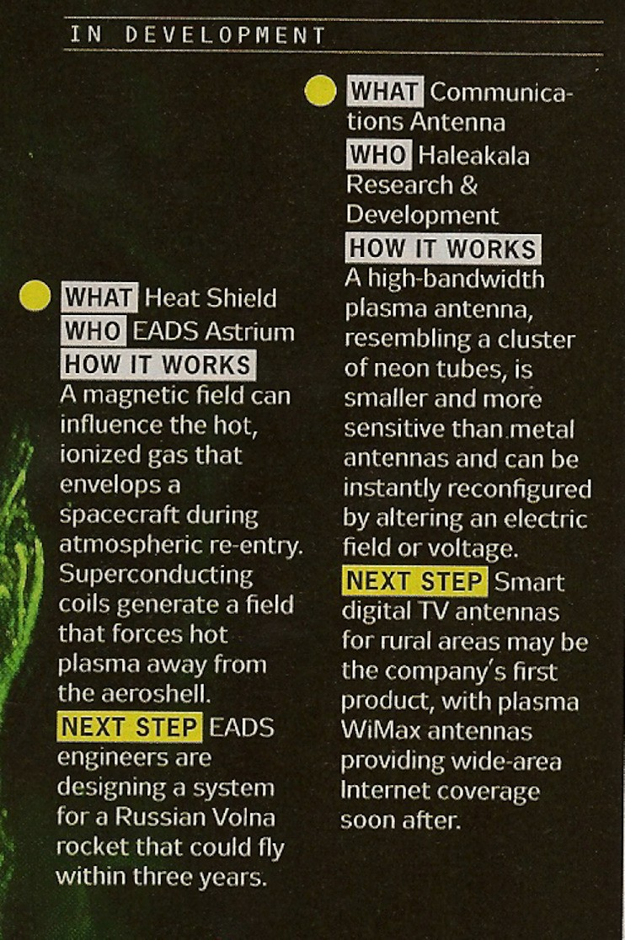

Addendum: Resumes

**1. Dr. Ted Anderson (Principal Investigator)**

Dr. Ted Anderson is the principal investigator of this proposal. He received his PhD in physics

from New York University in 1986. He worked taught at the University of Connecticut for 12 years and Rensselaer Polytechnic Institute for 16 years. He has published more work and has more patents on the plasma antenna than anyone. He has more :patents on the plasma antenna than anyone.

**Security Clearances (possibly not current) DOD and DOE Citizenship** United States

Phones: 508-867-3918 and 518-409-1010 (mobile phone).

e-mail: [AnderDrTed@aol.com,](mailto:AnderDrTed@aol.com) [tedanderson@haleakala-research.com](mailto:tedanderson@haleakala-research.com)

Home address: 7 Martin Road, Brookfield, MA. 01506 Highest degree **PhD in physics** from New York University **EDUCATION**

PhD, Physics New York University, New York, NY 1986

**ISSUED PATENTS (Several of my patents have appeared in the Antennas and Propagation Magazine. )**

|  |  |  |
| --- | --- | --- |
| 1 | 6,710,746 | Antenna having reconfigurable length |
| 2 | 6,700,544 | Near-field plasma reader |
| 3 | 6,674,970 | Plasma antenna with two-fluid ionization current |
| 4 | 6,657,594 | Plasma antenna system and method |
| 5 | 6,650,297 | Laser driven plasma antenna utilizing laser modified |
|  |  | maxwellian relaxation |
| 6 | 6,624,719 | Reconfigurable electromagnetic waveguide |
| 7 | 6,512,496 | Expandible antenna |
| 8 | 6,369,763 | Reconfigurable plasma antenna |
| 9 | 6,169,520 | Plasma antenna with currents generated by opposed photon |
| 10 | 6,118,407 | beams  Horizontal plasma antenna using plasma drift currents |
| 11 | 6,087,993 | Plasma antenna with electro-optical modulator |
| 12 | 6,087,992 | Acoustically driven plasma antenna |
| 13 | 6,046,705 | Standing wave plasma antenna with plasma reflector |
| 14 | 5,963,169 | Multiple tube plasma antenna |

1. 6,876,330 Reconfigurable antennas
2. 6,870,517 Configurable arrays for steerable antennas and wireless network incorporating the steerable antennas
3. 6,842,146 Plasma filter antenna system
4. 7,342,549. Configurable arrays for steerable antennas and wireless network incorporating the steerable antennas.
5. 6,922,173. Reconfigurable scanner and RFID system using the scanner
6. 6,700,544. Near-field plasma reader
7. 6,870,517. Configurable arrays for steerable antennas and wireless network incorporating the steerable antennas

22.. 7,292,191. Tunable plasma frequency devices

23. 7,453,403. Tunable plasma frequency devices.

**Filed patents:**

1. High SNR plasma antenna. Application Serial Number 12/324,876, Filed 12/01/2008.
2. Reconfigurable scanner and RFID. Application Serial Number 11/879,725, Filed 7/18/2007 Two more patent applications are planned to be filed within a month.

**Issued plasma waveguide patents.**

1. 6,812,895 Reconfigurable electromagnetic plasma waveguide used as a phase shifter and a horn antenna
2. 6,624,719 Reconfigurable electromagnetic waveguide

**PUBLICATIONS ( Very Partial List)**

* 1. Anderson, T., Alexeff I., Plasma Frequency selective Surfaces, IEEE Transactions on

Plasma Science, Vol. 35, no. 2, p. 407, April 2007.

* 1. Anderson, T., Alexeff, I., Experimental and Theoretical Results with Plasma Antennas, IEEE Transactions on Plasma Science,. Vol. 34 No. 2, April 2006
  2. Alexeff I., Anderson, T., Recent results for Plasma antennas, Physics of Plasmas, 15, 057104, (2008)
  3. Anderson, T., Alexeff I. Plasma Antenna Windowing: Theoretical and experimental Analysis, IEEE Transactions on Plasma Science, being processed for publication.
  4. Anderson, T., Alexeff, I., Reconfigurable Plasma Frequency Selective Surfaces, Submitted to IEEE Transactions on Plasma Science
  5. Anderson, T. Antenna Intensity Patterns Through open Plasma Windows, Submitted to IEEE Transactions on Antennas and Propagation
  6. Anderson, T, and Alexeff, I., Theory and Experiments of Plasma Antenna Radiation Emitted Through Plasma Apertures or Windows with Suppressed Back and Side Lobes, International Conference on Plasma Science 2002
  7. Anderson, T, and Alexeff, I., Storage And Release Of Electromagnetic Waves by Plasma Antennas and Waveguides, 33rd AIAA Plasmadynamics and Lasers Conference 2002
  8. Anderson, T. and Alexeff, I., Plasma Frequency Selective Surfaces, International Conference on Plasma Science 2003
  9. Anderson, T., Alexeff, I., Reconfigurable Plasma Frequency Selective Surfaces, Submitted to IEEE Transactions on Plasma Science
  10. Anderson, T. Antenna Intensity Patterns Through open Plasma Windows,

Submitted to IEEE Transactions on Antennas and Propagation

* 1. Anderson, T. Plasma Frequency Selective Surfaces, 2003 IEEE International Conference on Plasma Science, published in the IEEE Conference Record, IEEE catalog number 03CH37470
  2. Anderson, T. , Alexeff, Igor. Theory of Plasma Windowing Antennas, IEEE ICOPS, Baltimore, June 2004
  3. Anderson T, Alexeff T, Adavnces in Plasma Antenna Design, in IEEE Int Conf. Plasma Sci., Monterey, CA, Jine 20-23, 2005
  4. Anderson, Alexeff, Plasma Antennas I , presented at the SMi 8th annual Stealth Conference, London March 15-16, 2004

2. Professor Igor Alexeff

BA Harvard 1952 (Honors) Ph.D. Wisconsin 1959 (Physics)

**Education**

NSF Postdoctoral Appointment, University of Zurich, Switzerland (1959-1960).

**Positions**

1999-2000 President, IEEE Nuclear and Plasma Sciences Society

1997-present Professor of Electrical Engineering, Emeritus

1970-1996 Full Professor, University of Tennessee Electrical Engineering Department 1960-1970 Oak Ridge National Laboratory (Controlled Thermonuclear Fusion)

1952-1953 Westinghouse Research Laboratory (Helped develop 1st nuclear submarine)

**Honors and Activities**

Fellow-IEEE

Fellow-APS

Registered PE-Tennessee Over 10 Patents

Co-founder of the IEEE Nuclear and Plasma Sciences Society over 25 years ago.

Founder of the First IEEE International Conference on Plasma Science over 25 years ago in Knoxville, TN.

President of the IEEE Nuclear and Plasma Sciences Society, 1999-2000.

Founding President of The Tennessee Inventors Association, a state recognized inventor help organization.

Had overseas visiting professorships in Japan, India, South Africa, and Brazil.

**Selected Publications**

1. Observations of Ionic Sound Waves in Plasmas-Their Properties and Applications (with R. V.

Neidigh), Phys. Rev. 129, 516 (1963).

According to Lyman Spitzer, we were the first to observe propagating ion-acoustic waves.

1. Controlled Landau Damping of Ion-Acoustic Waves, I Alexeff, W. D. Jones, and D. Montgomery, Phys. Rev. Letters 19 (8) 422-425 (1967).

Here the Landau Damping was controlled by adding a trace of light atomic contaminant to the ion-acoustic wave, which had a thermal velocity close to the wave velocity.

1. Ion Acoustic Wave Excitation and Ion Sheath Evolution, Widner, M., Alexeff, I., Jones, W. D., and Lonngren, K., Phys. Fluids 13, 2532-2540,

This paper includes the ion energy spectrum striking the plate, and is referenced as the basic paper for ion implantation in solids.

1. Excitation of Pseudowaves in a Plasma via a Grid, ( with W. D. Jones and Karl Lonngren) Phys. Rev. Letters 2, 878-81, 1968.

This paper demonstrated a new, wave-like disturbance that can only exist in collisionless plasmas.

1. Nonexistence of Ion-Acoustic Waves and Landau Damping Driven Electrostatically in An Ideal Q-Machine, Kent Estabrook and Igor Alexeff, Phys. Rev. Letters 29, 9, 573-576, (1972). This paper includes a computer simulation that reproduces an experiment that cannot be done experimentally or theoretically. Since it invalidates the q-machine data, we did the first landau damping experiment for ion-acoustic waves (ref. 2).
2. Observation of Closed Loops in High-Voltage Discharges: A Possible Precursor of Magnetic Flux Trapping, Igor Alexeff and Mark Rader, IEEE Transactions on Plasma Science, Vol. 20, 6, pp 669-71, (Dec. 1992).

The possible first observations of artificial Ball Lightning.

1. Orbitron Operation at 1 THz, Igor Alexeff, Fred Dyer, and Wlodek Nakonieczny, International Journal of Infrared and Millimeter Waves, Vol. 6, No. 7, (1985).

This is a patented free electron maser in which electrons orbiting a positively-charged wire exhibit a negative-mass instability and radiate in the submillimeter range.

1. High-Power Microwave Sources (Book), Victor L. Granatstein and Igor Alexeff, Artech House, Boston, London, 1987.

Alexeff co-edited the book, and wrote chapter 7, "The Orbitron Microwave Maser".

1. U. S. Patent 4 818 185, Electromagnetic Apparatus Operating on Electrically Conducting Fluids 1989, Igor Alexeff.

This is the MHD "Worm Drive" that appeared in the movie, "The Hunt for Red October".

1. U. S. Patent 5 592 357, Electrostatic Charging Apparatus and Method, 1997, Mark S. Rader, Igor Alexeff, Peter P. Tsai and Larry C. Wadsworth.

This apparatus produces an enhanced corona discharge in atmospheric air by surrounding each corona point with an envelope of non-electron absorbing gas, such as helium

1. Dr. Kenneth A. Connor

**Education**

B.S.E.E. University of Wisconsin, 1968

M.S.E.E. University of Wisconsin, 1970

Ph.D. Polytechnic Institute of New York, 1975

**Professional Experience**

1974 – 1980 Assistant Professor

1980 – 1987 Associate Professor 1987 – Present Professor

1980 Visiting Scientist – Nagoya Bumpy Torus Group, Nagoya University, Japan 1984 Visiting Scientist – Plasma Diagnostics Group, Ioffe Institute, USSR

1987 – Present Scientific Advisor – Magsoft Corporation, Troy, NY 1992 – Present Director – Plasma Dynamics Laboratory, Rensselaer 2000 – Present Chair, ECSE Department

**Professional Affliations**

American Physical Society: 1970-present, Division of Plasma Physics

IEEE: 1967-present (Fellow, 1997), Nuclear and Plasma Sciences Society, Magnetics Society, Education Society, Antennas and Propagation Society, Instrumentation Society

Sigma Xi: 1974-present ASEE: 2001-present

**Selected Publications**

"3 Dimensional Finite Element Analysis of High Power Microwave Devices,” L. Nicolas, K. A. Connor, S. J. Salon, B. G. Ruth and L. F. Libelo., IEEE Trans. Magnetics, 29, 1642 (1993). "Measurements of the Space Potential of Electron Cyclotron Heated Plasmas in the Advanced Toroidal Facility", S. C. Aceto, K. A. Connor, J. G. Schwelberger and J. J. Zielinski, IEEE Trans. Plasma Science, 22, 388 (1994).

"Atomic Collision Processes Relevant for Heavy Ion Beam Probes", J. G. Schwelberger and K.

A. Connor, IEEE Trans. Plasma Science, 22, 418 (1994).

“Time Domain Finite Element Analysis of High Power Microwave Aperture Antennas,” K. Choi, S. J. Salon, K. A. Connor, IEEE Transactions on Magnetics, 31, 1622 (1995).

"Ballooning Characteristics in Density Fluctuations Observed with the 2 MeV Heavy Ion Beam Probe on the TEXT-U Tokamak," A. Fujisawa, A. Ouroua, J. W. Heard, T. P. Crowley, P. M. Schoch, K. A. Connor, R. L. Hickok, A. J. Wootton, Nuclear Fusion, vol 36, 375 (1996). "Measurements of Broadband Fluctuations and Plasma Potential with the 2 MeV Heavy Ion Beam Probe on the TEXT-U Tokamak," A. Ouroua, T.P. Crowley, K.A. Connor, D.R. Demers,

A. Fujisawa, R.L. Hickok, P.E. McLaren, P.M. Schoch, Fusion Engineering and Design, vol 34- 35, 613 (1997).

“Microwave Radiation from Slant Cut Cylindrical Antennas – Modeling an Experiment,” Vollaire, C., Nicholas, L., Connor, K.A., Salon, S.J., Ruth, B.G., Libelo, L.F., IEEE Transactions on Magnetics, vol. 34, 2712 (1998).

“A heavy ion beam probe for the Madison Symmetric Torus,” U. Shah; K. A. Connor; J. Lei, et al., Review of Scientific Instruments, vol 70, 967 (1999).

“Investigation of Microwave Heating with Time-Varying Material Properties,”

J. Braunstein, K. Connor, S. Salon, L. Libelo, IEEE Transactions on Magnetics, vol 35, 1813 (1999)

“Suppression of plasma electrons in the diagnostic ports of MST,” D.R. Demers, K.A. Connor, J. Lei, P.M. Schoch, U.Shah, Review of Scientific Instruments, vol. 72, 568 (2001)

“Radial electrostatic flux inferred from core measurements of potential and density fluctuations,”

D.R. Demers, P.M. Schoch, T.P.Crowley, K.A. Connor, Physics of Plasmas, vol. 8, 1278 (2001). “Initial measurements of the plasma potential in the Core of the MST reversed field pinch with a heavy ion beam probe,” D. R. Demers, J. Lei, U. Shah, P. M. Schoch, K. A. Connor, T. P. Crowley, J. G. Schatz, J. K. Anderson, J. S. Sarff, Czech J. Phys, vol 51, 1065 (2001).

1. Dr. Larry Barnett

**Education Summary:**

1978 Ph.D. EE, University of Tennessee Knoxville 1975 MSEE, University of Tennessee Space Institute 1972 BSEE, Tennessee Technological University

**Professional Associations:**

National Tsing Hua University, Taiwan, Dept of Physics, Consultant, 1988-2002. University of California Davis, Dept of Applied Science, Consultant, 2001-2002. Synchrotron Radiation Research Center, Taiwan, Contractor and Consultant, 1991-2002 Electronic Research Service Organization, Taiwan, Consultant and Contractor, 1999-2001. University of Utah, Dept. of Electrical Engr., Research Associate Professor, 1983 to 1990. NASA Lewis Research Center, Consultant, 1990-1991.

Naval Research Laboratory, Plasma Science Division, Research Physicist, 1980-1983. BK Dynamics, Senior Engineer, 1979-1980.

National Research Council Associate at the Naval Research Laboratory, 1978 to 1979. National Tsing Hua University, Taiwan, Visiting Expert, summer, 1988.

Georgia Technological Research Institute, Atlanta, GA., Consultant, 1991

**Experience Summary:**

Submillimeter O-Type Backward-Wave Oscillators High Power Solid State Electronics

Conventional Electronics and Diagnostics

Microwave and RF Circuits with Waveguide and Microstrip. Semiconductor Microwave and RF Electronics

Support Systems: Vacuum, Cryogenic, and Superconducting Magnets

**Selected Publications**

1. L. R. Barnett and I. Alexeff, "A Cyclotron Maser Using a Spatially Nonlinear Electrostatic Field",

*IEDM Technical Digest*, 168 (1979).

1. L. R. Barnett, K. R. Chu, J. M. Baird, V. L. Granatstein and A. T. Drobot, "Gain, Saturation, and Bandwidth Measurements of the NRL Gyrotron Traveling Wave Amplifier," *IEDM Tech. Dig*. 164

(1979).

1. L. R. Barnett, J. M. Baird, Y. Y. Lau, K. R. Chu, and V. L. Granatstein, "A High Gain Single Stage Gyrotron Traveling Wave Amplifier," *IEEE-IEDM Tech. Dig.* 314 (1980).
2. L. R. Barnett, J. M. Baird, A. W. Fliflet, V. L. Granatstein, "Circular-Electric Mode Waveguide Couplers and Junctions for Use in Gyrotron Traveling-Wave Amplifiers", *IEEE Trans. Microwave Theory and Techniques*, vol. 28, 1477 (1980).
3. A. W. Fliflet, L. R. Barnett, J. Mark Baird, "Mode Coupling and Power Transfer in a Coaxial Sector Wave-Guide with a Sector Angle Taper", *IEEE Trans. Microwave Theory and Techniques*, MTT-28. 1482, (1980).
4. W. M. Black, W. M. Bollen, R. Tobin, R. K. Parker, L. R. Barnett, and G. Farney, "A High-Power Magnetron for Air Breakdown Studies", *IEDM Technical Digest*, 180 (1980).
5. Y. Y. Lau, K. R. Chu, L. R. Barnett, V. L. Granatstein, "Gyrotron Traveling Wave Amplifier: I. Analysis of Oscillations," *Int. J. Infrared and Millimeter Waves*, vol. 2, 373 (1981).
6. Y. Y. Lau, K. R. Chu, L. R. Barnett, and V. L. Granatstein, "Gyrotron Traveling-Wave Amplifier:

II. Effects of Velocity Spread and Wall Resistivity," *Int. J. Infrared and Millimeter Waves,* vol. 2, 395 (1981).

1. K. R. Chu, Y. Y. Lau, L. R. Barnett, and V. L. Granatstein, "Theory of a Wideband Distributed Gyrotron Traveling Wave Amplifier," *IEEE Tran. Electron Devices*, vol. 28, 866 (1981).
2. L. R. Barnett, Y. Y. Lau, K. R. Chu, V. L. Granatstein, "An Experimental Wideband Gyrotron

Travelling Wave Amplifier," *IEEE Trans. Electron Devices*, vol. 28, 872 (1981).

11.V. L. Granatstein, M. E. Read, and L. R. Barnett, "Gyrotrons: Using Relativistic Electronics to Produce High-Power, High Efficiency, Millimeter-Wave Sources", *IEEE Transactions on Nuclear Science*, (1981).

12.Y. Y. Lau, J. M. Baird, L. R. Barnett, K. R. Chu, and V. L. Granatstein, "Cyclotron Maser Instability as a Resonant Limit of Space Charge Wave", *International Journal of Electronics*, vol.51, 331 (1981).

**Selected Projects**

1. Three 70 kWCW microwave transmitters using high power klystrons for powering a synchrotron storage ring facility.
2. High power waveguide automatch and circular polarization converter for a plasma etching chamber.
3. 45 kV, 50 kWCW switch mode power supply for TWT transmitter,
4. 150 kV pulse modulator for high voltage gyrotron research.
5. 30 kV 30 kW average power modulator system for EIO research.
6. Gyrotron (cyclotron maser) amplifiers and oscillators (approx. 10).
   1. Dr. Richard H. Nadolink

SELECTED ACCOMPLISHMENTS

* Appointed Executive Director of the Energetics Technolgy Center (ETC)- a 501 (3)(c) corporation in

Southern Maryland –established corporate organization and regional partnerships –Secured $10M

multi-year Navy funding and transitioned to CTO and BoD in October 2007.

* Responsible for planning, review, and coordination of Undersea Technology S&T program

~$50M/yr as CTO of the Naval Undersea Warfare Center.

* Successfully negotiated over a hundred Cooperative R&D Agreements with large and small

businesses in the US and foreign countries as well as a dozen Educational Partnership Agreements

with major universities

* Led the development of new technologies for autonomous undersea and surface vehicles for Navy

and commercial applications

* Won multi-million dollar proposal efforts from the DARPA, teaming with industry, academia, and

national labs

* Holder of 11 US patents ( 2 licensed ) in multi-disciplined areas such as hydrodynamics,

polymers,IR sensors, prototype manufacturing, and classified invention disclosures

* Licensed numerous Navy IP to commercial entities-spun off start up companies

**CAREER HISTORY**

From 2005 to 2006 he was employed as a senior consultant to the Office of Naval Research via contracts with Noesis and Iktara corporations. From 1993 to 2005 he was the Director for Research and Chief Technology Officer at the Naval Undersea Warfare Center – a Navy Senior Scientific Technical Manager position. As such he was primarily responsible for implementing all facets of Science and Technology including the planning, review, and assessment of the research and technology program with an annual budget of $50M+. Prior to being selected as the Director for Science and Technology, he headed the Weapon Technology and Advanced Prototyping Division for ten years. These line manager duties included supervision of over 125 scientists, engineers, and technicians responsible for applied research and exploratory development of future undersea systems.He received the Navy’s Superior Civilian Service Award in November 2001 for his Science & Technology leadership.

In 1995, he was recognized by the Society of Women Engineers with the Rodney Chipp Award. This award nationally

recognizes individuals who have made outstanding contributions to the recruiting, mentoring, and promotion of women

engineers in the workforce. He also received the Annual Award for Excellence in Equal Employment Opportunity.

He is a world-recognized expert in Hydrodynamics and in 1989 he received one of four distinguished chairs in Science and Engineering. He was chosen to receive the Annual Award for Excellence in Science. The American Defense Preparedness

Association awarded him the David Bushnell Award and the Silver Medal for his pioneering work in undersea warfare.

Dr. Nadolink's work has been widely published with over 50 journal articles and publications.

**EDUCATION AND MEMBERSHIPS**

Member, Board of Directors, Energetics Technology Center

Member, RI Governor’s Science and Technology Advisory Council

Member, Board of Governors, Newport Hospital Foundation, a part of LIFESPAN Member, Board of Advisors, Slater Technology Fund

Member, Economic Monitoring Collaborative of the Rhode Island Bays, Rivers, and Watershed Council Member Board of Directors, SonicWorks Corp.

Member, Sigma Xi, IEEE/OES, NDIA

BS, Physics, University of Massachusetts, Amherst

MS, Civil Engineering, University of Massachusetts, Amherst PhD, Engineering Physics, University of California, San Diego

* 1. James E. Raynolds, Ph.D.

Albany Nanotech

**Senior Scientist**

University at Albany – SUNY, 251 Fuller Road, Albany, NY 12203

Education

**1994 Ph.D.** Physics, Ohio State University, Department of Physics, Columbus, OH **1991 M.S.** Physics, Ohio State University, Department of Physics, Columbus, OH **1988 B.S.** Physics, University of Pittsburgh, Department of Physics, Pittsburgh, PA

**Professional Appointments**

October 2001-current **Senior Scientist,** Albany Nanotech

January 2000-current **Cofounder and Senior Advisory Scientist,** Evident Technologies,

Albany NY

June 1997-September 2001 **Scientist,** Lockheed-Martin Knolls Atomic Power Laboratory,

Schenectady, NY

September 1994-June 1997 **Postdoctoral Associate,** University of Michigan and General

Motors (joint appointment), Ann Arbor, MI

Closely Related Publications

1. J. Raynolds, M. Locascio, C. Ballinger, D. Landry, “An all optical switch using a nanocrystal based saturable absorber” (in preparation).
2. B. A. Munk, J. B. Pryor, J. Raynolds and R. J. Marhefka, "On Dielectric and Ohmic Losses in Frequency Selective Surfaces," 24th Antenna Workshop on Innovative Periodic Antennas, Noodwijk, The Netherlands, pp. 109-114, May 30 - June 1, 2001.
3. Spector, S. J., Astolfi, D. K., Doran, S. P., Lyszczarz, T. M., and Raynolds, J. E., “Infrared frequency selective surfaces fabricated using optical lithography and phase-shift masks”, J. Vac. Sci. Technol. B **19** (2001).

Other Publications

1. P.F. Baldasaro, J.E. Raynolds, G.W. Charache, D.M. DePoy, C.T. Ballinger, T. Donovan, and J.M. Borrego, “Thermodynamic Analysis of Thermophotovoltaic efficiency and power density tradeoffs”*,* J. Appl. Phys. **89,** 3319 (2001).
2. G.W. Charache, D.M. DePoy, J.E. Raynolds, P.F. Baldasaro, K.E. Miyano, T. Holden, F.H. Pollak, P.R. Sharps, M.L. Timmons, C.B. Geller, W. Mannstadt, R. Asahi, A.J. Freeman, W. Wolf, “Moss-Burstein and plasma reflection characteristics of heavily doped n-type InGaAs and InPAs”, J. Appl. Phys. **86**, 452 (1999).
3. Raynolds, J. E., “Enhanced electro-magnetic energy transfer between a hot and cold body at close spacing due to evanescent fields”, *Proceedings of the 4th NREL Conference on Thermophotovoltaic Generation of Electricity* (American Institute of Physics, 1999).
4. W.T. Geng, A.J. Freeman, R. Wu, C.B. Geller, J.E. Raynolds, “Embrittling and strengthening effects of H, B and P, on a sigma-5 Ni grain boundary”, Phys. Rev. B **60,** 7149 (1999).
5. J.E. Raynolds, E.R. Roddick, J.R. Smith, D.J. Srolovitz, “Impurity effects on adhesion at an interface between NiAl and Mo”, Acta. Materialia **47,** 3281 (1999).

Synergistic Activities

* Dr. Raynolds is currently an advisor to two summer students specializing in computational

electromagnetics and parallel computing. This activity is part of a research program that is

being developed to address fundamental theoretical questions arising in studies of nano- phase materials.

* Dr. Raynolds is cofounder of Evident Technologies Inc.; a startup company devoted to

applications of nano-phase materials. He played a key role in the theory and design of an all-

optical switch based on the non-linear optical properties of semiconductor nanocrystals.

* While at Lockheed Martin, Dr. Raynolds initiated a successful research program focused on

the use of micron-scale Frequency Selective Surfaces (FSS) as infrared filters for

Thermophotovoltaic spectral control. Theory was instrumental in leading the fabrication of FSS filters using phase shift lithography at MIT Lincoln Labs.

* Also while at Lockheed Martin, Dr. Raynolds won an engineering award for the use of first-

principles calculations to characterize and lead the development of optical filters based on

heavily doped semiconductors. The award recognized the substantial cost saving that resulted from discontinuing certain experiments that were predicted to be unsuccessful.

List of collaborators over the last 48 months

1. C. Ballinger, M. Locascio, D. Landry, J. Hibbs, Evident Technologies, Albany NY
2. P. Baldasaro, G. Charache, D. Depoy, T. Donovan, Lockheed Martin, Schenectady, NY
3. C. Geller, Bettis Atomic Power Laboratory, Pittsburgh, PA
4. A.J. Freeman, W. Mannstadt, R. Asahi, W.T. Geng, R. Wu, Northwestern University
5. F.H. Pollak, T. Holden, K.E. Miyano, Brooklyn College
6. P.R. Sharps and M.L. Timmons, Research Triangle Park, NC
7. W. Wolf, Molecular Simulations Inc., Orsay, France
8. J.M. Borrego, Rensselaer Polytechnic Institute
9. M.A. Johnson and D.C. Martin, University of Michigan
10. Dr. Shivkumar Kalyanaraman

Professional Preparation:

* + Indian Institute of Technology, IIT, Computer Science and Engg, B.Tech, Madras, India
  + The Ohio State University, Computer and Information Sciences M.S, Columbus, OH,

USA

* + The Ohio State University, Computer and Information Sciences Ph.D, Columbus, OH,

USA

Appointments

* + Dec 2001-present: Associate Professor, Dept of Electrical, Computer and Systems Engg,

Rensselaer Polytechnic Institute

* + Aug 1997-Dec 2001, Assistant Professor, Dept. of Electrical, Computer and Systems

Engg, Rensselaer Polytechnic Institute

* + Sept 1993-July 1997, Graduate Assistant, Dept. of Computer Information Sciences, Ohio

State University, Columbus, OH.

Honors and Awards:

* + Faculty Early Career Award, Rensselaer Polytechnic Institute, 2001
  + Selected in MIT Technology Review’s TR100, top innovators for the next millennium,

1999.

* + Ameritech Presidential Dissertation Fellowship award, The Ohio State University, 1997,

for outstanding graduate research work.

* + Indian Institute of Technology Merit Award 1989, for being 3rd out of nearly 100,000

students.

Selected Publications

G.L. Monoco, F. Azeem, S. Kalyanaraman, Y. Xia, “TCP-Friendly Marking for Scalable Best-Effort Services on the Internet,” Computer Communication Review, December 2001.

B. Sikdar, S. Kalyanaraman and K.S. Vastola, “An integrated model

for the latency and steady state throughput of TCP connections,” Performance Evaluation Journal, vol. 46, no. 2-3, pp. 139-154,

September 2001.

N. Natu, P. Rajagopal, S. Kalyanaraman, “GSC: A Generic Source-based Congestion Control Algorithm for Reliable Multicast,” Journal of Computer Communications, Vol

24, No. 5-6, March 2001, pp. 575-589.

S. Kalyanaraman, R. Jain, S. Fahmy, R. Goyal, and B. Vandalore, “The ERICA Switch Algorithm for ABR Traffic Management in

ATM Networks,” IEEE/ACM Transactions on Networking, Vol 8, No 1., February 2000.

S. Karandikar, S. Kalyanaraman, P. Bagal, B. Packer, “TCP

Rate Control,” Computer Communications Review (CCR), Vol 30, No 1, January 2000, pp. 45-58.

1. Dr. Alejandra Mercado

Professional Preparation:

* + University of Maryland Electrical Engineering B.S., 1990, College Park, MD, USA
  + University of Maryland Mathematics B.S., 1991, College Park, MD, USA
  + University of Maryland Electrical Engineering M.S.., 1996,College Park, MD, USA
  + University of Maryland Electrical Engineering Ph.D., 2001,College Park, MD,USA

Appointments:

* + 8/01 – present: Assistant Professor, Dept. of Electrical, Computer and Systems Eng.,

Rensselaer Polytechnic Institute

* + 01/01 – 7/01: Instructor, Dept. of Electrical and Computer Eng., University of Maryland

at College Park

* + 07/97 – 12/00: Research Assistant, Institute for Systems Research, University of

Maryland at College Park

* + 01/96 – 06/97: Teaching Assistant, Dept. of Electrical Engineering, University of

Maryland at College Park

* + 01/90 – 10/93: Design Engineer, LCC Incorporated, Arlington VA

Honors and Awards:

* + George Corcoran Memorial Award, 1997, For graduate teaching assistantship for the

1996-1997 academic year.

* + Maryland Diversity Grant, 1997, The fellowship covered the academic year 1997-1998.
  + Senatorial Scholarship, 1993, Maryland State Scholarship Board.
  + Golden Key National Honor Society, 1990, University of Maryland.
  + Senatorial Scholarship, 1987, Maryland State Scholarship Board.
  + High Entrance Examination, 1985, Selected by the University of Chile from among

highest ranking students in the Physics part of the University Entrance Examination of

Chile.

Relevant Publications:

1. Alejandra Mercado and K.J. Ray Liu, ”Adaptive QoS for Mobile Multimedia Applications with Power Control and Smart Antennas”, ICC 2000 (IEEE Communications Society), New Orleans, June 2000. Volume 1, pages 60-64.
2. Alejandra Mercado and K.J. Ray Liu, ”Rate Control for DS-CDMA Channels Using Power Control and Short Orthogonal Pseudo Random Codes”, IEEE Vehicular Technology Conference, Atlantic City, NJ, October 2001. Volume 3, pages 1716-1720.
3. Alejandra Mercado and K.J. Ray Liu, ”NP-Hardness of the Stable Matrix in Unit Interval Family Problem in Discrete Time”, Systems and Control Letters, volume 42, issue 4, pp. 261- 265, April 2001
4. Alejandra Mercado and K.J. Ray Liu, ”Adaptive QoS for Wireless Multimedia Networks Using Power Control and Smart Antennas”, to appear in IEEE Transactions on Vehicular Technology.

Volume II. Cost Proposal.

Total costs: $ 1,190,319 . Duration: 15 months

**Cost sharing opportunity.**

We have an opportunity on this proposal to offer NLWP cost sharing with the Air Force as a

STTP (SBIR Technology Transition Technology Program) or sometimes referred to as the CPP (Commercialization Pilot Program) to develop this technology as outlined in this proposal.

If you are interested in cost sharing, the Air Force contacts that manage this cost sharing work for MacAulay Brown, Inc. MacAulay Brown contracts with the Air Force to manage the STTP. My points of contact there are:

MacAulay-Brown, Inc.

1. Walt Fenstermacher

AF SBIR Transition Support 4021 Executive Drive

Dayton OH 45430-1062

(937) 490-4411

1. Darryl Stimson [darryl.stimson@macb.com](mailto:darryl.stimson@macb.com) Phone

Work: 937 490 4407

Fax: 937 426 5364

Cell: 937 308 1783

**Please see the include Excel Spreadsheet on costs a) Direct Labor.**

.

**Key personnel and rates.**

CEO and PI ($60/hr) Dr. T. Anderson CTO ($52.08hr) Dr. Igor Alexeff

Experimental Plasma Scientist ($50/hr) Dr. K. Connor Experimental Plasma Scientist ($50/hr). Dr. L. Barnett Antenna Engineer ($50/hr). Dr. R. Naolink

Plasma theory, code development ($50/hr) Dr. J.

Raynolds

Prototype Engineer ($50/hr) Dr. S. Kalyanaraman Computer Engineer ($50/hr) Dr. A. Mercado

These rates are in line with the educational value and experience of the individuals involved.

**b) Fringe Benefits and Overhead**. Zero.

1. **Travel.**

Location of origin and destination; Haleakala R&D, Inc in Brookfield, MA to and from University

of Tennessee, Knoxville, TN Number of travelers; 2 Duration: one week per month.

Air Fare: $ 1,0000.00 for two people Car rental: $600.00

Hotel for two people for one week: $ 2,000.00 Total: $3,600.00/month

For 15 months: $ 54,000.00

1. **Direct Materials**. zero
2. **Equipment.** zero
3. **Subcontracts**

Subcontract costs will be through the University of Tennessee. The amount is $ 147,318.84 over 15 months.

University of Tennessee subcontract budget.

1. The GRA (graduate research assistant) salaries are

20 hours: ($1352.92 per month/ student)X 2 students X 15 months = $ 40,587.60

1. Tuition for 9 hours/ semester for one student $2954 X 3 semesters X 2 students =

$ 17724.00

1. Health insurance is $90 per month /student X 15 months X 2 students =

$ 2,700.00.

Total before overhead = $ 101, 599.2

4. Overhead: F&A @ 45% = $ 45, 719.64 Total UT budget = $ 147, 318.84

1. **Direct Cost**. No other direct costs

*.*

1. **Indirect Cost.** No other indirect costs.

.

1. **General and Administrative Expense**. Zero

.

1. **Fee.** zero

**Submit your proposal using a Microsoft Excel compatible spreadsheet, based on the attached sample (see Appendix B). Provide explanatory notes, as requested above, which explain the basis for each cost element.**

Submitted

Total costs: $ 1,190,319. Duration: 15 months