Proposal for Solutions of Hypersonic Topics

1. **Radio Communication with Hypersonic Aerial Vehicle by Treating the Plasma Sheath as an Antenna.**

References [1-6] and supplementary material in section 18.8 [6] of cover this topic. The idea here is to use the plasma sheath as a leaky wave plasma antenna (Figures 1 and 2) and not try to drive electromagnetic waves at communication frequencies through the plasma with more power.

In this approach we are working with the plasma sheath instead of against it. At the present time there is no data yet.

A fast surface wave traveling near the speed of light on the outside of a plasma sheath couples readily to free space. Fast (Vp>c) and slow surface waves (Vp<<c) are launched by a conventional antenna on the inside of the sheath between the plasma and metal vehicle.

Fast surface waves propagate in low loss waveguide fashion. Slow surface waves are absorbed by the plasma.

Due to the finite conductivity of a relatively thin sheath then it is possible for a fast surface wave field to couple through and radiate by the process of antenna leaking.

It may take many wavelengths for the wave to leak through, depending on the plasma conductivity and thickness.

The plasma sheath becomes a leaky wave plasma antenna. This approach is not to eliminate the plasma sheath (very difficult) but optimize the sheath to use it as a leaky wave plasma antenna.

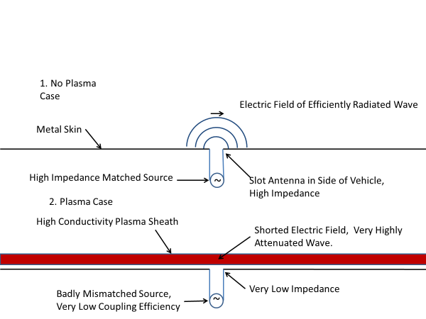

Figure 1. This is a schematic of the region near the metal skin with and without the plasma sheath.

.

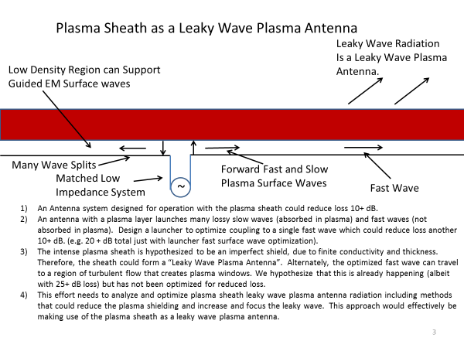

Figure 2. The design and physics for using the plasma sheath as a leaky wave plasma antenna to communicate through the plasma sheath.

**STATEMENT OF WORK.**

**Radio Communication with Hypersonic Aerial Vehicle by Treating the Plasma Sheath as an Antenna**

**Phase I.**

* **Using simulations, theoretical analysis, and experiments to study the wave launching of a slot antenna inside a plasma sheath.**
* **Determine sources of loss:**
  + **from impedance mismatching,**
  + **slow wave coupling,**
  + **fast wave launching loss,**
  + **loss thru plasma.**

**Phase II.**

* **Use simulations, analysis, and basic experiments to demonstrate principles of slow and fast surface wave couplings.**
* **Use simulations, analysis, and basic experiments to determine input impedance and matching of the antenna in the plasma sheath.**
* **We will simulate, analyze, and measure the fast wave coupling in the plasma sheath.**
* **Guided by standard antenna techniques we will simulate, analyze, and measure radiation resistance and radiation efficiency of the antenna in the plasma sheath to the inside fast surface wave.**
* **Optimize a single fast surface wave.**

**Phase III**

* **Continue to reduce those losses found in Phase 1 and 2 by tailoring the system and plasma sheath.**
* **Using simulations, analysis, and basic experiments we will study the fast surface wave coupling to the outside and how plasma density and thickness tradeoffs can increase the leaking and radiation.**
* **We will determine if we can reduce (not eliminate) the plasma frequency and/or thickness and increase the leaking with aerodynamic tailoring, charged plates, modest material injection, and modest magnets.**
* **Using simulations and basic experiments we will determine if our techniques can reduce the losses down to low enough levels at 1-6 GHz that will allow communications through the plasma sheath.**

**References**

[1] Chadwick, K. M., D. W. Boyer, and S. S. Andre, “Plasma and Flowfield Induced Effects

on Hypervelocity Reentry Vehicles for L-Band Irradiation at Near Broadside Aspect

Angles.” in 27th AIAA Plasmadynamics and Lasers Conference, New Orleans, LA, June

1996, <https://arc.aiaa.org/doi/10.2514/6.1996-2322>.

[2] Norris, G., “Plasma Puzzle: Radio Frequency-Blocking Sheath Presents a Hurdle to

Hypersonic Flight,” Aviation Week & Space Technology, March 2009, p. 58.

[3] Blottner, F. G., “Viscous Shock Layer at the Stagnation Point with Nonequilibrium Air

Chemistry,” AIAA Journal, Vol. 7, No. 12, December 1969, pp. 2281–2288, https://

arc.aiaa.org/doi/abs/10.2514/3.5528?journalCode=aiaaj.

[4] Hartunian, R. A., et al., “Implication and Mitigation of Radio Frequency Blackout

During Reentry of Reusable Launch Vehicles,” in AIAA Atmospheric Flight Mechanics

Conference, Hilton Head, South Carolina, August 20–23, 2007.

1. **Steering and Focusing Antenna Beams to Track Hypersonic Speeds Using the Physics of Refraction of EM Waves Through a Plasma**

**Introduction**

Refraction of electromagnetic waves and particles through a plasma has been studied by a number of researchers. In 1967, Hug et al [1] measured the index of refraction in an argon plasma. These results are very useful for plasma antennas since argon has been the gas of choice for plasma antennas due to the abundance and low cost. Atmospheric air plasma antennas have been patented and a useful application of this is a paper by Mathuthu et al [2] on the index of refraction, plasma frequency, and phase velocity in a laser induced air plasma. Specifically the patents by Anderson [3,4] are laser induced air plasma antennas. ELF plasma antennas designed and conceptualized by Anderson [5] can be laser induced air plasma antennas The effect of magnetic fields on plasma antennas have been theoretically simulated by Melazzi et al [6] and the effect on refraction through a plasma has been studied by Mesfin et al [7]. Useful for measuring refraction of plasma in plasma antennas, Tallents did research on measuring refraction in a plasma. The physics of refraction in a plasma is dependent on plasma density and plasma frequency. Experiments that connect refraction through a plasma as a function of plasma density have been done by

Petrov[8]. Gekelman et al [9 ] did plasma experiments on the complex index of refraction. Given the connection of plasma to metamaterials as shown by S.Sakai et al [10], excellent work on negative refraction was done by Zhan et al [ 11].

Both steering and focusing of antenna beams can be done by electromagnetic waves (or more appropriately called for this book antenna beams) through a plasma. Anderson [12] has a patent on steering and focusing antenna beams by refraction through a plasma. Essentially steering and focusing are one and the same. Focusing is just steering inward on two sides of plasma when an antenna beam passes through it. Plasma lenses have been used to focus laser beams and particle beams. Focusing of a high powered laser beam by a plasma was done by Habibi et al [13]. An excellent paper authored by Gordon et al [14] covers optical plasma lenses. Gushenets et al [15 ] and Katsouleas et al[16] used plasma lenses to focus electron beams. Linardakis et al [17] were the first to use the physics of refraction of antenna beams passing through a plasma to steer antenna beams. Electronic phased arrays using an array of metal antennas have significant insertion losses and mutual coupling that the physics of refraction of antenna beams passing through the plasma may overcome.

**Basic Physics of Refraction Theory of Electromagnetic Waves Propagating Through a Plasma.**

The phase speed of electromagnetic waves in a plasma is given by:

Description: \begin{displaymath}
v_p = \frac{c}{\sqrt{1-\omega_p^{ 2}/\omega^{2}}},
\end{displaymath} (1)

Where the plasma frequency is given by:

Description: \begin{displaymath}
\omega_p = \sqrt{\frac{n_e e^2}{\epsilon_0 m_e}}
\end{displaymath} (2)

In this paper we are experimenting in the region where the antenna frequency is greater than the plasma frequency:

 (3)

In this region refraction and not reflection takes place.

The phase speed of electromagnetic waves in a plasma is greater than in free space. The greater the density of the plasma, the greater the phase speed. Since the plasma density can be reconfigured, the steering and focusing of antenna beams by the physics of refraction through a plasma is reconfigurable [18,19]. The amount of refraction through a plasma depends on the path length through a plasma and the change in plasma density over that path length [18,19]. This physical process can also be considered as a plasma lens [18,19].

Refraction in a plasma depends on:

1. Plasma density
2. Path length
3. Gradient of plasma density
4. Wavelength

Refraction of electromagnetic waves in a plasma in which the frequency of the electromagnetic waves is above the plasma frequency for steering and focusing antenna beams is covered in [18,19]. This application is using this physics to track objects at hypersonic speeds.

An array of tubes or plate containing plasma is placed in the antenna beam path, as in front of a conventional feed horn/small array.

The phase shifting plasma channels focus and steer the antenna beam. In this application the operating frequency is above the plasma frequency, where the plasma is essentially a cold plasma with short relaxation time. The electromagnetic waves propagate through the plasma with a plasma frequency dependent phase velocity. This will require high pulses per second (pps) power supply with pulsing (e.g. pps of MHz with nano-sec pulse widths) or direct current.

The short relaxation time of the plasma in this design permits fast adjustment of phase shift in the plasma channels on the order of 1 to 10 micro-sec. Rapid changes in the plasma density account for rapid steering of electromagnetic waves through a plasma and this can be faster than steering an antenna beam by phased array technology and phase shifters and fast enough to track objects moving at hypersonic speeds. Antenna beam steering by refraction through a plasma of the order of 6 to 60 degrees per microsecond would not be unreasonable.

This is a very high angular speed of the antenna beam which results in an above hypersonic speed tangential velocity of the antenna beam. The phase speed of electromagnetic waves in a plasma can exceed the speed of light as explained in [18,19]. in the same way that phase speeds in waveguides and in plasmas exceed the speed of light. Nevertheless the transfer of energy and momentum does not exceed the speed of light.

Related to the plasma sheet or an array of multiple plasma tubes of small diameter is the plasma plasma sheet or an array of multiple plasma tubes of small diameter coupled with a metal flat plate reflector in which a plasma sheet or an array of small diameter tubes containing plasma encapsulated in ruggedized material is attached to a flat metal plate reflector. The advantage of this is that the electromagnetic waves refract through the plasma, reflect off of the metal plate, and refract back through the plasma giving a double refraction and twice the steering and focusing effect. The disadvantage is that the metal plate reduces stealth. But flat metal plates have a reduced RCS because of reduced back scattering differential and total cross section if oriented other than perpendicular to the antenna beam. A doubling of the total phase shift per thickness of the plasma plate would be achieved. This creates doubling of the steering and focusing effect by refraction through the plasma of the antenna beam.

The plasma array of tubes with plasma with or without a reflector is very stealth.

In the plasma/metal reflector design, a flat metal plate has very low effective radar cross section to adversary radar. Flat metal plates have a reduced RCS because of reduced back scattering differential and total cross section if oriented other than perpendicular to the antenna beam

Whether the plasma is on (ionized state) or off (extinguished state) the array of tubes or plate containing plasma is little more than a flat dielectric plate that would have even lower radar cross section than a flat metal plate.

Broadband wave matching techniques, such as dielectric cones on the array of tubes or plate containing plasma, and RF absorber on the edges, could make this plasma system with or without a reflector virtually invisible. By comparison a conventional phased array using metal elements has a very high radar cross section.

The plasma system using refraction to steer and focus an antenna beam can be more compact than a comparable metallic phased array. Plasma channels can be packed many per wavelength for compactness and low sidelobe control.

**STATEMENT OF WORK.**

**Steering and Focusing Antenna Beams to Track Hypersonic Speeds Using the Physics of Refraction of EM Waves Through a Plasma**

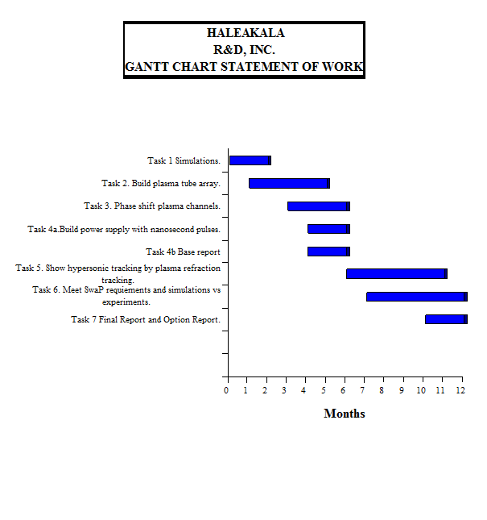

References

1. W. F. Hug, D. Evans, R. S. Tankin, and A. B. Cambel, *Measured Index of Refraction for Argon Plasma,* Phys. Rev. 162, 117 – Published 5 October 1967.
2. M. Mathuthu , R. Raseleka, A.Forbes , Nicholas West, *Radial Variation of Refractive Index, Plasma Frequency and Phase Velocity in Laser Induced Air Plasma,* Published in: IEEE Transactions on Plasma Science ( Volume: 34 , Issue: 6 , Dec. 2006 ) Page(s): 2554 – 2560
3. T. Anderson*, Laser driven plasma antenna utilizing laser modified Maxwellian relaxation.* Patent number 6,650,297, issued November 18, 2003.
4. T. Anderson, *Plasma antenna with electro-optical modulator*, Patent number 6,087,993, issued July 11, 2000.
5. T. Anderson, *ELF Plasma Antenna,* NUWC-NPT Technical Memorandum 972159, 30 September 1997, Approved for public release; distribution is unlimited.
6. D. Melazzi, V. Lancellotti, P. De Carlo, M. Manente, D. Pavarin, T. Anderson, *Numerical Investigation into the Performance of Two Reconfigurable Gaseous Plasma Antennas,* EuCAP 2014 Conference Proceedings.
7. Belayneh Mesfin, V. N. Mal'nev, E. V. Martysh, and Yu. G. Rapoport, *Waves and negative refraction in magnetized plasma with ferrite grains,* Physics of Plasmas 17, 112109 (2010).
8. V. G. Petrov, *Influence of refraction on plasma density measurements,* Plasma Physics Reports, April 2006, Volume 32, Issue 4, pp 311–316.
9. W. Gekelman et al, *Using plasma experiments to illustrate a complex index of refraction,* Am. J. Phys., Vol. 79, No. 9, September 2011.
10. S.Sakai,;K. Tachibana, *Plasmas as metamaterials: a review;* IOP Publishing Plasma Sources Science And Technology, Plasma Sources Sci. Technol. 21 (2012) 013001.
11. Y. Zhan and B. Guo, *Negative refraction in a rotational plasma metamaterial,* Published 9 November 2018 • © 2018 Hefei Institutes of Physical Science, Chinese Academy of Sciences and IOP Publishing, Plasma Science and Technology, Volume 21, Number 1.
12. T. Anderson, *Plasma Devices for Steering and Focusing Antenna Beams*; U.S. Patent Issue Number: 8,384,602, Issued February 26, 2013.
13. M. Habibi and M. Davoodianidalik, *Self-Focusing of High-Power Laser Beam through Plasma,*  Open access peer-reviewed chapter, October 3rd 2018.
14. D. F. Gordon, A. B. Stamm, B. Hafizi, L. A. Johnson, D. Kaganovich, R. F. Hubbard, A. S. Richardson, and D. Zhigunov, *Ideal form of optical plasma lenses,* Physics of Plasmas 25, 063101 (2018).
15. V. I. Gushenets et al., *Electrostatic Plasma Lens Focusing of an Intense Electron Beam in an Electron Source With a Vacuum Arc Plasma Cathode*, IEEE Transactions on Plasma Science, vol. 41, no. 8, pp. 2171-2176, Aug. 2013.
16. J. J. Su, T. Katsouleas, J. M. Dawson, and R. Fedele, *Plasma lenses for focusing particle beams*, Phys. Rev. A 41, 3321 – Published 1 March 1990.
17. P. Linardakis, G. Borg and N. Martin, *Plasma-based lens for microwave beam steering,* Electronics Letters, 13th April 2006 Vol. 42 No. 8.
18. Anderson, T. R. “Plasma Antennas Second Edition”, Chapter 13, Artech House, 2020.
19. Anderson, T. R. “Plasma Antennas Second Edition”, Section 18.8 supplementary material, Artech House, 2020.

**The Second Edition of my book titled “Plasma Antennas”:**

**Plasma Antennas, Second Edition, Theodore Anderson, Copyright: 2020 Artech House,**

**ISBN: 9781630817503**

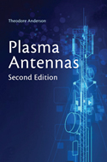

**My original book titled “Plasma Antennas”:**

|  |  |  |
| --- | --- | --- |
| GetBlob | ***Plasma Antennas***  *Theodore Anderson, Haleakala Research and Development, Inc.*   |  | | --- | | *ISBN 978-1-60807-143-2*  *Copyright 2011, Artech House.* | |

**Book Chapter**

*Frontiers in Antennas: Next Generation Design & Engineering,* chapter 10; Plasma Antennas, Theodore R. Anderson, McGraw -Hill, Frank Gross editor. ISBN 0071637931 / 9780071637930