**Steering and Focusing Antenna Beams to Track Hypersonic Speeds Using the Physics of Refraction of EM Waves Through a Plasma.**

***Abstract***

Tracking by using refraction of electromagnetic waves through a plasma is faster than electronic phased array antennas using phase shifters. If the plasma is formed by nanosecond pulses every microsecond, the density of the plasma can be reconfigured so fast that very rapid tracking is possible of vessels at hypersonic.

1. **Introduction**

Refraction of electromagnetic waves and particles through a plasma has been studied by a number of researchers. In 1967, Hug et al [1] measured the index of refraction in an argon plasma. These results are very useful for plasma antennas since argon has been the gas of choice for plasma antennas due to the abundance and low cost. Atmospheric air plasma antennas have been patented and a useful application of this is a paper by Mathuthu et al [2] on the index of refraction, plasma frequency, and phase velocity in a laser induced air plasma. Specifically the patents by Anderson [3,4] are laser induced air plasma antennas. ELF plasma antennas designed and conceptualized by Anderson [5] can be laser induced air plasma antennas The effect of magnetic fields on plasma antennas have been theoretically simulated by Melazzi et al [6] and the effect on refraction through a plasma has been studied by Mesfin et al [7]. Useful for measuring refraction of plasma in plasma antennas, Tallents did research on measuring refraction in a plasma. The physics of refraction in a plasma is dependent on plasma density and plasma frequency. Experiments that connect refraction through a plasma as a function of plasma density have been done by

Petrov[8]. Gekelman et al [9 ] did plasma experiments on the complex index of refraction. Given the connection of plasma to metamaterials as shown by S.Sakai et al [10], excellent work on negative refraction was done by Zhan et al [ 11].

Both steering and focusing of antenna beams can be done by electromagnetic waves (or more appropriately called for this book antenna beams) through a plasma. Anderson [12] has a patent on steering and focusing antenna beams by refraction through a plasma. Essentially steering and focusing are one and the same. Focusing is just steering inward on two sides of plasma when an antenna beam passes through it. Plasma lenses have been used to focus laser beams and particle beams. Focusing of a high powered laser beam by a plasma was done by Habibi et al [13]. An excellent paper authored by Gordon et al [14] covers optical plasma lenses. Gushenets et al [15 ] and Katsouleas et al[16] used plasma lenses to focus electron beams. Linardakis et al [17] were the first to use the physics of refraction of antenna beams passing through a plasma to steer antenna beams. Electronic phased arrays using an array of metal antennas have significant insertion losses and mutual coupling that the physics of refraction of antenna beams passing through the plasma may overcome.

1. **Basic Physics of Refraction Theory of Electromagnetic Waves Propagating Through a Plasma.**

The phase speed of electromagnetic waves in a plasma is given by:

Description: \begin{displaymath}
v_p = \frac{c}{\sqrt{1-\omega_p^{ 2}/\omega^{2}}},
\end{displaymath} (1)

Where the plasma frequency is given by:

Description: \begin{displaymath}
\omega_p = \sqrt{\frac{n_e e^2}{\epsilon_0 m_e}}
\end{displaymath} (2)

In this paper we are experimenting in the region where the antenna frequency is greater than the plasma frequency:

 (3)

In this region refraction and not reflection takes place.

The phase speed of electromagnetic waves in a plasma is greater than in free space. The greater the density of the plasma, the greater the phase speed. Since the plasma density can be reconfigured, the steering and focusing of antenna beams by the physics of refraction through a plasma is reconfigurable [18,19]. The amount of refraction through a plasma depends on the path length through a plasma and the change in plasma density over that path length [18,19]. This physical process can also be considered as a plasma lens [18,19].

Refraction in a plasma depends on:

1. Plasma density
2. Path length
3. Gradient of plasma density
4. Wavelength

Refraction of electromagnetic waves in a plasma in which the frequency of the electromagnetic waves is above the plasma frequency for steering and focusing antenna beams is covered in [18,19]. This application is using this physics to track objects at hypersonic speeds.

An array of tubes or plate containing plasma is placed in the antenna beam path, as in front of a conventional feed horn/small array.

The phase shifting plasma channels focus and steer the antenna beam. In this application the operating frequency is above the plasma frequency, where the plasma is essentially a cold plasma with short relaxation time. The electromagnetic waves propagate through the plasma with a plasma frequency dependent phase velocity. This will require high pulses per second (pps) power supply with pulsing (e.g. pps of MHz with nano-sec pulse widths) or direct current.

The short relaxation time of the plasma in this design permits fast adjustment of phase shift in the plasma channels on the order of 1 to 10 micro-sec. Rapid changes in the plasma density account for rapid steering of electromagnetic waves through a plasma and this can be faster than steering an antenna beam by phased array technology and phase shifters and fast enough to track objects moving at hypersonic speeds. Antenna beam steering by refraction through a plasma of the order of 6 to 60 degrees per microsecond would not be unreasonable.

This is a very high angular speed of the antenna beam which results in an above hypersonic speed tangential velocity of the antenna beam. The phase speed of electromagnetic waves in a plasma can exceed the speed of light as explained in [18,19]. in the same way that phase speeds in waveguides and in plasmas exceed the speed of light. Nevertheless the transfer of energy and momentum does not exceed the speed of light.

Related to the plasma sheet or an array of multiple plasma tubes of small diameter is the plasma plasma sheet or an array of multiple plasma tubes of small diameter coupled with a metal flat plate reflector in which a plasma sheet or an array of small diameter tubes containing plasma encapsulated in ruggedized material is attached to a flat metal plate reflector. The advantage of this is that the electromagnetic waves refract through the plasma, reflect off of the metal plate, and refract back through the plasma giving a double refraction and twice the steering and focusing effect. The disadvantage is that the metal plate reduces stealth. But flat metal plates have a reduced RCS because of reduced back scattering differential and total cross section if oriented other than perpendicular to the antenna beam. A doubling of the total phase shift per thickness of the plasma plate would be achieved. This creates doubling of the steering and focusing effect by refraction through the plasma of the antenna beam.

The plasma array of tubes with plasma with or without a reflector is very stealth.

In the plasma/metal reflector design, a flat metal plate has very low effective radar cross section to adversary radar. Flat metal plates have a reduced RCS because of reduced back scattering differential and total cross section if oriented other than perpendicular to the antenna beam

Whether the plasma is on (ionized state) or off (extinguished state) the array of tubes or plate containing plasma is little more than a flat dielectric plate that would have even lower radar cross section than a flat metal plate.

Broadband wave matching techniques, such as dielectric cones on the array of tubes or plate containing plasma, and RF absorber on the edges, could make this plasma system with or without a reflector virtually invisible. By comparison a conventional phased array using metal elements has a very high radar cross section.

The plasma system using refraction to steer and focus an antenna beam can be more compact than a comparable metallic phased array. Plasma channels can be packed many per wavelength for compactness and low sidelobe control.

References

1. W. F. Hug, D. Evans, R. S. Tankin, and A. B. Cambel, *Measured Index of Refraction for Argon Plasma,* Phys. Rev. 162, 117 – Published 5 October 1967.
2. M. Mathuthu , R. Raseleka, A.Forbes , Nicholas West, *Radial Variation of Refractive Index, Plasma Frequency and Phase Velocity in Laser Induced Air Plasma,* Published in: IEEE Transactions on Plasma Science ( Volume: 34 , Issue: 6 , Dec. 2006 ) Page(s): 2554 – 2560
3. T. Anderson*, Laser driven plasma antenna utilizing laser modified Maxwellian relaxation.* Patent number 6,650,297, issued November 18, 2003.
4. T. Anderson, *Plasma antenna with electro-optical modulator*, Patent number 6,087,993, issued July 11, 2000.
5. T. Anderson, *ELF Plasma Antenna,* NUWC-NPT Technical Memorandum 972159, 30 September 1997, Approved for public release; distribution is unlimited.
6. D. Melazzi, V. Lancellotti, P. De Carlo, M. Manente, D. Pavarin, T. Anderson, *Numerical Investigation into the Performance of Two Reconfigurable Gaseous Plasma Antennas,* EuCAP 2014 Conference Proceedings.
7. Belayneh Mesfin, V. N. Mal'nev, E. V. Martysh, and Yu. G. Rapoport, *Waves and negative refraction in magnetized plasma with ferrite grains,* Physics of Plasmas 17, 112109 (2010).
8. V. G. Petrov, *Influence of refraction on plasma density measurements,* Plasma Physics Reports, April 2006, Volume 32, Issue 4, pp 311–316.
9. W. Gekelman et al, *Using plasma experiments to illustrate a complex index of refraction,* Am. J. Phys., Vol. 79, No. 9, September 2011.
10. S.Sakai,;K. Tachibana, *Plasmas as metamaterials: a review;* IOP Publishing Plasma Sources Science And Technology, Plasma Sources Sci. Technol. 21 (2012) 013001.
11. Y. Zhan and B. Guo, *Negative refraction in a rotational plasma metamaterial,* Published 9 November 2018 • © 2018 Hefei Institutes of Physical Science, Chinese Academy of Sciences and IOP Publishing, Plasma Science and Technology, Volume 21, Number 1.
12. T. Anderson, *Plasma Devices for Steering and Focusing Antenna Beams*; U.S. Patent Issue Number: 8,384,602, Issued February 26, 2013.
13. M. Habibi and M. Davoodianidalik, *Self-Focusing of High-Power Laser Beam through Plasma,*  Open access peer-reviewed chapter, October 3rd 2018.
14. D. F. Gordon, A. B. Stamm, B. Hafizi, L. A. Johnson, D. Kaganovich, R. F. Hubbard, A. S. Richardson, and D. Zhigunov, *Ideal form of optical plasma lenses,* Physics of Plasmas 25, 063101 (2018).
15. V. I. Gushenets et al., *Electrostatic Plasma Lens Focusing of an Intense Electron Beam in an Electron Source With a Vacuum Arc Plasma Cathode*, IEEE Transactions on Plasma Science, vol. 41, no. 8, pp. 2171-2176, Aug. 2013.
16. J. J. Su, T. Katsouleas, J. M. Dawson, and R. Fedele, *Plasma lenses for focusing particle beams*, Phys. Rev. A 41, 3321 – Published 1 March 1990.
17. P. Linardakis, G. Borg and N. Martin, *Plasma-based lens for microwave beam steering,* Electronics Letters, 13th April 2006 Vol. 42 No. 8.
18. Anderson, T. R. “Plasma Antennas Second Edition”, Chapter 13, Artech House, 2020.
19. Anderson, T. R. “Plasma Antennas Second Edition”, Section 18.8 supplementary material, Artech House, 2020.
20. **Establishing the Plasma Sheath as a Plasma Antenna.**

**Plasma Sheath as a Leaky Wave Plasma Antenna.**

***Abstract***

The slot antenna in this section is necessary for the transmit and receiving communications with the missile’s electronics. Pumping energy into the plasma sheath by ground based plasma antennas and treating the plasma sheath as a ***rectenna.***

1. **Introduction.**

References [1-4] and supplementary material in section 18.8 [5] of *Plasma Antennas second edition* cover this topic. The idea here is to use the plasma sheath as a leaky wave plasma antenna (Figures 1 and 2) and not try to drive electromagnetic waves at communication frequencies through the plasma with more power.

In this approach we are working with the plasma sheath instead of against it.

1. **The Design and Physics.**

A fast surface wave traveling near the speed of light on the outside of a plasma sheath couples readily to free space. Fast (Vp>c) and slow surface waves (Vp<<c) are launched by a conventional antenna on the inside of the sheath between the plasma and metal vehicle.

Fast surface waves propagate in low loss waveguide fashion. Slow surface waves are absorbed by the plasma.

Due to the finite conductivity of a relatively thin sheath then it is possible for a fast surface wave field to couple through and radiate by the process of antenna leaking.

It may take many wavelengths for the wave to leak through, depending on the plasma conductivity and thickness.

The plasma sheath becomes a leaky wave plasma antenna.

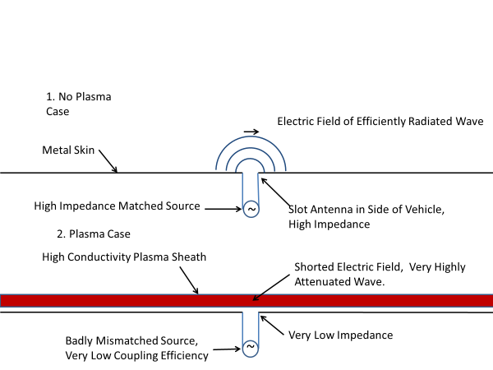

Figure 1. This is a schematic of the region near the metal skin with and without the plasma sheath.

.

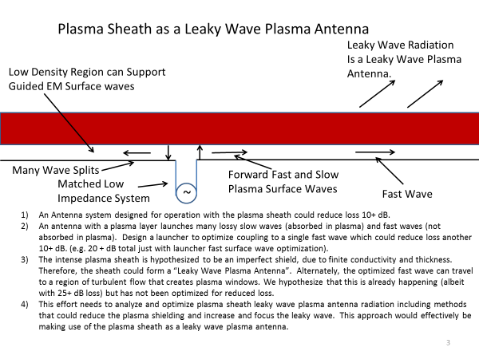

Figure 2. The design and physics for using the plasma sheath as a leaky wave plasma antenna to communicate through the plasma sheath.

**References**

[1] Chadwick, K. M., D. W. Boyer, and S. S. Andre, “Plasma and Flowfield Induced Effects

on Hypervelocity Reentry Vehicles for L-Band Irradiation at Near Broadside Aspect

Angles.” in 27th AIAA Plasmadynamics and Lasers Conference, New Orleans, LA, June

1996, <https://arc.aiaa.org/doi/10.2514/6.1996-2322>.

[2] Norris, G., “Plasma Puzzle: Radio Frequency-Blocking Sheath Presents a Hurdle to

Hypersonic Flight,” Aviation Week & Space Technology, March 2009, p. 58.

[3] Blottner, F. G., “Viscous Shock Layer at the Stagnation Point with Nonequilibrium Air

Chemistry,” AIAA Journal, Vol. 7, No. 12, December 1969, pp. 2281–2288, https://

arc.aiaa.org/doi/abs/10.2514/3.5528?journalCode=aiaaj.

[4] Hartunian, R. A., et al., “Implication and Mitigation of Radio Frequency Blackout

During Reentry of Reusable Launch Vehicles,” in AIAA Atmospheric Flight Mechanics

Conference, Hilton Head, South Carolina, August 20–23, 2007.

[5]. Anderson, T. R. “Plasma Antennas Second Edition”, Section 18.8 supplementary material, <https://us.artechhouse.com/mobile/Plasma-Antennas-Second-Edition-P2101.aspx> and scroll down.

Artech House, 2020.

**Disrupt/Deform (Destroy)**

**III. Dissipating the Plasma Sheath by Exciting Resonances in the Plasma Sheath as a Rectenna.**

***Abstract***

Treating the plasma sheath as a ***rectenna***, the density of the plasma is higher near the missile than in outside layer of the plasma sheath. This is why you can selectively pump energy into the more dense inside plasma layer by matching the plasma antenna frequency on the ground to the plasma frequency on the inside layer of the plasma sheath. This creates a dense plasma layer on a less dense plasma layer where the difference is high enough such that the resonance creates a Rayleigh-Taylor instability in plasma that leads to the termination of the plasma sheath.

The plasma antennas on the ground will have to scan over the estimated plasma frequencies in the sheath unit you match the plasma antenna frequency with the plasma sheath plasma frequency since we won't know exactly what that is. However we will know the range of what it is by experiments and simulations. Scanning over frequencies is much easier with plasma antennas than metal antennas because of the reconfigurability of plasma antennas.

**1. Plasma Resonances on a Cylindrical Plasma.**

* 1. **Experiments and simulations on plasma resonances of a cylindrical plasma column.**

Much of this topic is research done by T. Anderson [1]. Resonances were observed by Tonks [2] in scattering electromagnetic waves off of a cylindrical column of plasma. Experiments on scattering off of cylindrical plasmas can give valuable information on the utility of plasma antennas and plasma FSS. Tonks studied plasma discharge cylindrical columns and performed experiments of scattering electromagnetic waves off of a plasma cylindrical column. A schematic of the basic physical interaction is given in Figure 1. The experimental setup of the Tonks experiment is given in Figure 2 An electromagnetic wave from a signal source is propagated into a waveguide with dimensions corresponding to a cutoff wavelength of 10 cm. A thermionic-arc discharge column is situated at right angles to the incident waveguide electric field. Two direction couplers sample the amplitude of the incident wave and the amplitude of the reflected wave. The experiment consists of measuring the ratio of the scattered power reflected by the plasma to the power incident on the plasma as a function of the density of the plasma. The discharge column is a thermionic-arc discharge in mercury vapor at a pressure (10^-3 Torr) such that the plasma electron density is proportional to the dc current in the discharge. The plasma is collisionless since the mean free path of plasma electrons is much greater than the diameter of the plasma columns. The wavelength of the incident wave is much greater than the radius of the plasma column so that the electric field in the vicinity of the plasma column is nearly irrotational and the electric field can be derived from a scalar potential. The electrical potential satisfies Laplace’s equation with no z variation, both inside and outside the plasma. The boundary conditions at a dielectric-vacuum interface are that the normal component of the displacement and tangential component of the electric field be continuous. These conditions are satisfied at the plasma-air boundary.

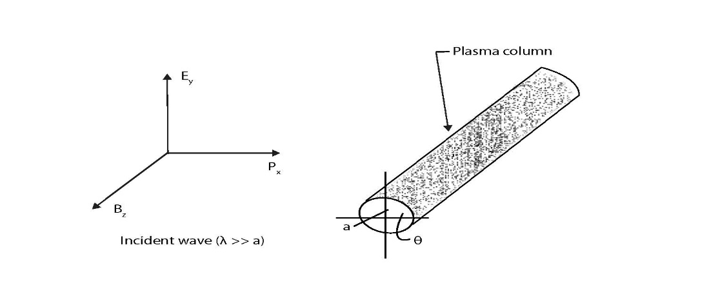

Figure 1. Scattering experiment basics showing incident polarization of the EM waves and the target plasma column.

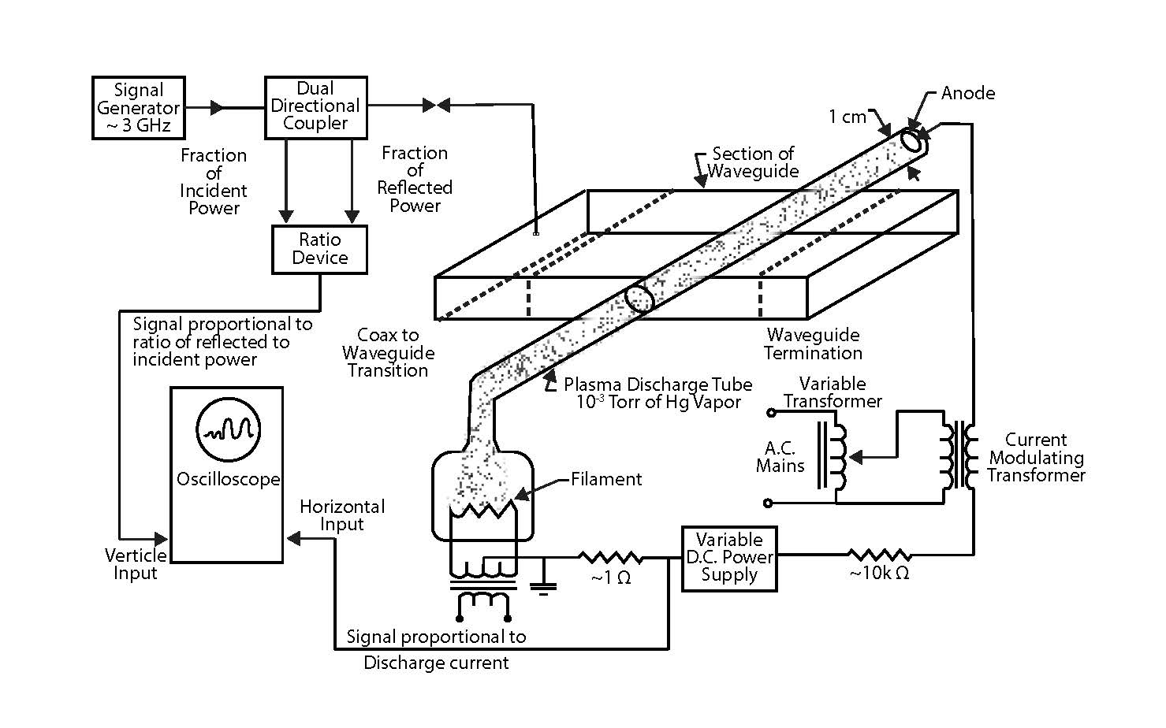

Figure 2. Experimental set up of the Tonk’s scattering experiment of electromagnetic waves off of a plasma cylindrical column.

The results of the Tonk’s scattering experiment are given in Figure 3.

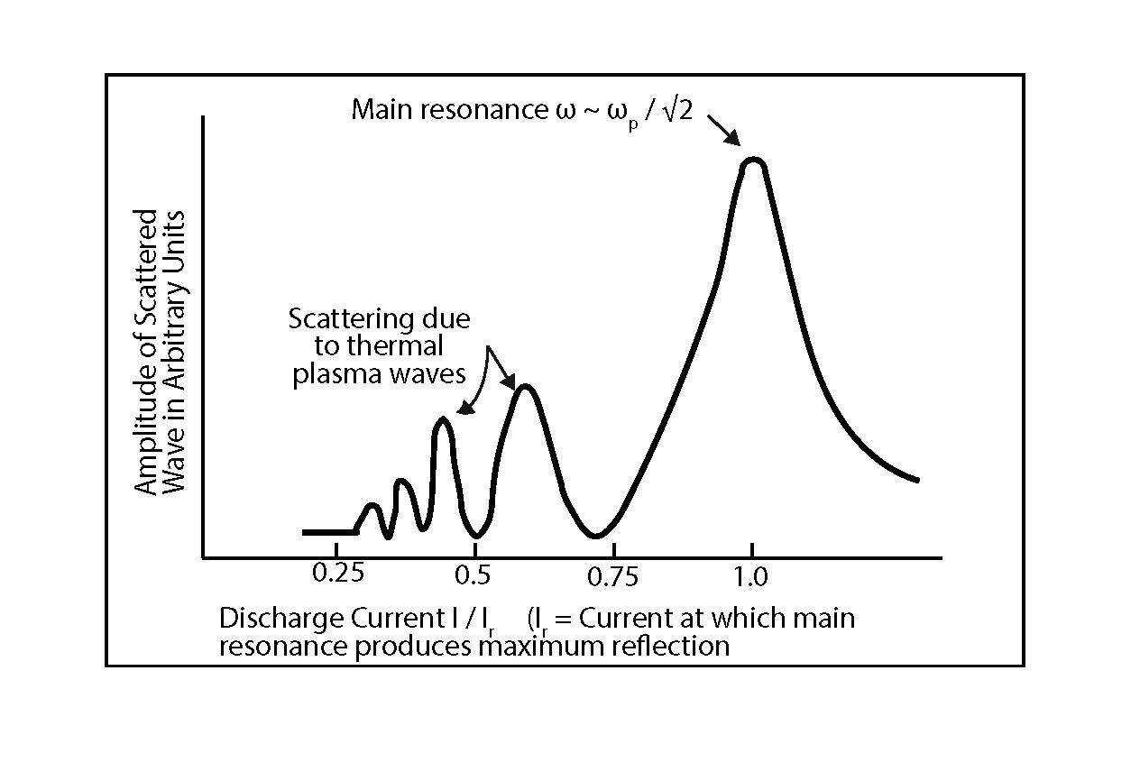

Figure 3 Amplitude of Scattered waves as a function of discharge current or plasma density. The peak resonance occurs at the plasma frequency divided by the square root of two. The square root of two factor comes in on the cylindrical geometry.

* 1. **Simulations and experiments of resonances in a plasma dipole antenna with a 100 MHz to 5 GHz sweep.**

The plasma dipole antenna has a length of 7.5 cm and a diameter of .25 cm. There are two capacitive bands connecting the feeds to the plasma dipole antenna in the center. In a simulation, a frequency sweep was done on the plasma dipole antenna from 100 MHz to 5 GHz. The plasma has a density of 10^19m^-3. The resonances in the radiated power are given are given in Figure 4 as well as a comparison to the same dipole antenna as a perfectly electric conductor (PEC). The resonance in the impedance is shown in Figures 5 and 6 [2]. An experiment was done by scattering electromagnetic waves off of a cylindrical plasma and sweeping from 100 MHz to 5 GHz. The results shown in Figure 7 shows the results of this scattering experiment with major and minor resonances similar in form to the simulation of Figure 4



Figure 4. Simulation with frequency sweep from 100 MHz to 5 GHz on the plasma dipole antenna with density 10^19^m-3.showing the radiated power. The background pressure of the plasma was 15mT and the electron temperature is 3 eV. This also shows the result of the PEC ( perfect electrical conductor) dipole of the same length.



Figure 5. This shows the real apert of the impedance resonantes between 3 GHz and 3.5 GHz. The real part of the impedance is 22 Ohms. Frequency sweep was from 100 MHz to 5 GHz on the plasma dipole antenna with density 10^19^m-3.showing resonances in the imaginary part of the impedance. The background pressure of the plasma was 15mT and the electron temperature is 3 eV.



Figure 6. is a plot of the imaginary part of the impedance and corresponds to the real part of the impedance Figure 4.

An experiment was done to observe resonances in the scattering of electromanetic waves off of a plasma cylinder as shown in Figure 7. A basic pulsing mechaism was used to ionize the plasma.The frequency sweep was given between 100 MHz and 5 GHz. The results are given in Figure 8. Major and minor resonances were observed as was predicted by the simulation in Figure 4.

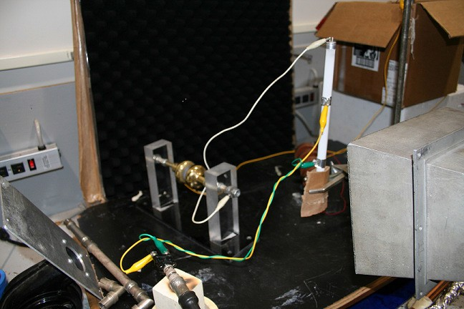

Figure 7.. Experimental setup for scattering electromagnetic waves off of a plasma dipole antenna and sweeping from 100 MHz to 5 GHz. This is an early experiment with early pulsing device.

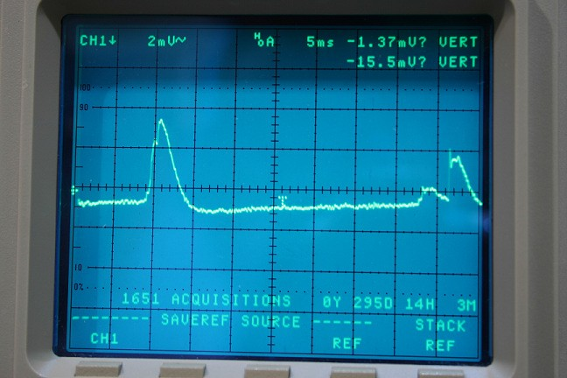

Figure 8. Results of the scattering experiment of Figure 7. Major and minor resonances are observed as is shown in the simulation of Figure 4.

1. **Plasma Sheath Instability and Dissipation**

As we saw in the last section when electromagnetic waves impinge upon a plasma sheath such that the electromagnetic wave frequency match the plasma frequency of the sheath, power can be pumped in the plasma and large amplitude oscillations will occur in the plasma.

In the mixture of fluids, the instability is triggered by the gravitational force acting on an inverted density gradient which we have by selectively pumping the electromagnetic energy in the upper layer of the plasma sheath. The basic magnetohydrodynamics equations are used to derive the dispersion relation for two plasma fluids of unequal densities. The conditions of the growth rate of the instability will be determined.

Rayleigh-Taylor instability [3] takes place when a lighter plasma fluid supports a heavier plasma fluid, then any perturbation of the interface grows and with the heavier plasma fluid penetrating into the lighter plasma fluid and the interface becomes unstable. The contact discontinuity between the two plasma fluids is unstable to perturbations that grow by converting potential energy to kinetic energy, causing parts of the low-density plasma fluid to rise, and parts of the high-density fluid to sink

We will solve the characteristics of the plasma sheath by numerically solving the magnetohydrodynamic equations to represent the sheath. A combination of the vessel-air friction at hypersonic speeds and pumping the plasma sheath with energy when the electromagnetic frequency matches or is close to the plasma frequency of the upper plasma layer next to the plasma sheath-vessel interface. This process will create a higher density plasma near the plasma sheath-vessel interface than at the plasma sheath-vessel interface. A Rayleigh-Taylor instability will occur and dissipate the plasma sheath. In summary, this will selectively create a high-density plasma over a lighter density plasma in the plasma sheath perpendicular to the gravitational field. This creates a Rayleigh-Taylor instability in the plasma.

In an alternative and more rigorous model, we will derive an Orr-Sommerfeld [4, 6] type equation for magnetohydrodynamics and determine the magnetic Reynolds number which gives a complex wave frequency. If there is an imaginary part of the wave frequency the Tollmien-Schlichting waves [5] will grow in amplitude and the plasma sheath will become unstable and dissipate.

**References**

1. Anderson, T. R. “Plasma Antennas Second Edition”, Section 18.4; Artech House, 2020.
2. Tonks, L., “The High Frequency Behavior of a Plasma,” Phys. Rev. Vol. 37, 1931, p.1458
3. P.G. Drazin and W. H. Reid;” Hydrodynamic Stability”, pg 324, Cambridge University Press, 1981.
4. P.G. Drazin and W. H. Reid; “Hydrodynamic Stability”, pg 156, Cambridge University Press, 1981.
5. P.G. Drazin and W. H. Reid; “Hydrodynamic Stability”, pg 239,Cambridge University Press, 1981.
6. Anderson, T.R., “Turbulent wall pressure and wall shear fluctuations calculated from the Orr-Sommerfeld equation with nonlinear forcing terms”, https://ui.adsabs.harvard.edu/abs/1996AIPC..375..477A/abstract