Satellite and Reflector Plasma Antennas

Dr. Theodore (Ted) Anderson Haleakala Research and Development, Inc.

7 Martin Road, Brookfield, MA., 01506, USA; [tedanderson@haleakala-research.com:](mailto:tedanderson@haleakala-research.com) [www.ionizedgasantennas.com](http://www.ionizedgasantennas.com/)

*Abstract*— Satellite plasma antennas benefit from the lower thermal noise at the frequencies they operate. Ground-based satellite antennas point at space where the thermal noise is about 5K. A low thermal noise, high data rate satellite plasma antenna system is possible with low noise plasma feeds and a low noise receiver. Satellite plasma antennas can operate in the reflective or refractive mode. Satellite plasma antennas can be flat or conformal and effectively parabolic. Electromagnetic waves reflecting off of a bank of plasma tubes get phase shifted as a function of the plasma density in the tube. This becomes an effective phase array except that the phase shifts are determined by the plasma density. If the plasma density in the tubes is computer controlled, the reflected beam can be steered or focused even when the bank of tubes is flat or conformal. In the refractive mode, the refraction of electromagnetic waves depends upon the density of the plasma. In the refractive mode, steering and focusing can be computer controlled even when the bank of tubes is flat. For two-dimensional steering and/or focusing, two banks of plasma tubes are needed. Receivers can be put behind satellite plasma antennas operating in the refractive mode. Anderson [1] wrote a comprehensive book on plasma antennas Alexeff and Anderson and [2]-[3] Anderson and Alexeff [4] have done theory, experiments, and have built prototype plasma antennas..

1. INTRODUCTION

One must distinguish the difference between the plasma or excitation frequency and the operating frequency of the plasma antenna. The plasma frequency is a measure of the amount of ionization in the plasma and the operating frequency of the plasma antenna is the same as the operating frequency of a metal antenna. The plasma frequency of a metal antenna is in the X-ray region of the electromagnetic spectrum whereas the plasma frequency of the plasma antenna can be varied. The greatest applications of the plasma antenna are when the plasma frequency is varied in the RF spectrum. In this sense, the metal antenna is a special case of the plasma antenna. High frequency plasma antennas refer to plasmas that have a high operating frequency and low frequency plasma antennas refer to plasma antennas that have a low operating frequency. Do not confuse plasma antenna operating frequency with plasma or excitation frequency.

High frequency plasma antennas can transmit and receive through lower frequency plasma antennas. This is not possible with metal antennas. Because of this principle, higher frequency plasma antennas can be nested inside lower

frequency plasma antennas and the lower frequency plasma antennas can transmit and receive through the higher frequency plasma antennas. Higher frequency plasma antenna arrays can transmit and receive through lower frequency plasma antenna arrays. Co-site interference occurs when larger frequency antennas block or partially block the radiation patterns of smaller higher frequency antennas. With plasma antennas, co-site interference can be eliminated or reduced because higher frequency plasma antennas can transmit and receive through lower frequency plasma antennas. Interference among plasma antennas can be reduced or eliminated by turning all the plasma antennas off (extinguishing the plasma) except the plasma antennas that are transmitting and/or receiving. This is not possible with metal antennas. One should be careful not to confuse the operating frequency of the plasma antenna with the plasma frequency. The plasma frequency is proportional to the square root of the density of unbound electrons in the plasma. In a metal the plasma frequency is fixed in the X-ray frequency region, but in plasma antennas, the plasma frequency can be made to vary in the RF region. This property gives plasma antennas some of their reconfiguration properties. A general rule is that when an incident electromagnetic wave upon a plasma antenna is such that the frequency of the incident electromagnetic wave is greater than the plasma frequency of the plasma, the incident electromagnetic wave passes through the plasma without attenuation. If the incident electromagnetic wave has a frequency much less than the plasma frequency, the plasma behaves similar to a metal. The frequency at which plasma behaves like a metal or a dielectric is reconfigurable. The plasma frequency is a natural frequency of the plasma and it is a measure of the amount of ionization in the plasma. Both plasma antennas and metal antennas increase in size as the frequencies they operate goes down to maintain geometric resonance and high efficiency. However as the frequency of operation of the plasma antenna decreases, the density of the plasma needed to operate the plasma antenna also goes down. A rule of thumb is that the plasma frequency should be about twice the operating frequency of the plasma antenna. Hence the plasma frequency goes down as the frequency of the plasma antenna goes down. As the plasma frequency decreases, the plasma antenna becomes transparent to a greater bandwidth of electromagnetic waves. In short as the plasma antenna increases in size, the RCS of the plasma antenna goes down whereas for the corresponding metal antenna, the RCS goes up as the metal antenna increases in size. This gives the plasma antenna some great advantages at low frequencies over the corresponding metal antenna. In addition plasma antennas do not receive electromagnetic noise greater than the plasma

frequency since these frequencies pass through the plasma antenna.

Thermal noise in a plasma antenna is less than the thermal noise in a metal antenna at the higher frequencies. Higher frequencies mean that there is a point in the RF spectrum in which the thermal noise of plasma antennas is equal to the thermal noise of metal antennas. At higher frequencies than this point, the plasma antenna thermal noise decreases drastically compared to a metal antenna. Below this point the thermal noise of the plasma antenna is greater than a metal antenna. For a flourescent tube which has been built as a plasma antenna, the point where the thermal noise of the plasma antenna is equal to the metal antenna is about 1 GHz. This point can be decreased in frequency by decreasing the plasma pressure. The plasma in the plasma antennas are inert gases that operate at energies and frequencies in which Ramsauer Townsend Effects apply.

Ramsauer Townsend Effects mean that the electrons in the plasma diffract around the ions and neutral atoms in the plasma. This means that the collision rate of the unbound electrons in the plasma with ions and neutral atoms is small and much smaller than in a metal. This phenomenon contributes to the lower thermal noise plasma antennas have over corresponding metal antennas.

.

1. THERMAL NOISE IN REGARD TO SATELLITE AND REFLECTOR PLASMA ANTENNAS

*.*

The Nyquist Theorem indicates the thermal noise is:

Keep in mind that this analysis has been and is for a fluorescent lamp. Plasma antennas have been made out of florescent lamps because they are inexpensive and it shows that people can do research and development and build prototypes of the plasma antenna technology cheaply.

When plasma antennas are ruggedized with custom made plasma tubes, the gas pressure inside the plasma tubes can be made much less than in a fluorescent bulb and lower the frequency at which the plasma antenna thermal noise is equal to the metal antenna thermal noise.

Using the highest gas pressure in a florescent tube of 2 millimeters, the frequency at which the plasma antenna and the metal antenna have the same thermal noise is 1.27 GHz. Using the lowest gas pressure of a fluorescent tube of 1 micron, this cross over frequency at which the plasma antenna thermal noise and the metal antenna thermal noise are equal is much lower. Above the cross over frequency where the thermal noise of the plasma antenna and the metal antenna, the plasma antenna thermal noise drops rapidly.

As stated above, custom made plasma tubes can be made such that pressure is much lower than in a fluorescent lamp. This would give a number in which the thermal noise of the plasma antenna and the metal antennas are equal much lower than

1.27 GHz antenna frequency.

Again, florescent tubes have been used often to make plasma antennas because this has been an inexpensive way to do our plasma antenna research and development. Custom made plasma tubes are being planned to be made to be rugged and have lower noise than metal antennas over very wide frequency range.

*H*  4*RKT*

, where H is the noise spectrum as Volts

squared per Hertz R is the resistance of the object in Ohms, K is Boltzmann’s constant in Joules per degree K, and T is the temperature in degrees K. This equation is a low-frequency approximation, but for metals this approximation is correct, since in metals the collision frequency is a terahertz.

The correction term found by Anderson in chapter 12 of [1] and is:

*H*    4*RKT* ( 1

)

2

1. PLASMA REFLECTOR ANTENNA

With this apparatus, stealth, reconfigurability, and protection from electronic warfare is demonstrated.

Reflected patterns were measured for conventional reflector antenna and a plasma tube reflector for performance comparison. In these experiments, the antenna configurations were designed as an offset fed, cylindrical parabolic reflector. The conventional solid antenna is a parabolic cylinder 28”

 (2)

◆

1

2

*cc*

(1)

high, by 36.5” long, with the parabolic shape in the vertical dimension. It is an offset design, with the parabolic segment being the outer 28” of a 52” diameter dish. The focal distance

Where  is the frequency of the transmitter in Hertz,

and *cc* is the electron-gas atom collision frequency in Hertz. Computing the noise figure in volts squared per Hertz, a metal

antenna operating at 10 GHz gives us 1.04 exp -21.

For the plasma antenna at 10 GHz, we obtain 4.29 exp-24. Thus in this frequency range, the noise in the plasma antenna is much less than the metal antenna. Of course, at low enough frequencies, the inequality is reversed, but we can address that by reducing the gas pressure in custom made plasma tubes. Note that we used the upper limit for gas pressure in a COTs

plasma tube. Using the lowest pressure in a COTS plasma tube

would reduce the plasma noise by about a factor of 2000.

for the parabola is 13”, which yields a 13” depth for the parabola at the highest point. The antenna is fed by a line source feed which is accomplished by the use of a pillbox antenna. The pillbox antenna is mounted at the front of the reflector antenna, in the prime focus configuration and has a flared mouth to provide a nominal –10 dB amplitude taper across the vertical dimension of the reflector. The pillbox feed is itself a parabola in the lengthwise dimension. The focal distance of the pillbox parabola is 9”, and the depth of the pillbox including feed flare is approximately 14”. The plate spacing of the feed parallel plates was chosen to allow the resulting horizontal polarization (i.e. the electric field is parallel to the long dimension of the reflector). The frequency

of operation for the test was selected to be 3.0 GHz, which is well within the bandwidth of the WR-284 waveguide being used in the design. A photograph of the solid reflector antenna is seen in Figure 1.

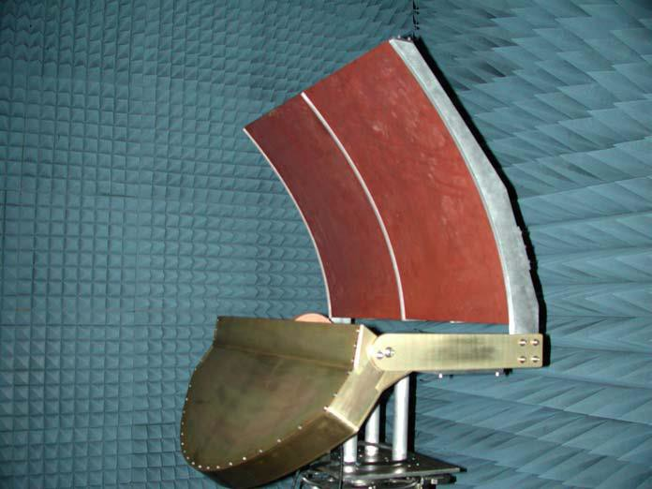

Figure 1. Solid Metal Reflector Antenna

The plasma configuration consisted of simply replacing the solid reflector surface with a plasma tube configuration having the same nominal shape and dimensions.

A photograph of this system is shown in Figure 2.

The plasma reflector is comprised of 17 fluorescent light tubes, with a nominal projected tube to tube spacing of 1.5”. The tube spacing was chosen to provide efficient operation at

3.0 GHz. The tubes were arranged to conform to the same cylindrical parabolic shape as the baseline solid reflector. They formed a reflecting surface 24.75” inches high, measured from the top perimeter of the highest tube to the bottom perimeter of the lowest tube. The tubes were supported by two vertically shaped Plexiglass supports that were drilled with holes to slide the tubes through.

The commercially available florescent tubes are 35.125” long , including the metal end caps. The actual bulb length (electrode to electrode spacing) is 33.5”.

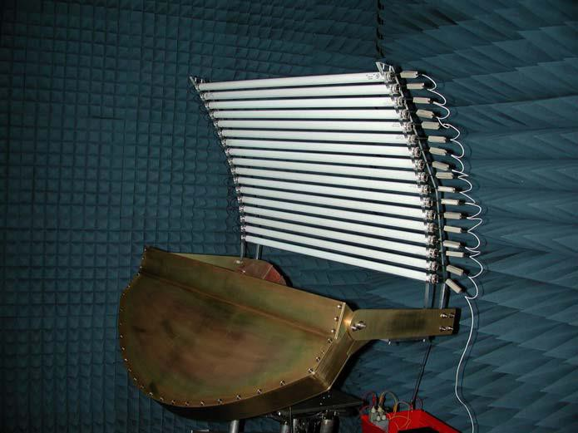

Figure 2. Plasma Reflector Antenna

The plasma tubes were fired in a pulse mode. Antenna patterns were measured at 3.0 GHz. Sample antenna patterns for the reference solid reflector and for the Proof-of-Principle plasma reflector are plotted together in Figure 3. As seen in the figure, the patterns are a very good match between the Proof-of- Principle plasma antenna and those of the reference solid conventional antenna. Figure 3 also shows the received signal from the plasma antenna when the tubes are not energized. It is seen that received signal has dropped by approximately –20 dB in milliseconds. This signal level is primarily due to reflections from the plasma containers and the electrodes. This level could easily be reduced to below the –30 dB level with proper design attention.

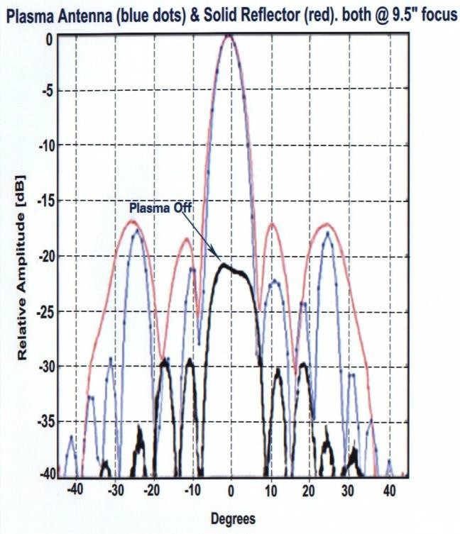

Figure 3. Radiation Patterns. The above plot shows that the plasma antenna reflector antenna had lower sidelobes than the corresponding metal reflector antenna. No theory has been done to date to predict this effect, but it may be due to the soft surface effects of the plasma reflective to the metal.

1. SATELLITE PLASMA ANTENNAS

An arrangement of plasma antennas can be flat and effectively parabolic and can electronically focus and steer RF signals without phased arrays. Applications can be for both static (e.g. Direct TV) and dynamic as in dish antennas attached to vehicles, ships, or aircraft.

A plasma layer can reflect microwaves if the incident electromagnetic wave frequency is less than the plasma frequency. A plane surface of plasma can steer and focus a microwave beam on a time scale of milliseconds. Cutoff is defined as the displacement current and the electron current cancel when electromagnetic waves impinge on a plasma surface. The electromagnetic waves are cutoff from penetrating the plasma. The basic observation is that a layer of

plasma beyond microwave cutoff reflects microwaves with a phase shift that depends on plasma density.

1. *Reflective Mode.*

Exactly at cutoff, the displacement current and the electron current cancel. Therefore there is a antinode at the plasma surface, and the electric field reflects in phase. As the plasma density increases from cutoff the reflected field increasingly reflects out of phase. Hence the reflected electromagnetic wave is phase shifted depending on the plasma density. This is similar to the effects of phased array antennas with electronic steering except that the phase shifting and hence steering and focusing comes from varying the density of the plasma from one tube to the next and phase shifters used in phased array technology is not involved. This allows us to use a layer of plasma tubes to reflect microwaves. By varying the plasma density in each tube, the phase of the reflected signal from each tube can be altered. The reflected signal can be steered and focused in analogy to what occurs in a phased array antenna. The steering and focusing of the mirror can occur on a time scale of milliseconds.

Fig 4. Shows steering and focusing when the plasma density is above cutoff (reflective mode).

On the left is a bank of tubes containing plasma reflects EM waves and steers and focuses the beam in one direction. On the right a perpendicular bank of tubes containing plasma reflects and steers and focuses the EM waves in the perpendicular direction. A horn antenna in the lower right transmits or receives the EM waves. The banks of tubes containing plasma can be flush with a surface or supported in other ways

Plasma satellite (other frequencies apply) antenna can be flush with a wall, roof, or any static or moving surface which can be flat or curved. They can also be mounted in other ways.

1. *Refractive Mode*

Steering and focusing when the plasma density is below cutoff is the refractive mode as shown in Fig. 6 below.



Focused and/or steered Microwaves

Figure 4. Incident RF waves on the right impinge on plasma tubes with different densities but with the plasma densities above cutoff

Focusing or steering can be achieved depending on how the plasma densities are varied from tube to tube.



Figure 5. Banks of tubes containing plasma displaced and perpendicular to each other**.**

Focused and/or steered Microwaves

Figure 6. Steering and focusing when the plasma density is below cutoff is the refractive mode.

Incident RF waves on the left impinge on plasma tubes with different densities but with the plasma densities below cutoff. Focusing or steering can be achieved depending on how the plasma densities are varied from tube to tube.

Feed horns and receivers can be put behind satellite plasma antennas operating in the refractive mode. This eliminates the problem of the blind spot and feed losses caused by the feed horn and receiver in front of a metal satellite antenna.

The above phenomena is also known as a convergent plasma lens.

A convergent plasma lens can focus electromagnetic waves to decrease beamwidths, increase directivity, and increase antenna range. A divergent plasma lens can also be created. Both convergent and divergent plasma lenses lead to

reconfigurable beamwidths.

Basic plasma satellite (works at other frequencies) antenna design with two banks of perpendicular plasma tubes for steering and/or focusing in two dimensions with plasma densities-below-cutoff.

This is in the refractive not reflective mode. This system can apply to both a moving or static surface and steer and/or focus satellite signals by varying the plasma density among the plasma tubes with computer control in space and/or time.

A plasma satellite (works at other frequencies) antenna is mounted between the received or transmitted antenna signals in which the two banks of tubes( for two dimensional steering) with plasma with variable density from one tube to the next to steer and focus the antenna beam as Fig. 7 shows.



Figure 7. Steering and focusing in two dimensions when the plasma density is below cutoff is the refractive mode. EM waves are incident from left to right on the left side of the two banks of plasma tubes. A schematic of a receiver antenna is on the right side of the two banks of plasma tubes.

This system can eliminate the parabolic dish. Tubes can be within a wavelength apart. Such a wavelength corresponds to the transmitted or received frequency. This system can be completely encapsulated in Synfoam of an aesthetical shape. Plasma in tubes into the page steer and/or focus satellite signals in the z direction. Plasma in tubes parallel to the page steer and/or focus satellite signals azimuthally. The antenna signals for both the transmitting and receiving modes pass through both banks of tubes and are steered and focused by refraction. One dimensional (with one bank of tubes) steering and/or focusing may be enough for the static satellite plasma antenna.

An electronically steerable and focusing bank of plasma tubes can be made by having plasma densities in the tubes below cutoff but with the plasma densities varying from tube to tube. Electronic steering and focusing in either of the above cases can be made in two dimensions by having two perpendicular banks of tubes. This can also steer and focus horizontal, vertical, circular, and elliptically polarized signals.

With plasma electronic steering and focusing, parabolic reflector antennas are not needed.

Plasma physics allows us to use a layer of plasma tubes to reflect microwaves

1. PLASMA IS A TYPE OF METAMATERIAL.

Sakai and Tachibana [5] developed a fundamental understanding of electromagnetic wave propagation in and around plasmas, which included new functions of plasmas as metamaterials, including a photonic-crystal-like behavior with a negative refractive index state and a nonlinear bifurcated electric response, by describing specific plasma structures.

1. CONCLUSIONS.

Satellite plasma antennas benefit from the lower thermal noise at the frequencies they operate. Ground based satellite antennas point at space where the thermal noise is about 5 degrees K. A low thermal noise, high data rate satellite plasma antenna system is possible with low noise plasma feeds and a low noise receiver. Satellite plasma antennas can operate in the reflective or refractive mode. Satellite plasma antennas need not be parabolic but can be flat or conformal and effectively parabolic. Electromagnetic waves reflecting off of a bank of plasma tubes get phase shifted as a function of the plasma density in the tube. This becomes an effective phase array except that the phase shifts are determined by the plasma density. If the plasma density in the tubes is computer controlled, the reflected beam can be steered or focused even when the bank of tubes is flat or conformal. In the refractive mode, the refraction of electromagnetic waves depends upon the density of the plasma. In the refractive mode, steering and focusing can be computer controlled even when the bank of tubes is flat. For two dimensional steering and/or focusing, two banks of plasma tubes are needed. Feed horns and receivers can be put behind satellite plasma antennas operating in the refractive mode. This eliminates the problem of the blind spot and feed losses caused by the feed horn and receiver in front of a metal satellite antenna. The above phenomena of using a bank of plasma tubes to focus electromagnetic waves is also known as a convergent plasma lens. A convergent plasma lens can focus electromagnetic waves to decrease beamwidths, increase directivity, and increase antenna range. A divergent plasma lens can also be created. Both convergent and divergent plasma lenses lead to reconfigurable beamwidths.

Plasma waveguides and co-axial cables can be feeds for plasma antennas. Plasma feeds as well as the plasma antennas have reconfigurable impedances. If the impedance of the plasma antenna is changed, the impedance of the plasma feeds can be changed to maintain impedance matching. In the history of antennas, it has been difficult to develop low frequency directional and electronically steerable antennas that fit on land vehicles and aircraft. Low frequency means the wavelength is on the order or larger than the vehicle. With plasma antennas this is possible with multipole expansions of clusters of plasma antennas that are all within a wavelength of each other. This depends on the ability of turning plasma antennas on or off (extinguishing the plasma) to create reconfigurable multipoles of plasma antennas that can be rotated in time creating directional and steerable antenna

beams. This is not possible with metal antennas because they cannot be turned on and off.

Plasma antennas have been housed in a synthetic foam called Synfoam. When this synthetic foam hardens it makes very strong and lightweight tubes that can be used as plasma tubes to make plasma antennas. These rugged tubes can be readily manufactured. Synfoam has been tested to have an index of refraction close to one and hence very transparent to electromagnetic waves. Synfoam is very heat resistant. The ruggedized smart plasma antenna uses Synfoam to house the plasma and florescent tubes are not used. Gorilla Glass by Corning and Lexan Glass tubes are also options for housing plasmas. Plasma antennas can also be miniaturized and contained in commercially available cold cathode tubes used for liquid crystal displays. Ball and socket glass tubes inserted inside plastic tubes can be used to make flexible plasma antennas that can be shaped in various forms. In summary, the plasma of plasma antennas can be housed in Synfoam, miniaturized cold cathode tubes, ball and socket glass tubes,

Lexan Glass and Gorilla Glass by Corning. These materials can readily be manufactured.

REFERENCES

[1]. T. Anderson, “Plasma Antennas”, Artech House, ISBN:978-1-60807-144-9; 2011,

[http://www.artechhouse.com/Main/books/1923.aspx,](http://www.artechhouse.com/Main/books/1923.aspx)

[2] T. Anderson, I. Alexeff, “Plasma frequency selective surfaces”, IEEE Transactions on Plasma Science, Vol. 35, no. 2, p. 407, 2007

[3]. I. Alexeff, T. Anderson.,T.,2006, “Experimental and theoretical results with plasma antennas”, IEEE Transactions on Plasma Science, Vol. 34, No.2.

[4]. I. Alexeff.; T. Anderson, “Recent results of plasma antennas” *,* Physics of Plasmas, 15, 057104, 2008.

[5]. S. Sakai, K. Tachibana, 2012; “Plasmas as metamaterials”: a review; IOP Publishing Plasma Sources

Science And Technology, Plasma Sources Sci. Technol. 21 (2012) 013001